Supplementary Material

Table S1. Reclassification of the reference and target dataset for accuracy assessment analysis. The reference (GLC-SHARE) and classified (LUH2) data were reclassified into four common classes: (1) forest, (2) crops, (3) open areas, and (4) urban. Classes absent in the focus dataset were masked-out.

original class code |  |  | original  class name |  | code (name) after reclassification
GLC-SHARE
1 |  | Artificial surfaces |  |  | 4 (urban)
2 |  | Cropland |  |  | 2 (crops)
3 |  | Grassland |  |  | 3 (open areas)
4 |  | Tree covered areas |  |  | 1 (forest)
5 |  | Shrubs covered areas |  |  | 3 (open areas)
6 |  | Herbaceous vegetation, aquatic or regularly flooded |  |  | 3 (open areas)
7 |  | Mangroves |  |  | 3 (open areas)
8 |  | Sparse vegetation |  |  | 3 (open areas)
9 |  | Bare soil |  |  | 3 (open areas)
10 |  | Snow and glaciers |  |  | masked-out
11 |  | Water bodies |  |  | masked-out
LUH2
1 | C3 Annual Crops (c3ann) |  |  | 2 (crops)
2 | C3 Nitrogen-Fixing Crops (c3nfx) |  |  | 2 (crops)
3 | C3 Perennial Crops (c3per) |  |  | 2 (crops)
4 | C4 Annual Crops (c4ann) |  |  | 2 (crops)
5 | C4 Perennial Crops (c4per) |  |  | 2 (crops)
6 | Managed Pasture (pastr) |  |  | 3 (open areas)
7 | Forested Primary Land (primnf) |  |  | 1 (forest)
8 | Non-Forested Primary Land (primn) |  |  | 3 (open areas)
9 | Rangeland (range) |  |  | 3 (open areas)
10 | Potentially Forested Secondary Land (secdf) |  |  | 1 (forest)
11 | Potentially Non-Forested Secondary Land (secdn) |  |  | 3 (open areas)
12 | Urban Land (urban) |  |  | 4 (urban)

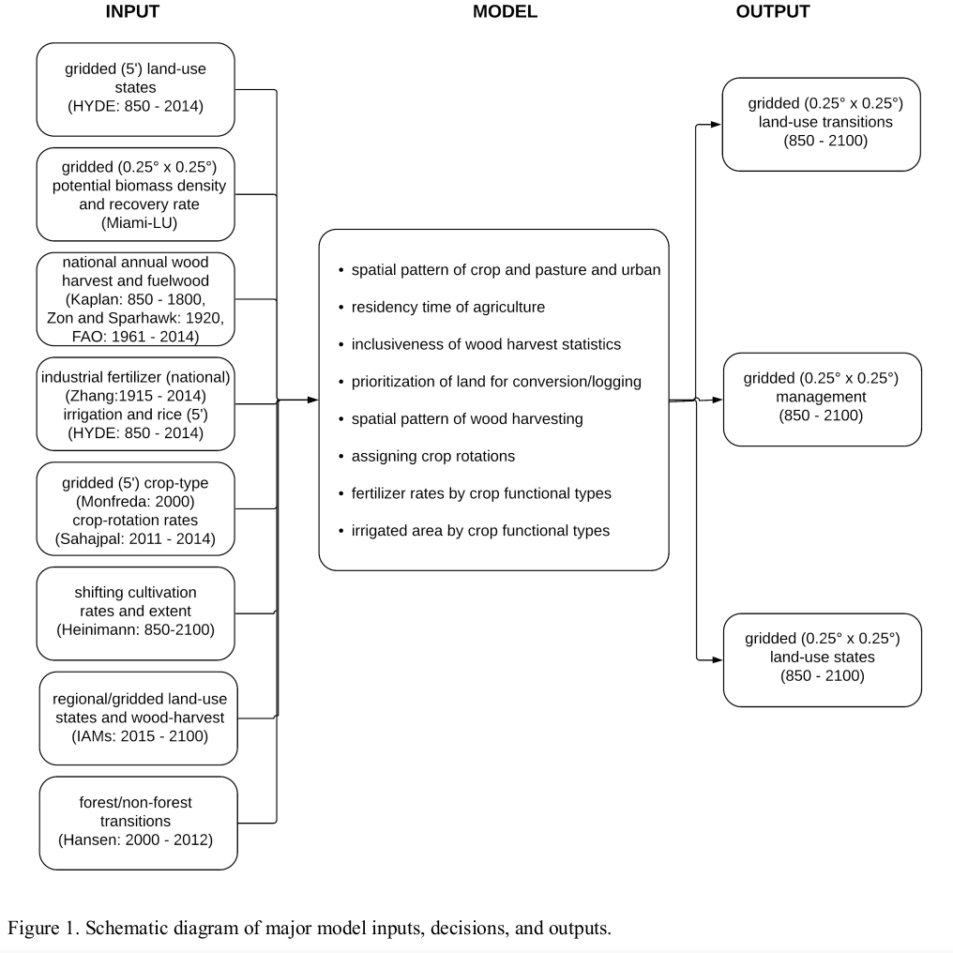

Figure S1. Framework to generate land use and land cover states of Land-Use Harmonization (LUH2, Hurtt et al . 2020)

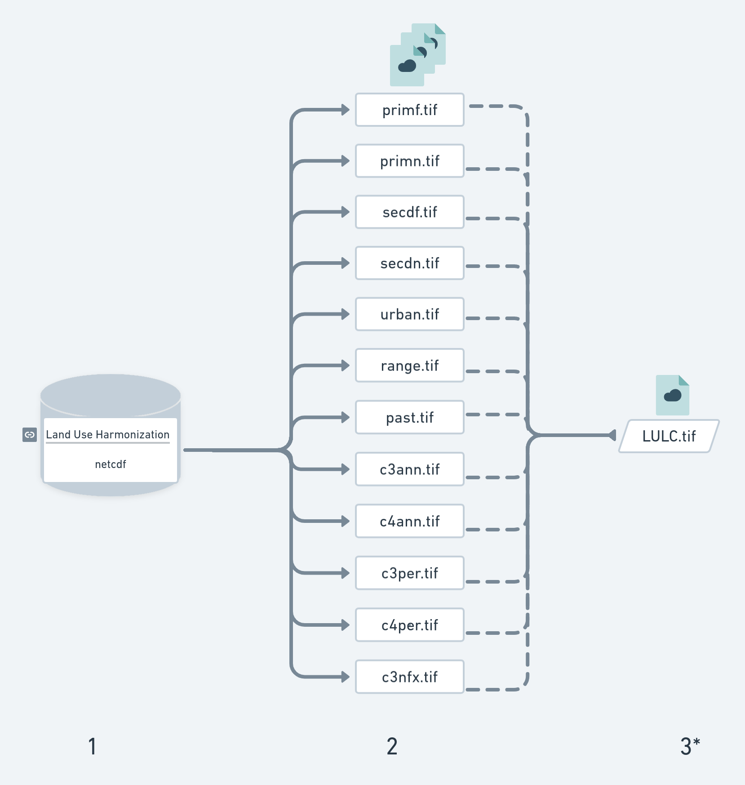

Figure S2. Workflow: 1) Extract every single state (state-files) per year from 850 to 2100, with two future scenarios (SSP2 and SSP5) from 2015 on; 2) Save every state-files (continuous data) in TIFF format; and 3*) Create new categorical data (LULC-files) of land-use land-cover combining 12 state-files in TIFF format.

