Supporting Information

Data curation on species occurrence records placed in unrecognized distributions shapes our understanding of plant bioclimatic niches
Cristina Ronquillo^{*,1}, Juliana Stropp², Joaquín Hortal¹
¹ Dept. Biogeography & Global Change, Museo Nacional de Ciencias Naturales (MNCN-CSIC), Madrid, Spain
² Department of Biogeography, Trier, University, Trier, Germany

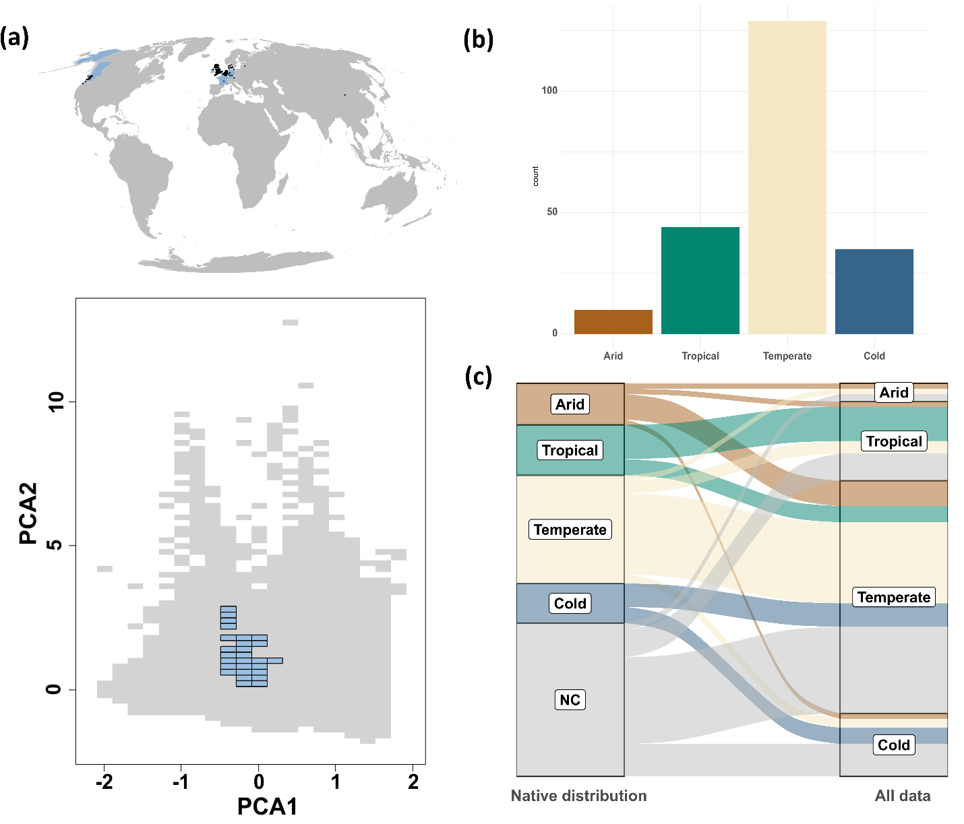
Figure S1. (a) Example using Cotoneaster rehderi of map (Mollwide projection) and species’ niche configurations at 0.2 x 0.2 resolution based on the information of species records only available in their introduced niche (blue). (b) Number of species found in each main climate of Köppen–Geiger classes. (c) Changes in the major Köppen–Geiger climate class occupied by species. Left panel consider only the records placed in their native ranges (‘NC’ corresponds to those species with no native information available). Right panel considers all records available for a species in GBIF (native range, introduced range and range outliers). Note that some species may appear in multiple climate classes.

Figure S2. Species realised niche comparison between scales using cells at 0.2 x 0.2 (left) and 0.5 x 0.5 resolution (right). Grey area corresponds to the available environment. This example corresponds to Cycas revoluta.
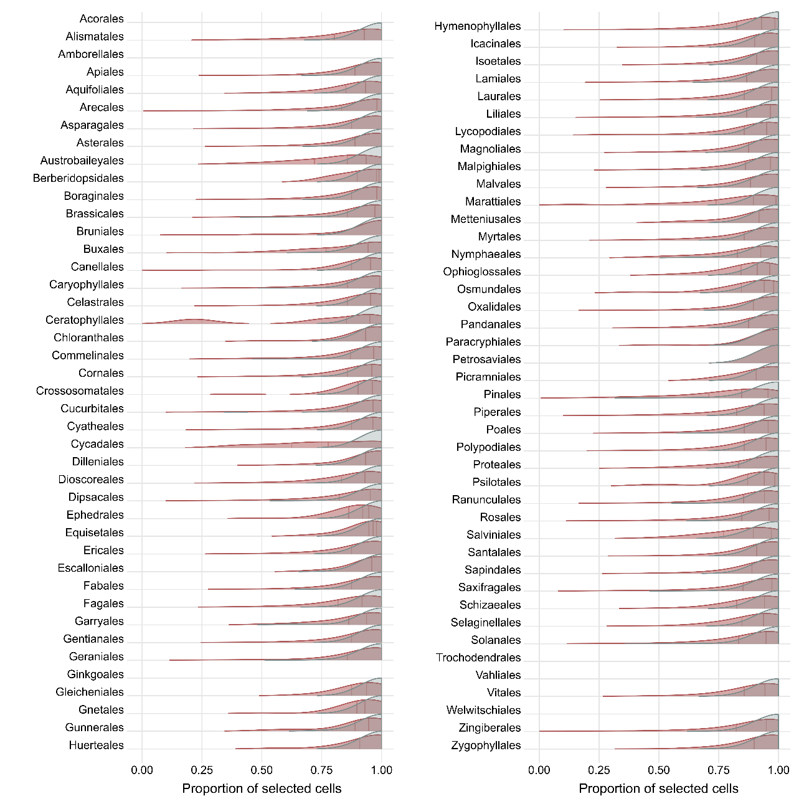
Figure S3. Distribution per order of the proportion of 0.2 x 0.2 cells selected after discarding only their introduced range (grey), and after discarding their introduced range and environmental outliers (red) of all the species evaluated per order. Red lines indicate quartiles of the distribution (note that in the grey area, the three quartiles are placed in 1.00 for all orders).
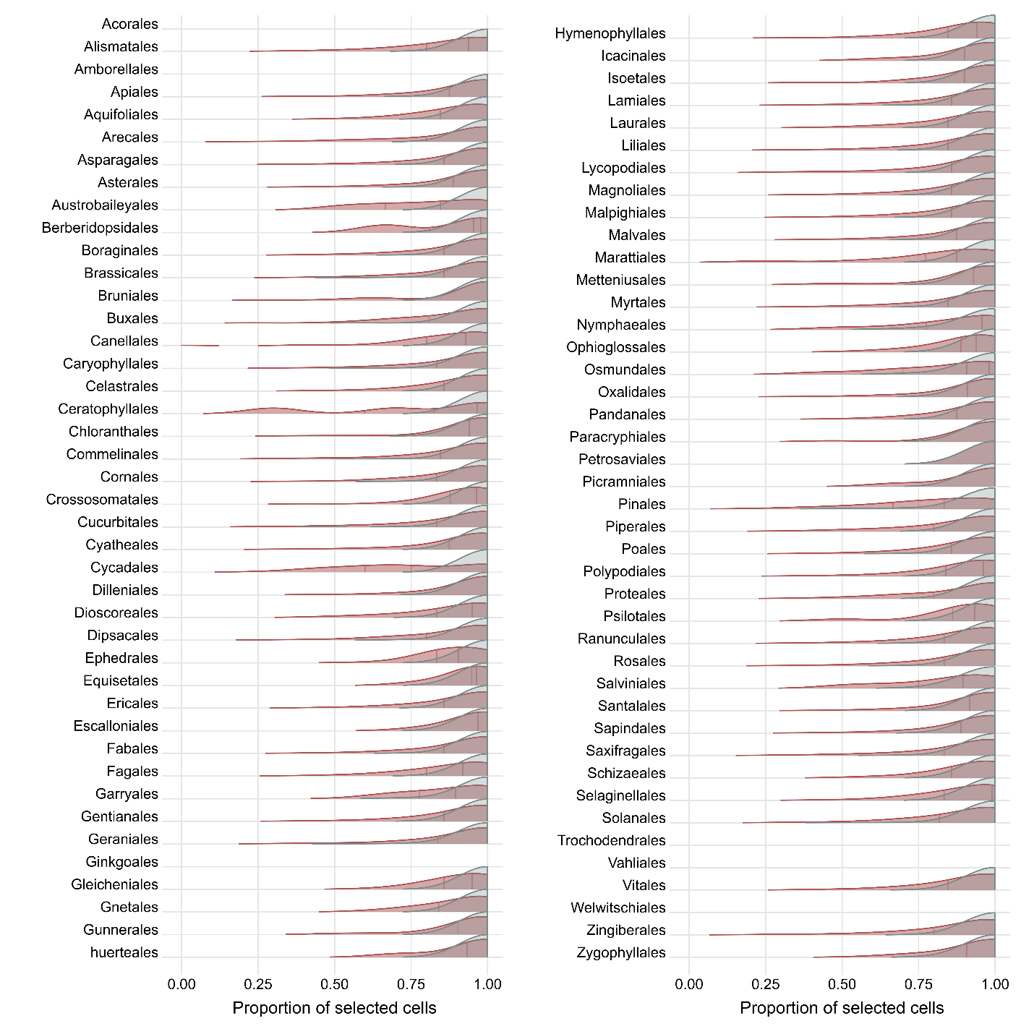
Figure S4. Distribution per order of the proportion of 0.5 x 0.5 cells selected after discarding only their introduced range (grey), and after discarding their introduced range and environmental outliers (red) of all the species evaluated per order. Red lines indicate quartiles of the distribution (note that in the grey area, the three quartiles are placed in 1.00 for all orders).

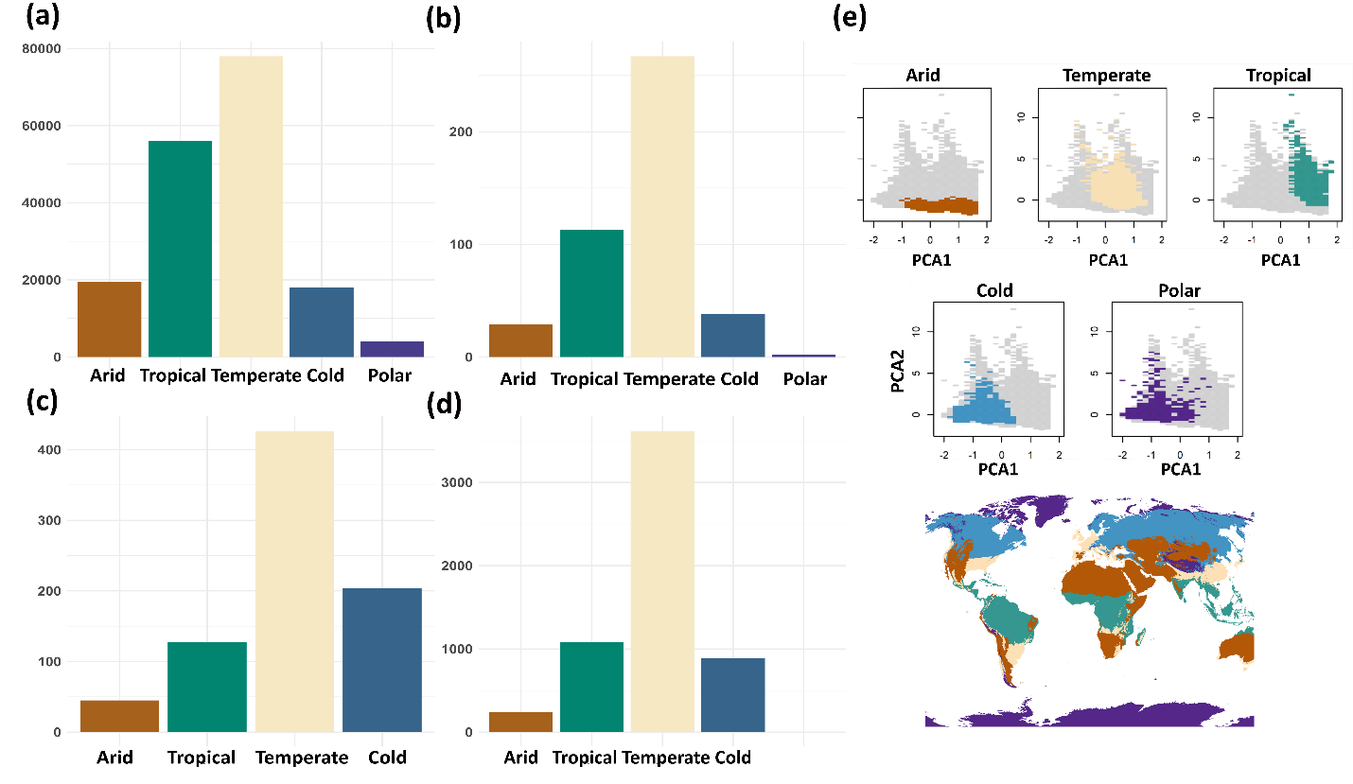
Figure S5. Number of species found in each main climate of Köppen–Geiger classes by species’ niche configuration. (a) Native niche; (b) native niche do not overlap the introduced niche; (c) introduced niche is included into the native niche; (d) both native and introduced niches partially overlap. Some species were classified in multiple climate classes. (e) Environmental area occupied by a grid of centroids at 50km overlapped by each main climate class polygon from Köppen-Geiger map.
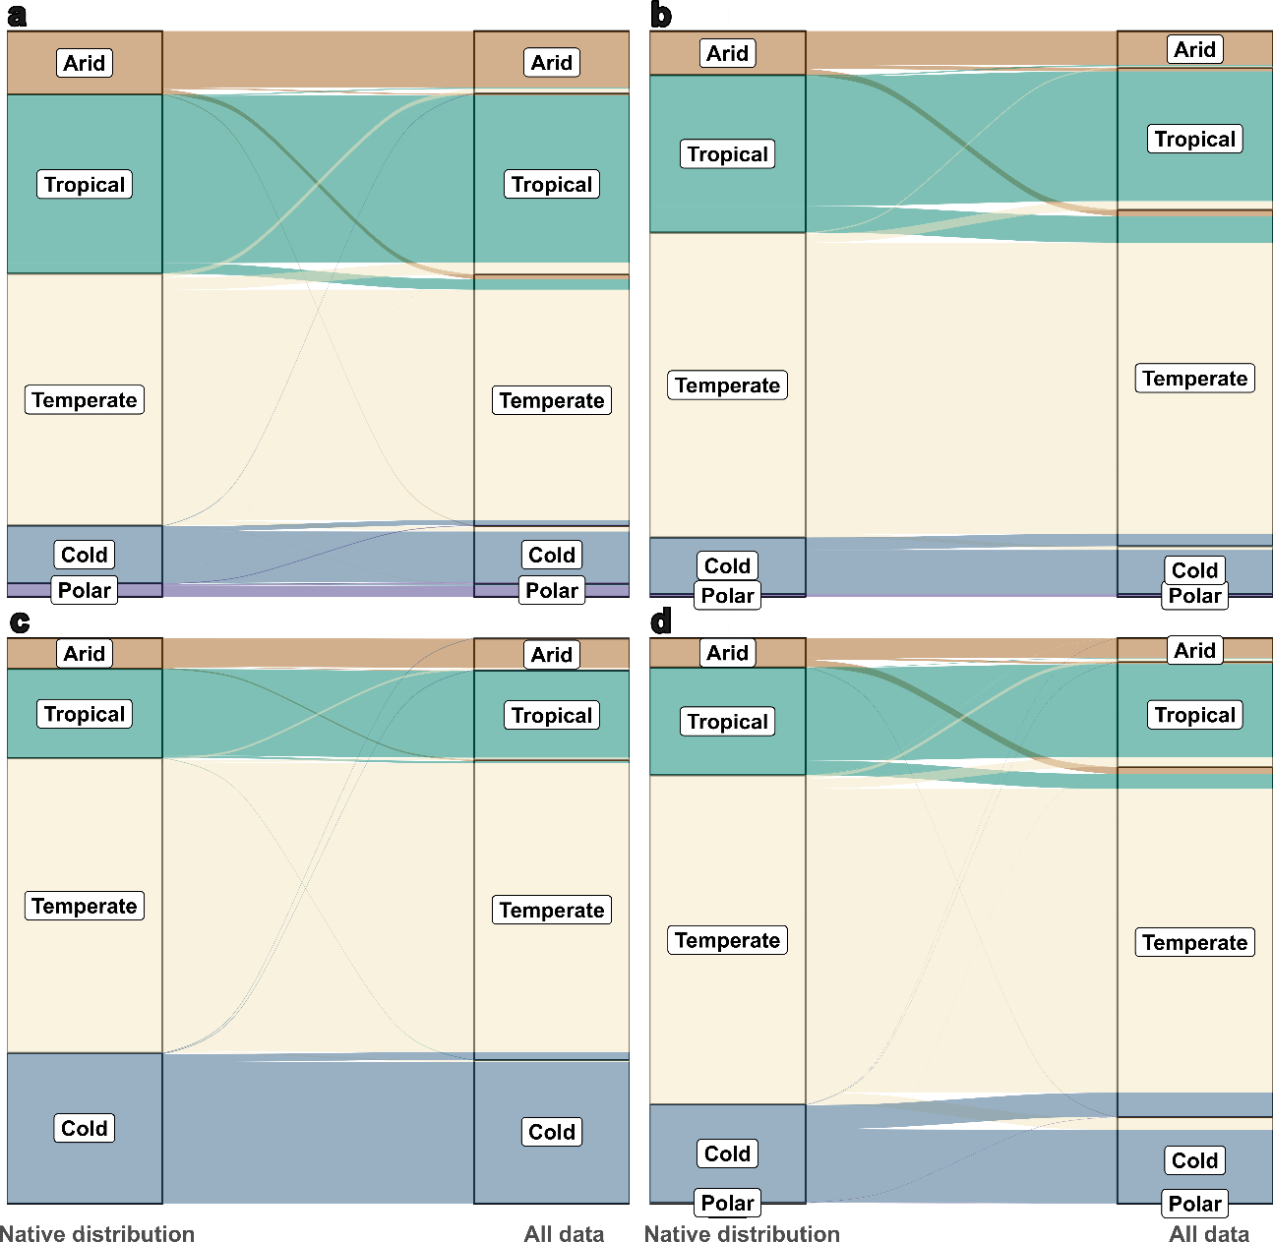
Figure S6. Changes in the major Köppen–Geiger climate class occupied by species in each hypothesised species’ niche configuration (a) native niche; (b) native niche does not overlap the introduced niche; (c) introduced niche is included into the native niche; (d) both native and introduced niches partially overlap. Left panels consider only the records placed in their native ranges while right panel considers all records available for a species in GBIF (native range, introduced range and geographical outliers). Note that some species may appear in multiple climate classes.

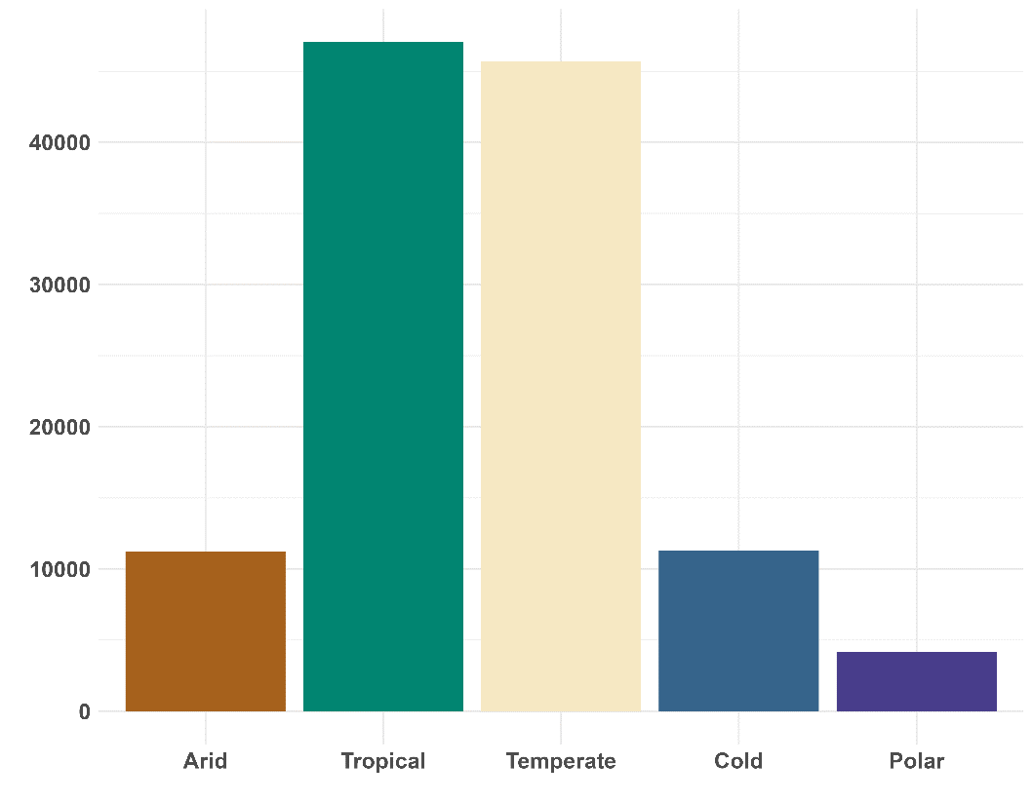
Figure S7. Number of species with less than 10 validated occurrences found in each main climate of Köppen–Geiger classes.

Figure S8. Comparison between the bioclimatic space occupied by (left) a dataset filtered by temporal range 1980-2010 (N occurrences = 19,034; n cells = 68; n cells native = 6; n cells introduced = 32) and (right) a dataset with no temporal filter (N occurrences = 41,885; n cells = 97; n cells native = 23; n cells introduced = 56). Light grey area corresponds to the available environment, dark grey area to all species data (environmental outliers), yellow native and blue or introduced range of the botanical countries. The example corresponds to Ginkgoales – Ginkgo biloba.
Table S1. Number of occurrences of terrestrial vascular plants downloaded from GBIF. Number of occurrences before (N_init) and after the curation process (N_valid) by order. Group column refers to batches of download and reference column the corresponding download citation. Reference for each download process correspond to ‘GBIF.org. GBIF Occurrence Download. Accessed from R via rgbif (https://github.com/ropensci/rgbif)’ and include de DOI and date of access.
Group | Order | N_init | N_valid | Reference
1 | Cycadales | 1,049,753 | 17,459 | doi.org/10.15468/dl.azvz2j on 2023-12-04
1 | Ginkgoales | 1,049,753 | 41,885 | doi.org/10.15468/dl.azvz2j on 2023-12-04
1 | Ephedrales | 1,049,753 | 25409 | doi.org/10.15468/dl.azvz2j on 2023-12-04
1 | Gnetales | 1,049,753 | 2,731 | doi.org/10.15468/dl.azvz2j on 2023-12-04
1 | Welwitschiales | 1,049,753 | 370 | doi.org/10.15468/dl.azvz2j on 2023-12-04
1 | Lycopodiales | 1,049,753 | 342,765 | doi.org/10.15468/dl.azvz2j on 2023-12-04
1 | Isoetales | 1,049,753 | 31,559 | doi.org/10.15468/dl.azvz2j on 2023-12-04
1 | Selaginellales | 1,049,753 | 75,575 | doi.org/10.15468/dl.azvz2j on 2023-12-04
2 | Pinales | 5,811,183 | 3,036,375 | doi.org/10.15468/dl.9b77sf on 2023-12-04
3 | Cyatheales | 10,678,617 | 122,357 | doi.org/10.15468/dl.fdh443 on 2023-12-19
3 | Equisetales | 10,678,617 | 990,975 | doi.org/10.15468/dl.fdh443 on 2023-12-19
3 | Gleicheniales | 10,678,617 | 35,893 | doi.org/10.15468/dl.fdh443 on 2023-12-19
3 | Hymenophyllales | 10,678,617 | 122,702 | doi.org/10.15468/dl.fdh443 on 2023-12-19
3 | Marattiales | 10,678,617 | 8,211 | doi.org/10.15468/dl.fdh443 on 2023-12-19
3 | Ophioglossales | 10,678,617 | 122,448 | doi.org/10.15468/dl.fdh443 on 2023-12-19
3 | Osmundales | 10,678,617 | 100,204 | doi.org/10.15468/dl.fdh443 on 2023-12-19
3 | Polypodiales | 10,678,617 | 3,913,148 | doi.org/10.15468/dl.fdh443 on 2023-12-19
3 | Psilotales | 10,678,617 | 13,184 | doi.org/10.15468/dl.fdh443 on 2023-12-19

Table S1. Continuation
3 | Salviniales |  | 54,331
3 | Schizaeales |  | 44,537
4 | Asparagales | 13,818,899 | 6,587,274 | doi.org/10.15468/dl.gg56hh on 2023-12-20
5 | Acorales | 8,273,943 | 32,194 | doi.org/10.15468/dl.csvjtn on 2023-12-20
5 | Alismatales | 8,273,943 | 2,249,707 | doi.org/10.15468/dl.csvjtn on 2023-12-20
5 | Arecales | 8,273,943 | 199,839 | doi.org/10.15468/dl.csvjtn on 2023-12-20
5 | Commelinales | 8,273,943 | 247,176 | doi.org/10.15468/dl.csvjtn on 2023-12-20
5 | Dioscoreales | 8,273,943 | 193,755 | doi.org/10.15468/dl.csvjtn on 2023-12-20
5 | Liliales | 8,273,943 | 1,175,928 | doi.org/10.15468/dl.csvjtn on 2023-12-20
5 | Pandanales | 8,273,943 | 41,628 | doi.org/10.15468/dl.csvjtn on 2023-12-20
5 | Petrosaviales | 8,273,943 | 66 | doi.org/10.15468/dl.csvjtn on 2023-12-20
5 | Zingiberales | 8,273,943 | 122,151 | doi.org/10.15468/dl.csvjtn on 2023-12-20
6 | Poales - Cyperaceae | 12,387,428 | 6,093,984 | doi.org/10.15468/dl.a3nxbr on 2023-12-21
7 | Poales - Poaceae | 34,472,764 | 15,858,863 | doi.org/10.15468/dl.ujcaem on 2023-12-21

Table S1. Continuation
8 | Poales - Bromeliaceae, Eriocaulaceae, Flagellariaceae, Joinvilleaceae, Mayaceae, Restionaceae, Thurniaceae, Typhaceae, Juncaceae, Centrolepidaceae, Ecdeiocoleaceae, Rapateaceae, Xyridaceae | 6,606,563 | 3,341,560 | doi.org/10.15468/dl.ya87yp on 2023-12-21
9 | Amborellales | 301 | 133 | doi.org/10.15468/dl.2n6uw9 on 2023-12-21
9 | Aquifoliales (*Cardiopterales included) | 630,446 | 322,818 | doi.org/10.15468/dl.2n6uw9 on 2023-12-21
9 | Austrobaileyales | 27,761 | 10,010 | doi.org/10.15468/dl.2n6uw9 on 2023-12-21
9 | Berberidopsidales | 1,446 | 928 | doi.org/10.15468/dl.2n6uw9 on 2023-12-21
9 | Boraginales | 3,464,032 | 2,166,907 | doi.org/10.15468/dl.2n6uw9 on 2023-12-21
9 | Bruniales | 9,751 | 7,036 | doi.org/10.15468/dl.2n6uw9 on 2023-12-21

Table S1. Continuation
9 | Buxales | 155,315 | 68,450 | doi.org/10.15468/dl.2n6uw9 on 2023-12-21
9 | Canellales | 50,967 | 37,723 | doi.org/10.15468/dl.2n6uw9 on 2023-12-21
9 | Celastrales | 916,014 | 499,580 | doi.org/10.15468/dl.2n6uw9 on 2023-12-21
9 | Ceratophyllales | 113,119 | 71,236 | doi.org/10.15468/dl.2n6uw9 on 2023-12-21
9 | Chloranthales | 31,983 | 13,354 | doi.org/10.15468/dl.2n6uw9 on 2023-12-21
9 | Cornales | 999,045 | 577,979 | doi.org/10.15468/dl.2n6uw9 on 2023-12-21
9 | Crossosomatales | 59,975 | 33,187 | doi.org/10.15468/dl.2n6uw9 on 2023-12-21
9 | Cucurbitales | 508,586 | 319,184 | doi.org/10.15468/dl.2n6uw9 on 2023-12-21
9 | Dilleniales | 171,890 | 123,456 | doi.org/10.15468/dl.2n6uw9 on 2023-12-21
9 | Escalloniales | 27,837 | 19,908 | doi.org/10.15468/dl.2n6uw9 on 2023-12-21
9 | Garryales | 24,342 | 16,999 | doi.org/10.15468/dl.2n6uw9 on 2023-12-21
9 | Gunnerales | 21,029 | 17,750 | doi.org/10.15468/dl.2n6uw9 on 2023-12-21
9 | Icacinales | 9,921 | 4,965 | doi.org/10.15468/dl.2n6uw9 on 2023-12-21
9 | Laurales | 733,911 | 447,330 | doi.org/10.15468/dl.2n6uw9 on 2023-12-21
9 | Magnoliales | 417,815 | 258,585 | doi.org/10.15468/dl.2n6uw9 on 2023-12-21
9 | Metteniusales | 14,986 | 5,879 | doi.org/10.15468/dl.2n6uw9 on 2023-12-21
9 | Nymphaeales | 312,358 | 85,982 | doi.org/10.15468/dl.2n6uw9 on 2023-12-21
9 | Paracryphiales | 16,677 | 13,242 | doi.org/10.15468/dl.2n6uw9 on 2023-12-21
9 | Picramniales | 8,361 | 5,488 | doi.org/10.15468/dl.2n6uw9 on 2023-12-21
9 | Piperales | 467,950 | 286,594 | doi.org/10.15468/dl.2n6uw9 on 2023-12-21
9 | Proteales | 1,034,482 | 547,116 | doi.org/10.15468/dl.2n6uw9 on 2023-12-21
9 | Santalales | 597,708 | 352,454 | doi.org/10.15468/dl.2n6uw9 on 2023-12-21

Table S1. Continuation
9 | Saxifragales | 3,604,277 | 2,145,658 | doi.org/10.15468/dl.2n6uw9 on 2023-12-21
9 | Trochodendrales | 2,218 | 1,534 | doi.org/10.15468/dl.2n6uw9 on 2023-12-21
9 | Vahliales | 436 | 112 | doi.org/10.15468/dl.2n6uw9 on 2023-12-21
9 | Vitales | 448,020 | 292,635 | doi.org/10.15468/dl.2n6uw9 on 2023-12-21
9 | Zygophyllales | 188,472 | 102,162 | doi.org/10.15468/dl.2n6uw9 on 2023-12-21
10 | Brassicales | 7,584,771 | 4,259,413 | doi.org/10.15468/dl.ecup6s on 2023-12-21
10 | Solanales | 3,480,410 | 2,156,598 | doi.org/10.15468/dl.ecup6s on 2023-12-21
11 | Apiales | 10,355,848 | 4,703,887 | doi.org/10.15468/dl.adsrne on 2023-12-21
12 | Ericales | 10,444,699 | 6,257,648 | doi.org/10.15468/dl.skuc7m on 2023-12-21
12 | Geraniales | 2,760,733 | 1,565,056 | doi.org/10.15468/dl.skuc7m on 2023-12-21
13 | Fagales | 11,186,279 | 4,864,653 | doi.org/10.15468/dl.6dkmb5 on 2023-12-21
14 | Fabales | 22,151,584 | 11,261,960 | doi.org/10.15468/dl.j62gfn on 2023-12-22
15 | Malpighiales | 13,793,178 | 6,566,193 | doi.org/10.15468/dl.t2je5u on 2023-12-22
16 | Ranunculales | 11,115,949 | 5,462,935 | doi.org/10.15468/dl.8b5gk4 on 2023-12-22
17 | Lamiales | 31,193,319 | 15,456,318 | doi.org/10.15468/dl.yg88mt on 2023-12-22

Table S1. Continuation
18 | Gentianales | 9,665,264 | 4,788,035 | doi.org/10.15468/dl.b5qfwg on 2023-12-22
19 | Asterales | 38,904,818 | 18,322,485 | doi.org/10.15468/dl.xwy43y on 2023-12-22
20 | Caryophyllales | 21,631,305 | 10,059,643 | doi.org/10.15468/dl.3vmpzd on 2023-12-22
21 | Myrtales | 13,138,456 | 4,020,638 | doi.org/10.15468/dl.6vbtxb on 2023-12-22
21 | Malvales | 13,138,456 | 2,448,233 | doi.org/10.15468/dl.6vbtxb on 2023-12-22
22 | Rosales | 24,140,523 | 11,176,526 | doi.org/10.15468/dl.aa22q3 on 2023-12-22
23 | Dipsacales | 6,263,250 | 2,906,620 | doi.org/10.15468/dl.pfunjf on 2023-12-22
24 | Sapindales | 6,349,951 | 3,627,476 | doi.org/10.15468/dl.66sshv on 2025-05-26
24 | Huerteales | 6,149 | 2,708 | doi.org/10.15468/dl.66sshv on 2025-05-26
25 | Oxalidales | 1,502,662 | 874,780 | doi.org/10.15468/dl.6v64vp on 2025-05-26

Table S2. Number of occupied cells of the available environment by each order using at 0.2 x 0.2 (CS_Cells_0.2) and 0.5 x 0.5 resolution (CS_Cells_0.5). Proportion of cells based on the available environment: 613 cells at 0.2 x 0.2 (prop_0.2) and 138 at 0.5 x 0.5 size (prop_0.5).
Order | CS_Cells_0.2 | prop_0.2 | CS_Cells_0.5 | Prop_0.5 | Order | CS_Cells_0.2 | prop_0.2 | CS_Cells_0.5 | prop_0.5
Acorales | 198 | 0.323 | 51 | 0.370 | Hymenophyllales | 363 | 0.592 | 96 | 0.696
Alismatales | 518 | 0.845 | 121 | 0.877 | Icacinales | 198 | 0.323 | 56 | 0.406
Amborellales | 13 | 0.021 | 7 | 0.051 | Isoetales | 307 | 0.501 | 76 | 0.551
Apiales | 526 | 0.858 | 123 | 0.891 | Lamiales | 558 | 0.910 | 127 | 0.920
Aquifoliales | 344 | 0.525 | 80 | 0.580 | Laurales | 382 | 0.623 | 95 | 0.688
Arecales | 345 | 0.563 | 82 | 0.594 | Liliales | 492 | 0.803 | 116 | 0.841
Asparagales | 537 | 0.876 | 125 | 0.906 | Lycopodiales | 452 | 0.737 | 108 | 0.783
Asterales | 562 | 0.917 | 129 | 0.935 | Magnoliales | 359 | 0.586 | 86 | 0.623
Austrobaileyales | 235 | 0.383 | 60 | 0.435 | Malpighiales | 547 | 0.892 | 126 | 0.913
Berberidopsidales | 54 | 0.088 | 23 | 0.167 | Malvales | 469 | 0.765 | 114 | 0.826
Boraginales | 488 | 0.796 | 115 | 0.833 | Marattiales | 213 | 0.347 | 62 | 0.449
Brassicales | 520 | 0.848 | 123 | 0.891 | Metteniusales | 179 | 0.292 | 52 | 0.377
Bruniales | 120 | 0.196 | 45 | 0.326 | Myrtales | 540 | 0.881 | 126 | 0.913
Buxales | 222 | 0.362 | 51 | 0.370 | Nymphaeales | 339 | 0.553 | 81 | 0.587
Canellales | 229 | 0.374 | 67 | 0.486 | Ophioglossales | 392 | 0.639 | 92 | 0.667
Caryophyllales | 548 | 0.894 | 126 | 0.913 | Osmundales | 269 | 0.439 | 75 | 0.543
Celastrales | 441 | 0.719 | 101 | 0.732 | Oxalidales | 454 | 0.741 | 108 | 0.782
Ceratophyllales | 252 | 0.411 | 66 | 0.478 | Pandanales | 299 | 0.488 | 85 | 0.616
Chloranthales | 252 | 0.411 | 65 | 0.471 | Paracryphiales | 117 | 0.191 | 48 | 0.348
Table S2. Continuation
Commelinales | 368 | 0.600 | 90 | 0.652 | Petrosaviales | 28 | 0.046 | 17 | 0.123
Cornales | 415 | 0.677 | 99 | 0.717 | Picramniales | 146 | 0.238 | 41 | 0.297
Crossosomatales | 263 | 0.429 | 68 | 0.493 | Pinales | 459 | 0.749 | 109 | 0.790
Cucurbitales | 426 | 0.695 | 98 | 0.710 | Piperales | 385 | 0.628 | 90 | 0.652
Cyatheales | 328 | 0.535 | 85 | 0.616 | Poales | 572 | 0.933 | 132 | 0.957
Cycadales | 193 | 0.315 | 57 | 0.413 | Polypodiales | 538 | 0.878 | 126 | 0.913
Dilleniales | 236 | 0.385 | 62 | 0.449 | Proteales | 357 | 0.582 | 88 | 0.638
Dioscoreales | 378 | 0.617 | 89 | 0.645 | Psilotales | 236 | 0.385 | 65 | 0.471
Dipsacales | 432 | 0.705 | 104 | 0.754 | Ranunculales | 527 | 0.860 | 124 | 0.899
Ephedrales | 201 | 0.328 | 51 | 0.370 | Rosales | 556 | 0.907 | 127 | 0.92
Equisetales | 403 | 0.657 | 94 | 0.681 | Salviniales | 260 | 0.424 | 63 | 0.457
Ericales | 550 | 0.896 | 126 | 0.913 | Santalales | 440 | 0.718 | 104 | 0.754
Escalloniales | 238 | 0.388 | 68 | 0.493 | Sapindales | 460 | 0.750 | 104 | 0.754
Fabales | 540 | 0.881 | 125 | 0.906 | Saxifragales | 489 | 0.798 | 118 | 0.855
Fagales | 473 | 0.772 | 110 | 0.797 | Schizaeales | 307 | 0.501 | 85 | 0.616
Garryales | 168 | 0.274 | 43 | 0.312 | Selaginellales | 378 | 0.617 | 89 | 0.645
Gentianales | 531 | 0.861 | 120 | 0.87 | Solanales | 464 | 0.757 | 109 | 0.79
Geraniales | 401 | 0.654 | 96 | 0.696 | Trochodendrales | 87 | 0.142 | 32 | 0.232
Ginkgoales | 97 | 0.158 | 27 | 0.196 | Vahliales | 29 | 0.047 | 12 | 0.087
Gleicheniales | 305 | 0.498 | 83 | 0.601 | Vitales | 382 | 0.623 | 90 | 0.652
Gnetales | 169 | 0.276 | 51 | 0.370 | Welwitschiales | 14 | 0.023 | 7 | 0.051
Gunnerales | 249 | 0.406 | 75 | 0.543 | Zingiberales | 348 | 0.568 | 90 | 0.652
Huerteales | 165 | 0.269 | 50 | 0.362 | Zygophyllales | 247 | 0.403 | 61 | 0.442

Table S3. Wilcoxon test outputs by each order using cells of 0.2 x 0.2 (N_0.2, pvalue0.2) and 0.5 x 0.5 resolution (N_0.5, pvalue0.5).
Order | N_0.2 | Pvalue0.2 | N_0.5 | Pvalue0.5
Acorales | 3 | 0.25 | 3 | 0.25
Alismatales | 793170 | 0 | 547581 | 0
Amborellales | 1 | 0.5 | 1 | 0.5
Apiales | 795691 | 0 | 411778 | 0
Aquifoliales | 19503 | 0 | 11628 | 0
Arecales | 140185 | 0 | 90525 | 0
Asparagales | 15138753 | 0 | 8551180 | 0
Asterales | 23164221 | 0 | 11522400 | 0
Austrobaileyales | 861 | 0 | 630 | 0
Berberidopsidales | 3 | 0.186 | 3 | 0.186
Boraginales | 344035 | 0 | 179700 | 0
Brassicales | 778128 | 0 | 391170 | 0
Bruniales | 45 | 0.005 | 36 | 0.007
Buxales | 595 | 0 | 406 | 0
Canellales | 300 | 0 | 276 | 0
Caryophyllales | 4947085 | 0 | 2750685 | 0
Celastrales | 74691 | 0 | 39903 | 0
Ceratophyllales | 10 | 0.063 | 6 | 0.091
Chloranthales | 253 | 0 | 136 | 0

Table S3. Continuation
Commelinales | 43660 | 0 | 21945 | 0
Cornales | 26565 | 0 | 16836 | 0
Crossosomatales | 406 | 0 | 253 | 0
Cucurbitales | 132870 | 0 | 80200 | 0
Cyatheales | 16290 | 0 | 9316 | 0
Cycadales | 6903 | 0 | 6216 | 0
Dilleniales | 6216 | 0 | 3240 | 0
Dioscoreales | 27495 | 0 | 17205 | 0
Dipsacales | 90951 | 0 | 54285 | 0
Ephedrales | 820 | 0 | 496 | 0
Equisetales | 120 | 0 | 66 | 0.002
Ericales | 4558690 | 0 | 2802528 | 0
Escalloniales | 136 | 0 | 105 | 0.001
 | 20075616 | 0 | 10481331 | 0
Fagales | 218130 | 0 | 137550 | 0
Garryales | 78 | 0.001 | 78 | 0.001
Gentianales | 10776403 | 0 | 2514403 | 0
Geraniales | 28203 | 0 | 15931 | 0
Ginkgoales | 1 | 0.5 | 1 | 0.5
Gleicheniales | 2211 | 0 | 1596 | 0
Gnetales | 153 | 0 | 91 | 0.001

Table S3. Continuation
Gunnerales | 91 | 0.001 | 36 | 0.007
Huerteales | 28 | 0.011 | 21 | 0.02
Hymenophyllales | 32385 | 0 | 19900 | 0
Icacinales | 820 | 0 | 325 | 0
Isoetales | 595 | 0 | 325 | 0
Lamiales | 16683976 | 0 | 9642636 | 0
Laurales | 346528 | 0 | 222111 | 0
Liliales | 150975 | 0 | 88410 | 0
Lycopodiales | 10440 | 0 | 6555 | 0
Magnoliales | 274911 | 0 | 155961 | 0
Malpighiales | 12293361 | 0 | 6507028 | 0
Malvales | 1396956 | 0 | 658378 | 0
Marattiales | 990 | 0 | 780 | 0
Metteniusales | 136 | 0 | 78 | 0.001
Myrtales | 5160078 | 0 | 2467531 | 0
Nymphaeales | 1081 | 0 | 666 | 0
Ophioglossales | 1770 | 0 | 946 | 0
Osmundales | 120 | 0 | 78 | 0.001
Oxalidales | 92235 | 0 | 46360 | 0
Pandanales | 16110 | 0 | 9730 | 0
Paracryphiales | 10 | 0.05 | 10 | 0.049

Table S3. Continuation
Petrosaviales | 0 | 1 | 0 | 1
Picramniales | 136 | 0 | 36 | 0.007
Pinales | 87153 | 0 | 69006 | 0
Piperales | 347361 | 0 | 213531 | 0
Poales | 28324101 | 0 | 15738855 | 0
Polypodiales | 3744216 | 0 | 2320935 | 0
Proteales | 245350 | 0 | 148240 | 0
Psilotales | 36 | 0.007 | 28 | 0.011
Ranunculales | 1082656 | 0 | 630003 | 0
Rosales | 3752430 | 0 | 2124891 | 0
Salviniales | 820 | 0 | 561 | 0
Santalales | 111628 | 0 | 52326 | 0
Sapindales | 1747515 | 0 | 881128 | 0
Saxifragales | 357435 | 0 | 216153 | 0
Schizaeales | 2628 | 0 | 1275 | 0
Selaginellales | 22155 | 0 | 12246 | 0
Solanales | 1189653 | 0 | 697971 | 0
Trochodendrales | 3 | 0.25 | 3 | 0.25
Vahliales | 3 | 0.25 | 1 | 0.5
Vitales | 30381 | 0 | 17020 | 0
Welwitschiales | 1 | 0.5 | 1 | 0.5

Table S3. Continuation
Zingiberales | 137550 | 0 | 89676 | 0
Zygophyllales | 3655 | 0 | 1540 | 0

Table S4. Number of species by order after occurrence records curation and taxonomic harmonisation (nSpp). Number of species with range outliers (nSpp_outliers) and their proportion by order from 0 to 1 (pSpp_outliers). Number of species with more than 50 % of range outliers (nSpp_50%_outliers) and their proportion by order from 0 to 1 (pSpp_50%_outliers). Number of species with more than 50% of their cells (0.2 x 0.2) defined by range outliers (nSpp_50%_CS_outliers) and their proportion by order from 0 to 1 (pSpp_50%_CS_outliers).
Order | nSpp | nSpp_outliers | pSpp_outliers | nSpp_50%_outliers | pSpp_50%_outliers | nSpp_50%_CS_outliers | pSpp_50% CS outliers
Acorales | 2 | 2 | 1.00 | 0 | 0.00 | 0 | 0.00
Alismatales | 3,762 | 1281 | 0.34 | 91 | 0.02 | 82 | 0.02
Amborellales | 1 | 1 | 1.00 | 0 | 0.00 | 0 | 0.00
Apiales | 4,555 | 1301 | 0.29 | 91 | 0.02 | 55 | 0.01
Aquifoliales | 610 | 203 | 0.33 | 15 | 0.02 | 4 | 0.01
Arecales | 2,120 | 546 | 0.26 | 40 | 0.02 | 46 | 0.02
Asparagales | 27,056 | 5676 | 0.21 | 467 | 0.02 | 335 | 0.01
Asterales | 28,070 | 7015 | 0.25 | 526 | 0.02 | 344 | 0.01
Austrobaileyales | 76 | 43 | 0.57 | 6 | 0.08 | 4 | 0.05
Berberidopsidales | 3 | 2 | 0.67 | 0 | 0.00 | 0 | 0.00
Boraginales | 2,572 | 851 | 0.33 | 72 | 0.03 | 43 | 0.02
Brassicales | 4,056 | 1274 | 0.31 | 83 | 0.02 | 59 | 0.01
Bruniales | 76 | 9 | 0.12 | 1 | 0.01 | 3 | 0.04
Buxales | 116 | 35 | 0.30 | 3 | 0.03 | 2 | 0.02
Canellales | 97 | 26 | 0.27 | 3 | 0.03 | 3 | 0.03
Caryophyllales | 10,308 | 3244 | 0.31 | 317 | 0.03 | 189 | 0.02

Table S4. Continuation
Celastrales | 1,130 | 395 | 0.35 | 28 | 0.02 | 21 | 0.02
Ceratophyllales | 6 | 4 | 0.67 | 1 | 0.17 | 1 | 0.17
Chloranthales | 67 | 22 | 0.33 | 1 | 0.01 | 0 | 0.00
Commelinales | 849 | 300 | 0.35 | 18 | 0.02 | 19 | 0.02
Cornales | 634 | 230 | 0.36 | 10 | 0.02 | 8 | 0.00
Crossosomatales | 57 | 28 | 0.49 | 1 | 0.02 | 1 | 0.02
Cucurbitales | 2,212 | 534 | 0.24 | 45 | 0.02 | 32 | 0.01
Cyatheales | 661 | 186 | 0.28 | 16 | 0.02 | 16 | 0.02
Cycadales | 297 | 118 | 0.40 | 9 | 0.03 | 29 | 0.10
Dilleniales | 496 | 113 | 0.23 | 7 | 0.01 | 4 | 0.01
Dioscoreales | 712 | 243 | 0.34 | 21 | 0.03 | 11 | 0.02
Dipsacales | 1,065 | 433 | 0.41 | 38 | 0.04 | 33 | 0.03
Ephedrales | 61 | 40 | 0.66 | 0 | 0.00 | 0 | 0.00
Equisetales | 18 | 15 | 0.83 | 0 | 0.00 | 0 | 0.00
Ericales | 11,256 | 3088 | 0.27 | 188 | 0.02 | 173 | 0.02
Escalloniales | 103 | 16 | 0.16 | 0 | 0.00 | 0 | 0.00
Fabales | 20,128 | 6451 | 0.32 | 329 | 0.02 | 247 | 0.01
Fagales | 1,419 | 671 | 0.47 | 34 | 0.02 | 32 | 0.02
Garryales | 27 | 12 | 0.44 | 0 | 0.00 | 0 | 0.00
Gentianales | 18,150 | 4771 | 0.26 | 391 | 0.02 | 265 | 0.01
Geraniales | 718 | 242 | 0.34 | 15 | 0.02 | 17 | 0.02
Ginkgoales | 1 | 1 | 1.00 | 1 | 1.00 | 0 | 0.00

Table S4. Continuation
Gleicheniales | 149 | 68 | 0.46 | 3 | 0.02 | 1 | 0.01
Gnetales | 40 | 17 | 0.43 | 0 | 0.00 | 1 | 0.03
Gunnerales | 54 | 15 | 0.28 | 2 | 0.04 | 1 | 0.02
Huerteales | 32 | 5 | 0.16 | 0 | 0.00 | 0 | 0.00
Hymenophyllales | 495 | 267 | 0.54 | 27 | 0.05 | 14 | 0.03
Icacinales | 139 | 41 | 0.29 | 4 | 0.03 | 1 | 0.01
Isoetales | 170 | 36 | 0.21 | 2 | 0.01 | 1 | 0.01
Lamiales | 22,045 | 5939 | 0.27 | 461 | 0.02 | 324 | 0.01
Laurales | 3,030 | 850 | 0.28 | 59 | 0.02 | 46 | 0.02
Liliales | 1,497 | 568 | 0.38 | 57 | 0.04 | 33 | 0.02
Lycopodiales | 381 | 147 | 0.39 | 13 | 0.03 | 15 | 0.04
Magnoliales | 2,808 | 752 | 0.27 | 41 | 0.01 | 41 | 0.01
Malpighiales | 16,061 | 5090 | 0.32 | 355 | 0.02 | 279 | 0.02
Malvales | 6,137 | 1718 | 0.28 | 136 | 0.02 | 70 | 0.01
Marattiales | 128 | 49 | 0.38 | 11 | 0.09 | 6 | 0.05
Metteniusales | 55 | 16 | 0.29 | 1 | 0.02 | 0 | 0.00
Myrtales | 11,500 | 3307 | 0.29 | 223 | 0.02 | 234 | 0.02
Nymphaeales | 94 | 48 | 0.51 | 3 | 0.03 | 1 | 0.01
Ophioglossales | 98 | 60 | 0.61 | 2 | 0.02 | 0 | 0.00
Osmundales | 22 | 15 | 0.68 | 0 | 0.00 | 0 | 0.00
Oxalidales | 1,833 | 605 | 0.33 | 27 | 0.01 | 24 | 0.01

Table S4. Continuation
Pandanales | 1,152 | 188 | 0.16 | 17 | 0.01 | 10 | 0.01
Paracryphiales | 31 | 4 | 0.13 | 0 | 0.00 | 0 | 0.00
Petrosaviales | 4 | 1 | 0.25 | 1 | 0.25 | 0 | 0.00
Picramniales | 48 | 17 | 0.35 | 1 | 0.02 | 0 | 0.00
Pinales | 627 | 427 | 0.68 | 27 | 0.04 | 43 | 0.07
Piperales | 3,525 | 867 | 0.25 | 104 | 0.03 | 83 | 0.02
Poales | 20,494 | 7676 | 0.37 | 451 | 0.02 | 301 | 0.01
Polypodiales | 7,457 | 2823 | 0.38 | 238 | 0.03 | 151 | 0.02
Proteales | 1,854 | 703 | 0.38 | 8 | 0.00 | 54 | 0.03
Psilotales | 14 | 8 | 0.57 | 0 | 0.00 | 1 | 0.07
Ranunculales | 4,390 | 1515 | 0.35 | 113 | 0.03 | 76 | 0.02
Rosales | 7,491 | 2822 | 0.38 | 239 | 0.03 | 157 | 0.02
Salviniales | 66 | 40 | 0.61 | 1 | 0.02 | 1 | 0.02
Santalales | 2,019 | 487 | 0.24 | 35 | 0.02 | 22 | 0.01
Sapindales | 6,144 | 2,648 | 0.43 | 134 | 0.02 | 75 | 0.01
Saxifragales | 2,542 | 873 | 0.34 | 86 | 0.03 | 70 | 0.03
Schizaeales | 163 | 72 | 0.44 | 2 | 0.01 | 3 | 0.02
Selaginellales | 598 | 210 | 0.35 | 9 | 0.02 | 6 | 0.01
Solanales | 4,016 | 1580 | 0.39 | 101 | 0.03 | 67 | 0.02
Trochodendrales | 2 | 2 | 1.00 | 0 | 0.00 | 0 | 0.00
Vahliales | 3 | 2 | 0.67 | 0 | 0.00 | 0 | 0.00
Vitales | 770 | 251 | 0.33 | 13 | 0.02 | 9 | 0.01

Table S4. Continuation
Welwitschiales | 1 | 1 | 1.00 | 0 | 0.00 | 0 | 0.00
Zingiberales | 2,102 | 554 | 0.26 | 61 | 0.03 | 40 | 0.02
Zygophyllales | 261 | 88 | 0.34 | 8 | 0.03 | 2 | 0.01

Table S5. Proportion (‘Prop’) of changes by assemblage based on the major climate type occupied by a species using only the native occurrences or all data available in GBIF. Red values correspond to those proportions up to 10% of the changes in the native main climate. In bold changes that keep the same climate type despite of the subset chosen. Note that some species appeared in multiple climate classes.
 | Change | Prop |  | Change |  | Prop
a | Arid -> Arid | 0.889 | a | Tropical -> Tropical |  | 0.932
a | Arid -> Cold | 0.015 | a | Tropical -> Arid |  | 0.007
a | Arid -> Polar | 0.001 | a | Tropical -> Cold |  | 0.000
a | Arid -> Temperate | 0.074 | a | Tropical -> Polar |  | 0.000
a | Arid -> Tropical | 0.021 | a | Tropical -> Temperate |  | 0.062
a | Cold -> Cold | 0.878 | b | Arid -> Arid |  | 0.771
a | Cold -> Arid | 0.013 | b | Arid -> Temperate |  | 0.143
a | Cold -> Polar | 0.023 | b | Arid -> Tropical |  | 0.086
a | Cold -> Temperate | 0.086 | b | Cold -> Cold |  | 0.778
a | Cold -> Tropical | 0.000 | b | Cold -> Temperate |  | 0.222
a | Polar -> Polar | 0.829 | b | Polar -> Polar |  | 1
a | Polar -> Arid | 0.002 | b | Temperate -> Temperate |  | 0.953
a | Polar -> Cold | 0.106 | b | Temperate -> Arid |  | 0.004
a | Polar -> Temperate | 0.062 | b | Temperate -> Cold |  | 0.013
a | Polar -> Tropical | 0.001 | b | Temperate -> Tropical |  | 0.030
a | Temperate -> Temperate | 0.913 | b | Tropical -> Tropical |  | 0.826
a | Temperate -> Arid | 0.017 | b | Tropical -> Arid |  | 0.008
a | Temperate -> Cold | 0.019 | b | Tropical -> Temperate |  | 0.165
a | Temperate -> Polar | 0.003 | b
a | Temperate -> Tropical | 0.048 | b

 | Table S5. Continuation
c | Arid -> Arid | 0.932 | d | Arid -> Arid | 0.647
c | Arid -> Temperate | 0.045 | d | Arid -> Cold | 0.007
c | Arid -> Tropical | 0.023 | d | Arid -> Temperate | 0.267
c | Cold -> Cold | 0.947 | d | Arid -> Tropical | 0.080
c | Cold -> Arid | 0.005 | d | Cold -> Cold | 0.750
c | Cold -> Temperate | 0.048 | d | Cold -> Arid | 0.006
c | Temperate -> Temperate | 0.980 | d | Cold -> Temperate | 0.245
c | Temperate -> Arid | 0.007 | d | Polar -> Polar | 0.250
c | Temperate -> Cold | 0.005 | d | Polar -> Cold | 0.250
c | Temperate -> Tropical | 0.007 | d | Polar -> Temperate | 0.500
c | Tropical -> Tropical | 0.976 | d | Temperate -> Temperate | 0.920
c | Tropical -> Temperate | 0.024 | d | Temperate -> Arid | 0.011
 |  |  | d | Temperate -> Cold | 0.039
 |  |  | d | Temperate -> Tropical | 0.030
 |  |  | d | Tropical -> Tropical | 0.847
 |  |  | d | Tropical -> Arid | 0.004
 |  |  | d | Tropical -> Temperate | 0.149

Table S6. Proportion (‘Prop’) of changes by assemblage based on the major climate type occupied by a species using only the native occurrences or all data available in GBIF. Red values correspond to those proportions up to 10% of the changes in the native main climate. In bold changes that keep the same climate type despite of the subset chosen. Note that some species appeared in multiple climate classes. ‘NC’ corresponds to those species with no native information available.
Change | Prop
Arid -> Arid | 0.130
Arid -> Cold | 0.130
Arid -> Temperate | 0.609
Arid -> Tropical | 0.130
Cold -> Cold | 0.409
Cold -> Temperate | 0.591
NC -> Arid | 0.047
NC -> Cold | 0.212
NC -> Temperate | 0.565
NC -> Tropical | 0.176
Temperate -> Temperate | 0.750
Temperate -> Arid | 0.050
Temperate -> Cold | 0.083
Temperate -> Tropical | 0.117
Tropical -> Tropical | 0.667
Tropical -> Temperate | 0.333

