Journal of Melittology

A new species of Ptiloglossa from Mexico,
with new records of Ptiloglossa cyaniventris from Panama and Costa Rica (Hymenoptera: Colletidae)

Ricardo Ayala¹ & Michael S. Engel^{2,3}

¹ Estación de Biología Chamela, Instituto de Biología, Universidad Nacional Autónoma de México (UNAM), Apartado Postal 21, San Patricio, Jalisco, 48980, México (rayala@ib.unam.mx).
² Division of Entomology, Natural History Museum, and Department of Ecology & Evolutionary Biology, 1501 Crestline Drive – Suite 140, University of Kansas, Lawrence, Kansas 66045, USA (msengel@ku.edu).
³ Division of Invertebrate Zoology, American Museum of Natural History, Central Park West at 79th Street, New York, New York 10024-5192, USA (mengel@amnh.org).

Abstract. A new bee species of the genus Ptiloglossa Smith (Colletidae: Diphaglossinae: Caupolicanini) is described and figured from Jalisco, Mexico, while new records are provided for Ptiloglossa cyaniventris Friese from Panama and a single locality in Costa Rica. Ptiloglossa chamelensis Ayala & Engel, new species, is endemic to Mexico and is close to P. rugata Moure, both sharing a similar shape in the fused metatibial spur, but in the new species the metatibia is widest at the level of the spur, and the female has black integument with dense yellow pubescence on metasomal terga I–IV. Ptiloglossa cyaniventris is newly recorded from males collected in Panama and Costa Rica and is characteristic for its dark integument, with intense metallic blue highlights on the metasomal terga, the narrow and long metatibia, and elongate metabasitarsus with an anterior, longitudinal ridge and slightly depressed outer surface.

INTRODUCTION

The genus Ptiloglossa Smith comprises 55 species of crepuscular bees occurring from the southern United States through to Argentina, and with its greatest diversity in the tropics and in South America (Michener, 1966, 2007). Although their crepuscular habits are well known (e.g., Roberts, 1971), other aspects of their biology have not been extensively investigated. The most complete information on nesting biology is provided by Roberts (1971) for P. guinnae Roberts, Rozen (1984) for Ptiloglossa arizonensis Timberlake, P. jonesi Timberlake, and P. fulvopilosa (Cameron), and Sarzetti et al. (2013) for P. tarsata (Friese) and P. matutina (Schrottky).
The genus is one of three genera in the Caupolicanini (Diphaglossinae), and can be distinguished from Crawfordapis Moure and Caupolicana Spinola (inclusive of Willinkapis Moure and Zikanapis Moure: Michener, 1966, 2007), by the usual presence of metallic blue or green iridescence, the fusion of the outer metatibial spur to the metatibia in males, and the metabasitarsus less than twice as long as broad in females, the second metatarsomere broader than long in females, and the usual presence of hooked setae laterally on metasomal sternum V in females (although this is not evident in P. arizonensis and P. hoplopoda Moure). Michener et al. (2003) discussed the presence among some Ptiloglossa of dull, smooth, impunctate, glabrous areas on the lateral, down-curved extremities of metasomal terga II–IV or V, and that these are also found in Zikanapis, perhaps suggestive of some kind of relationship, although this remains to be explored. Species-level relationships need to be resolved among Ptiloglossa and all Caupolicanini, as is true for most groups of bees (Engel, 2011). Particularly important works on the systematics of the genus are those by Friese (1898) and Moure (1945, 1987), the latter with keys to the species then known. The studies by Smith (1861), Cresson (1878), Fox (1895), Cockerell (1912), and Michener (1954) are critical for the fauna of Mesoamerica, while those of Friese (1898, 1904, 1908), Schrottky (1902, 1906), and Moure (1945, 1987) are of most value for those species in South America. The neotropical diversity of Ptiloglossa was summarized by Ayala et al. (1996), Urban & Moure (2001), and Urban et al. (2007), to which may be added the two species from northern Mexico and the southern United States (Fox, 1895).
Species of Ptiloglossa, as well as those of other Caupolicanini, can be quite complex, with variations in the coloration of the pubescence and integument, including notable sexual dimorphism (e.g., Moure, 1945; Michener, 1954, 1966; Michener et al., 2003; Michener & Engel, 2009). The reality that many species are known only from a single sex or even from only the holotype makes it challenging to circumscribe taxa in a meaningful and modern context (e.g., Gonzalez et al., 2013), and several of those taxa proposed from South America are assuredly color variants of a single biological entity. Study of material may also be hampered by collection into fluids, making it difficult to distinguish between closely similar species.
Here we provide descriptions of a new species of Ptiloglossa from Mexico and new records for P. cyaniventris Friese from Panama and Costa Rica, a taxon previously known only from southwestern Colombia. The new species is described so as to make its names available for forthcoming larger treatments of the diversity in this genus (Ayala, in prep.). The new species brings the North American diversity of the genus to 10 species.

MATERIAL AND METHODS

The present study includes specimens of Ptiloglossa provided by the following collections, starting with the acronym for each: IB-UNAM: Instituto de Biología, Universidad Nacional Autónoma de México, Mexico City, Mexico; CDWR: Collection of David W. Roubik, Smithsonian Tropical Research Institute, Panama; SEMC: Division of Entomology, University of Kansas Natural History Museum, Lawrence, Kansas, USA; DZUP: Coleção de Entomologia Pe. J.S. Moure, Departamento de Zoologia, Universidade Federal do Paraná, Curitiba, Brazil; INBIO: Instituto Nacional de Biodiversidad, Santo Domingo de Heredia, Costa Rica. In total 36 specimens, 16 females and 20 males, were examined for the two species reported.
Description of the new species was based on the holotype, with comments on variation observed among paratypes. Morphological terminology follows that of Michener (2007) and Engel (2001). Measurements provided in the descriptions are for the holotype and were taken with an ocular micrometer attached to an Olympus SZ60 stereomicroscope. Photomicrographs were prepared using a Nikon Coolpix 990 attached to the C-mount of an Olympus SZH stereomicroscope except profile images were taken with a Canon EOS 7D and 50 mm macro Sigma lens.

SYSTEMATICS

Genus Ptiloglossa Smith

Ptiloglossa chamelensis Ayala and Engel, new species
(Figs. 1–8)

Diagnosis: The new species is similar in appearance to P. rugata Moure but may be distinguished in females by the vertex, upper frons, and mesosoma with dark pubescence (Figs. 3, 8); gena with whitish pubescence (Fig. 8); metasomal terga II–IV with moderately dense yellow pubescence (Fig. 8), integument with noticeable greenish highlights. Males can be recognized by the combination of a projected clypeus with the upper discal area prominent (Figs. 2); short ocellocular distance (Fig. 2), metatibia widest apically at level of fused spur; fused metatibial spur wide and flat proximally, then projecting apically (Fig. 4); and the metasomal terga with apical bands of yellow pubescence (Fig. 1).
Description: ♂: Total body length 21 mm; forewing length 15.5 mm. Mandible reddish brown with apex darker, relatively straight, slightly longer than lower interocular distance. Malar space short, much less than basal mandibular width, less than diameter of first flagellomere. Labrum, clypeus, and scape yellow; labrum prominent medially, rounded, smooth; clypeus projected, prominent in upper part, flattened, upper discal area with a medial depression, integument shiny, finely and faintly imbricate, pubescence confined to lateral areas. Clypeo-ocular distance short; lower paraocular area with yellowish pubescence, including interantennal area, contrasting with interocellar area where setae have darkened apices; vertex with fuscous setae. Scape with yellowish brown at extreme apex, scape reaching upper margin of median ocellus; pedicel and first flagellomere reddish brown, remainder of flagellum dark reddish brown. Compound eyes strongly convergent above; vertex below tangent of upper margin of compound eyes; ocellocular space narrow, less than half diameter of first flagellomere; posterior interocellar distance only slightly shorter than ocellar diameter; distance from ocelli and posterior margin of vertex distinctly greater ocellar diameter; posterior margin of vertex strongly convex in dorsal view; distance from posterior border of compound eye to occiput short, less than ocellar diameter. Gena with yellowish setae, lighter than those on face.
Mesosoma with dark brown to light yellowish brown pubescence, setae with darkened reddish apices, pleura similar to nota but sternal areas of mesosoma medially with setae shorter and slightly more sparse. Tegula yellowish brown, translucent. Wing membranes hyaline, slightly tinged color of parchment; veins brown to dark brown. Legs with fulvous to brown integument; fore- and midlegs with yellowish brown pubescence; mesofemur with darker integument in basal half; metafemur with dark brown setae on outer surface, with paler setae towards posterior; mesotibia with dark setae on outer and posterior surfaces, inner anterior margin with yellow setae; mesotibia gradually widened apically, maximal width at level of fushed outer metatibial spur (Fig. 4); outer metatibial spur broad and flattened proximally, then tapering quickly and apically projected (Fig. 4); wide space between base of spur and apical articulation of metatibia (Fig. 4); inner metatibial spur thin and longer than fused outer metatibial spur; metabasitarsus with dark setae on posterior margin, remainder of surface with reddish brown setae; metabasitarsus flattened, with a rounded angle along anterior margin near base (Fig. 4); remainder of metatarsomeres with integument and pubescence brown. Lateral surfaces of propodeum with long setae with darkened apices; basal area of propodeum very finely and faintly imbricate, shiny.
First metasomal tergum with long brown hairs on upper surface, such setae frequently with darkened apices; tergum I with long setae on discal area frequently paler than those elsewhere; terga I–V with dark brown integument, medially on terga II and III sometimes with narrow, transverse area of lighter brown; terga II–V with golden yellow to golden greenish highlights, such highlights more intense toward margins and laterally; apical margins of terga II–IV hyaline; terga II–IV apically with bands of short, suberect to appressed, simple, yellow setae, contrasting with darker setae on remainder of surface (Fig. 1); terga with longer, whitish setae along lateral extremities; terga V and VI with longer, more erect, branched, dark fuscous setae, except apically on tergum V some whitish, shorter, branched setae apically near margin; sterna I–IV with whitish, erect, branched setae, matching those on lateral extremities of corresponding terga I–II; sterna V and VI with fuscous setae; sternum VI medially extended to an acutely rounded point, gently elevated medio-longitudinally toward apical point (however, not strongly ridged or carinate), this area with dense fuscous setae, laterally with prominent, ventrally-pointed, dentiform projections. Hidden sterna VII and VIII and genitalia as in figures 5–7.
♀: Total body length 20 mm; forewing length 13 mm. Mandible dark reddish brown, slightly lighter medially, with apex darker; head largely dark reddish brown to black, labrum and apical margin of clypeus lighter reddish brown. Clypeus finely imbricate, surface weakly and faintly irregular in places in apical half; clypeus slightly projected with discal area somewhat flattened. Pubescence of clypeus, paraocular area, and frons whitish, intermingled with a few longer, more fuscous setae; setae of upper frons, ocellocular area, interocellar area, vertex, and upper paraocular area dark fuscous. Frontal groove evident between interantennal space and median ocellus. Inner margin of compound eyes subparallel. Scape slightly exceeding upper margin of median ocellus; scape dark reddish brown, as on remainder of antenna. Ocellocular area only slightly shorter than lateral ocellar diameter; posterior interocellar distance greater than ocellar diameter; distance between ocelli and occiput slightly greater than ocellar diameter. Occipital margin posterior to ocelli broadly concave in dorsal view. Gena with whitish setae.
Mesosoma with dark fuscous pubescence, only paler to whitish on metanotum and propodeum, those pale setae of metanotum with fuscous apices. Legs dark brown to reddish brown, setae generally dark fuscous to dark reddish; mesofemur with whitish setae on posterior surface; metafemoral and metatibial scopal setae whitish, remainder of pubescence dark fuscous outer surfaces, more reddish brown on inner surfaces. Tegula brown to reddish brown, semitranslucent. Wing membranes and veins as described for male; second submarginal cell narrowed anteriorly, anterior border well-defined, length less than one-third length of anterior border of third submarginal cell. Basal area of propodeum finely imbricate.
Metasomal integument dark reddish brown to dark brown, integument of terga I–IV with golden yellow metallic luster, weaker in basal halves. Setae of tergum I long, dense tufts laterally, with a small dark spot; terga II–IV with short, suberect to appressed, yellow pubescence of uniform size in apical halves, resulting in banded appearance (Fig. 8) owing to more fuscous setae basally and dark underlying integument; lateral areas of terga II–V with tufts of long setae, less dense than those on tergum I; terga V–VI with black integument and pubescence, such setae longer and more erect; sterna I–V with reddish brown to dark brown in apical halves, more fulvous to reddish brown basally; setae of sterna I–IV or V reddish brown, those of sterna VI and sometimes V dark fuscous, hooked setae laterally on sterna II–IV more reddish.
Holotype: ♂, México: Jalisco: Chamela, 26/30-IX-1985. F.D. Parker & T.L. Griswold (IB-UNAM).
Paratypes: Mexico: Jalisco: 1♂, Estación de Biología Chamela, 25 Sep. [September] 1985, C.D. Michener (SEMC). 1♂, Estación de Biología Chamela, 30 Sep. [September] 1985, J.G. Rozen (IB-UNAM). 1♂, Estación de Biología Chamela, 13–23 Oct. [October] 1986, J. Chemsak (IB-UNAM). 1♂, Estación de Biología Chamela, 29 Sep. [September] 1985, D.W. Roubik (CDWR). 1♂, Estación de Biología Chamela, 5 Oct. [October] 1985, J.G. Rozen, 6:30–7:30 am (IB-UNAM). 1♀, Estación de Biología Chamela, 17-IX-85 [17 September 1985], F.A. Noguera (SEMC). 1♀, Chamela, 26-VII-1982 [27 July 1982], 998, coll. S.H. Bullock (SEMC). 1♀, Chamela, 13-IX-1983 [13 September 1983], 1608, coll. S.H. Bullock (SEMC). 1♀, 21 km N. Melaque, Fiesta Americana sign [‘Los Angeles Locos’], X-16/22-1987 [16–22 October 1987], Chemsak & Powell, at lites [sic: ‘lights’] (SEMC). 1♂, Km 56 Car. #200, N of Cuitzmala 75 m, 6- IX-1977 (IB-UNAM). 1♀, 21 km N. Melaque, Fiesta Americana sign [“Los Angeles Locos”], 11-VII-1987 [11 July 1987], Chemsak & Powell (IB-UNAM). Michoacán: 1♂, 3♀♀, 2 mi. N. Gabriel Zamora, 18 June 1968, coll. D.H. Janzen, plant #1988 (SEMC). 1♀, 2 mi. N. Gabriel Zamora, 10 June 1968, coll. D.H. Janzen, plant #1988, 6:12 am (SEMC). Morelos: 1♂, Sierra de Huautla, CEAMICH, 2 km N., 4 km W. 14-IX-1996 [14 September 1996], R. Brooks (SEMC). Nayarit: 1♀, 2 mi E. de San Blas, 2-VII-1968 [2 July 1968], D.H. Janzen, ex Antigonon sp, 6:35 am (SEMC). Sinaloa: 6♀♀, 3 mi. NW. Concha, 20-VII-1953, 60 ft., Univ. Kans. Mex. Expedition, taken on Amoreuxia palmatifida [Bixaceae] (SEMC).
Etymology: The specific epithet refers to the Estación de Biología Chamela, of the Instituto de Biología, Universidad Nacional Autónoma de México (UNAM), a locality that has been the subject of many melittofaunal studies (Ayala, 1988, 2004), as well as for other groups of insects (García-Aldrete et al., 2004).
Distribution: Presently known only from localities along the Pacific Coast in Mexico, between the states of Sinaloa and Jalisco. In Michoacán individuals were taken in the Balsas River Basin suggesting that this species may have a distribution associated with tropical deciduous forest on the Pacific Coast of Mexico, a habitat that ranges from Sinaloa to Oaxaca.
Comments: Males of this species are close to P. rugata as is evident by the laminar shape of the fused metatibial spur which is projected and narrow toward the apex. In P. chamelensis the metatibia is clearly widened at the level of the spur and ocellocular distance is quite narrow. Some specimens of P. chamelensis have similar striations on the basal area of the propodeum, as in P. rugata. Females of both species have dark integument on the metasoma, but in P. chamelensis the pubescence is abundant and yellow and the integument has a golden-greenish highlight. The clypeus of the female of P. rugata is more prominent and robust, forming in some specimens a discal depression. Ptiloglossa chamelensis seems to form a group of closely related species with P. tomentosa (Friese) and P. rugata.

Ptiloglossa cyaniventris Friese
(Figs. 9–14)

Ptiloglossa cyaniventris Friese, 1925: 13 [♂].

Diagnosis: Males of P. cyaniventris are quite characteristic for the black integument of the metasoma with strong dark metallic blue highlights (Fig. 9), which may be slightly greenish or blue-green on the terga; a long and thin metatibia with dark brown to nearly black integument (Figs. 9, 11), contrasting with the color of pubescence on area facial and mesosoma that is mostly ochraceous to yellow ochre; the shape of the fused metatibial spur (Fig. 11); a long metabasitarsus with anterior ridge elevated along its length, producing a narrow anterior-facing surface and wider, slightly depressed outer surface; compound eyes strongly converging above (Fig. 10); the vertex set below the upper tangent of the compound eyes in facial view (Fig. 10); and the form of the male terminalia (Figs. 12–14).
Description: ♂: Total body length 17.6–20.3 mm; forewing length 13.1–16.1 mm. Mandible reddish brown with apex black (Fig. 10), straight, as long as lower interocular distance (Fig. 10). Malar space short, much shorter than basal mandibular width. Labrum and clypeus yellow (Fig. 10); labrum smooth with rounded surface. Clypeus projected, with discal area relatively flat to slightly depressed (Fig. 10). Compound eyes strongly converging above (Fig. 10). Ocellocular distance extremely short, similar to posterior interocellar distance, narrower than minimum width of first flagellomere; interocellar posterior distance shorter than an ocellar diameter. Vertex below upper tangent of compound eyes in facial view; ocelli situated below level of vertex in facial view. Occipital margin posterior to ocelli strongly depressed. Facial and genal pubescence yellow, setae of vertex fuscous, upper frons intermingled with yellow and fuscous setae.
Mesosoma with integument dark reddish brown to nearly black in some places; pubescence generally yellow ocher to ochraceous, most specimens with setae of mesoscutum with apices darkened. Mesoscutum and mesoscutellum strongly punctate, more so on mesoscutum, punctures separated by a puncture width or less; basal area of propodeum medially faintly imbricate, impunctate, and shiny, laterally surface more prominently imbricate and similar to lateral surfaces of propodeum, laterally surface may be weakly transversely striate, such striae never extend into medial third of disc. Forelegs largely yellow to orangish brown on outer surfaces and paler so on lateral and inner surfaces; midlegs dark brown to nearly black, with lighter areas of yellow to yellow brown on inner surfaces, metatarsus lighter; hind legs largely dark reddish brown to nearly black; metatibia and metabasitarsus elongate; metafemur whitish pubescence, otherwise setae lightly fuscous to black; fused outer metatibial spur elongate, subtriangular proximally, narrow and acute at apex, distally curved (Fig. 11), inner margin without serrations and with single margin; anterior surface of metatibia with a abundant, fuscous, erect, plumose setae, such setae a little longer than width of metatibia; metabasitarsus with an anterior edge elevated along length, delimiting distinct, narrow anterior-facing surface from wider outer surface (itself distinct from the inner surface bearing the dense, thickened, stiff, apicall-directed, simple setae).
Metasoma with integument nearly black, with strong, bright, metallic blue highlights, greenish highlights also present on terga. Tergum I with abundant, pale yellow to whitish pubescence except those medioapically sometimes more ochraceous; terga II–VII with more sparse, dark fuscous, suberect pubescence, terga II–IV without apical bands, black setae short, terga V and VI with black pubescence longer; tergum II with tufts of whitish setae at lateral extremities; sterna I–IV with abundant, whitish, plumose pubescence, contrasting in color with dark integument of corresponding terga; sternum V with long, whitish setae only laterally, otherwise setae fuscous; sternum VI with fuscous setae, with medioapical margin extended, with a strong, longitudinal elevation (nearly carinate) along medioapical extension, short, dentiform projections extending ventrally on apical margin and lateral on either side of medioapical extension. Hidden sterna VII and VIII and genitalia as in figures 12–14.
♀: Unknown.
New records: Panama: 1♂, Colon Prov., (Santa Rita Ridge), 30 km SW Colon, 5 May 1981, R.W. Brooks (SEMC). 1♂, Colón Prov., Portobelo 12 km SW, Santa Rita Ridge, 18 May 1988, D.W. Roubik (CDWR). 3♂♂, Panamá Prov., Chepo, 23 km NE, Carti Rd, 28 May 1982, D.W. Roubik, No. 46, 58 (CDWR). 1♂, Panamá Prov., Corti Rd. 22, abr., ex Psychotria luxurians, col. D.W. Roubik (IB-UNAM). 1♂, Panamá Prov., Chepo 23 km E, Carti Rd., 20 June 1982, D. Roubik, No. 50 (DZUP). 1♂, Panama Prov., 14 Km W. El Llano (Carti Rd. Km 9), 22 April 1981, on Psychotria sp., R.W. Brooks (SEMC). 2♂♂, Panama Prov., 15 Km N. El Llano (Carti Rd.), 10 May 1981, on Psychotria sp., R.W. Brooks (SEMC). Costa Rica: 1♂, Finca la Tirimbina, La Virgen de Sarapiqui. 9/06/1997 (Trat: B/LR, Parcela: 9, COLCTA: so 65-3, spa: 3/3) (INBIO).
Distribution: Presently known only from Panama, a single locality in Costa Rica, and southwestern Colombia (west of Popayan, Cauca). The species likely ranges along the western region of Colombia up through Panama and into Costa Rica.
Comments: This is a peculiar species among other Ptiloglossa, noteworthy for its elongate body with a dark, nearly black, metasoma bearing strong bluish and greenish metallic highlights, and this contrasting with the light brown color of the pubescence on the mesosoma and first metasomal tergum, and in combination with elongate hind legs with dark integument. The shape of the fused metatibial spur is similar to P. costaricana Moure, but lacks the serrated area on the spur. Padre Moure had misidentified P. cyaniventris as he had considered them to be associated with P. fulvopilosa in his collection in Curitiba, while true P. cyaniventris were labeled with a manuscript name as a putative new species (but it is now clear that had it been published it would have been synonymous with P. cyaniventris). Examination of the holotype of P. fulvopilosa reveals that it has nothing to do with P. cyaniventris, and definitive specimens of the latter were apparently never seen by Padre Moure. There is considerable variation in color from within a single locality, specimens ranging with setae more intensely yellowish to more ochraceous, and from having the anterior legs more yellow to light reddish brown, but all have identical sternal and genitalic forms. The female of the species remains unknown. It is hoped that by bringing these new localities to the attention of melittologists that collecting efforts during the early morning hours might be intensified and the female and biology of P. cyaniventris discovered.

ACKNOWLEDGEMENTS

We thank the curators of the aforementioned collections for providing the material which permitted us to conduct this work, and to two anonymous reviewers for their informative comments. This is a contribution of the Division of Entomology, University of Kansas Natural History Museum.

REFERENCES

Ayala, R. 1988. Abejas silvestres (Hymenoptera: Apoidea) de Chamela, Jalisco, México. Folia Entomológica Mexicana 77: 395–493.
Ayala, R. 2004. Fauna de abejas silvestres (Hymenoptera: Apoidea). In: García-Aldrete, A.N., & R. Ayala (Eds.), Artrópodos de Chamela: 193–219. Universidad Nacional Autónoma de México; Mexico D.F., Mexico; xi+227 pp.
Ayala, R., T. Griswold, & D. Yanega. 1996. Apoidea (Hymenoptera). In: Llorente-Bousquets, J., A.N. García-Aldrete, & E. González-Soriano (Eds.), Biodiversidad, Taxonomía y Biogeografía de Artrópodos de México: Hacia una Síntesis de su Conocimiento: 423–464. Universidad Nacional Autónoma de México; México D.F.; Mexico; xvi+660 pp.
Cockerell, T.D.A. 1912. Descriptions and records of bees – XLIV. Annals and Magazine of Natural History, Series 8 9(53): 554–568.
Cresson, E.T. 1878. Descriptions of new species of North American bees. Proceedings of the Academy of Natural Sciences, Philadelphia 30: 181–221.
Engel, M.S. 2001. A monograph of the Baltic amber bees and evolution of the Apoidea (Hymenoptera). Bulletin of the American Museum of Natural History 259: 1–192.
Engel, M.S. 2011. Systematic melittology: Where to from here? Systematic Entomology 36(1): 2–15.
Fox, W.J. 1895. Third report on some Mexican Hymenoptera, principally from Lower California. Proceedings of the California Academy of Sciences, Series 2 5(1): 260–273.
Friese, H. 1898. Monographie der Bienengattungen Megacilissa, Caupolicana, Diphaglossa, und Oxaea. Annalen des kaiserlich-königlichen naturhistorischen Hofsmuseum, Wien 13(1): 59–86.
Friese, H. 1904. Zweiter Nachtrag zu den Bienengattungen Caupolicana, Ptiloglossa und Oxaea (Hym.). Zeitschrift für Hymenopterologie und Dipterologie 4(1): 17–20.
Friese, H. 1908. Die Apidae (Blumenwespen) von Argentina nach den Reisenergebnissen der Herren A.C. Jensen-Haarup und P. Jörgensen in den Jahren 1904–1907. Verlag ‘Flora og Fauna’; Silkeborg, Denmark; 111+[4] pp.
Friese, H. 1925. Neue neotropische Bienenarten, zugleich II. Nachtrag zur Bienenfauna von Costa Rica (Hym.). Stettiner Entomologische Zeitung 86(2): 1–41.
García-Aldrete, A.N., & R. Ayala, eds. 2004. Artrópodos de Chamela. Universidad Nacional Autónoma de México; Mexico D.F., Mexico; xi+227 pp.
Gonzalez, V.H., T. Griswold, & M.S. Engel. 2013. Obtaining a better taxonomic understanding of native bees: Where do we start? Systematic Entomology 38(4): 645–653.
Michener, C.D. 1954. Bees of Panamá. Bulletin of the American Museum of Natural History 104(1): 1–176.
Michener, C.D. 1966. The classification of the Diphaglossinae and North American species of the genus Caupolicana (Hymenoptera, Colletidae). University of Kansas Science Bulletin 46(20): 717–751.
Michener, C.D. 2007. The Bees of the World [2nd Edition]. John Hopkins University Press; Baltimore, MD; xvi+[i]+953 pp., +20 pls.
Michener, C.D., & M.S. Engel. 2009. Caupolicana in Central America (Hymenoptera, Colletidae, Diphaglossinae). ZooKeys 5: 53–64.
Michener, C.D., M.S. Engel, & R. Ayala. 2003. The bee genus Caupolicana in Central America (Hymenoptera: Colletidae). Journal of the Kansas Entomological Society 76(2): 160–171.
Moure, J.S. 1945. Contribuição para o conhecimento dos Diphaglossinae, particularmente Ptiloglossa (Hym.-Apoidea). Arquivos do Museu Paranaense 4(6): 137–178.
Moure, J.S. 1987 [1989]. Contribuição para o conhecimento do gênero Ptiloglossa (Hymenoptera, Colletidae). Acta Biológica Paranaense 16(1–4): 107–131.
Roberts, R.B. 1971. Biology of the crepuscular bee Ptiloglossa guinnae n. sp. with notes on associated bees, mites, and yeasts. Journal of Kansas Entomological Sociaty 44(3): 283–294.
Rozen, J.G., Jr. 1984. Nesting biology of diphaglossine bees (Hymenoptera, Colletidae). American Museum Novitates 2786: 1–33.
Sarzetti, L.C., J.F. Genise, M.V. Sánchez, J.L. Farina, & M.A. Molina. 2013. Nesting behavior and ecological preferences of five Diphaglossinae species (Hymenoptera, Apoidea, Colletidae) from Argentina and Chile. Journal of Hymenoptera Research 33: 63–82.
Schrottky, C. 1902. Ensaio sobre as abelhas solitarias do Brasil. Revista do Museu Paulista 5: 330–613.
Schrottky, C. 1906. Die Nestanlage der Bienengattung Ptiloglossa Sm. Zeitschrift für Wissenschaftliche Insektenbiologie 2: 323–325.
Smith, F. 1861. Descriptions of new genera and species of exotic Hymenoptera. Journal of Entomology 1(3): 146–155. [Nota bene: This part was printed June 1861]
Urban, D., & J.S. Moure. 2001. Catálogo de Apoidea da região Neotropical (Hymenoptera, Colletidae). II. Diphaglossinae. Revista Brasileira de Zoologia 18(1): 1–34.
Urban, D., J.S. Moure, & G.A.R. Melo. 2007. Diphaglossini Vachal, 1909. In: Moure, J.S., D. Urban, & G.A.R. Melo (Eds.), Catalogue of Bees (Hymenoptera, Apoidea) in the Neotropical Region: 691–710. Sociedade Brasileira de Entomologia; Curitiba, Brazil; xiv+1058 pp. [updated online at: http://www.moure.cria.org.br/catalogue; last accessed 11 June 2014].

FIGURE CAPTIONS

Figure 1. Lateral photograph of male of Ptiloglossa chamelensis, new species, from Mexico.

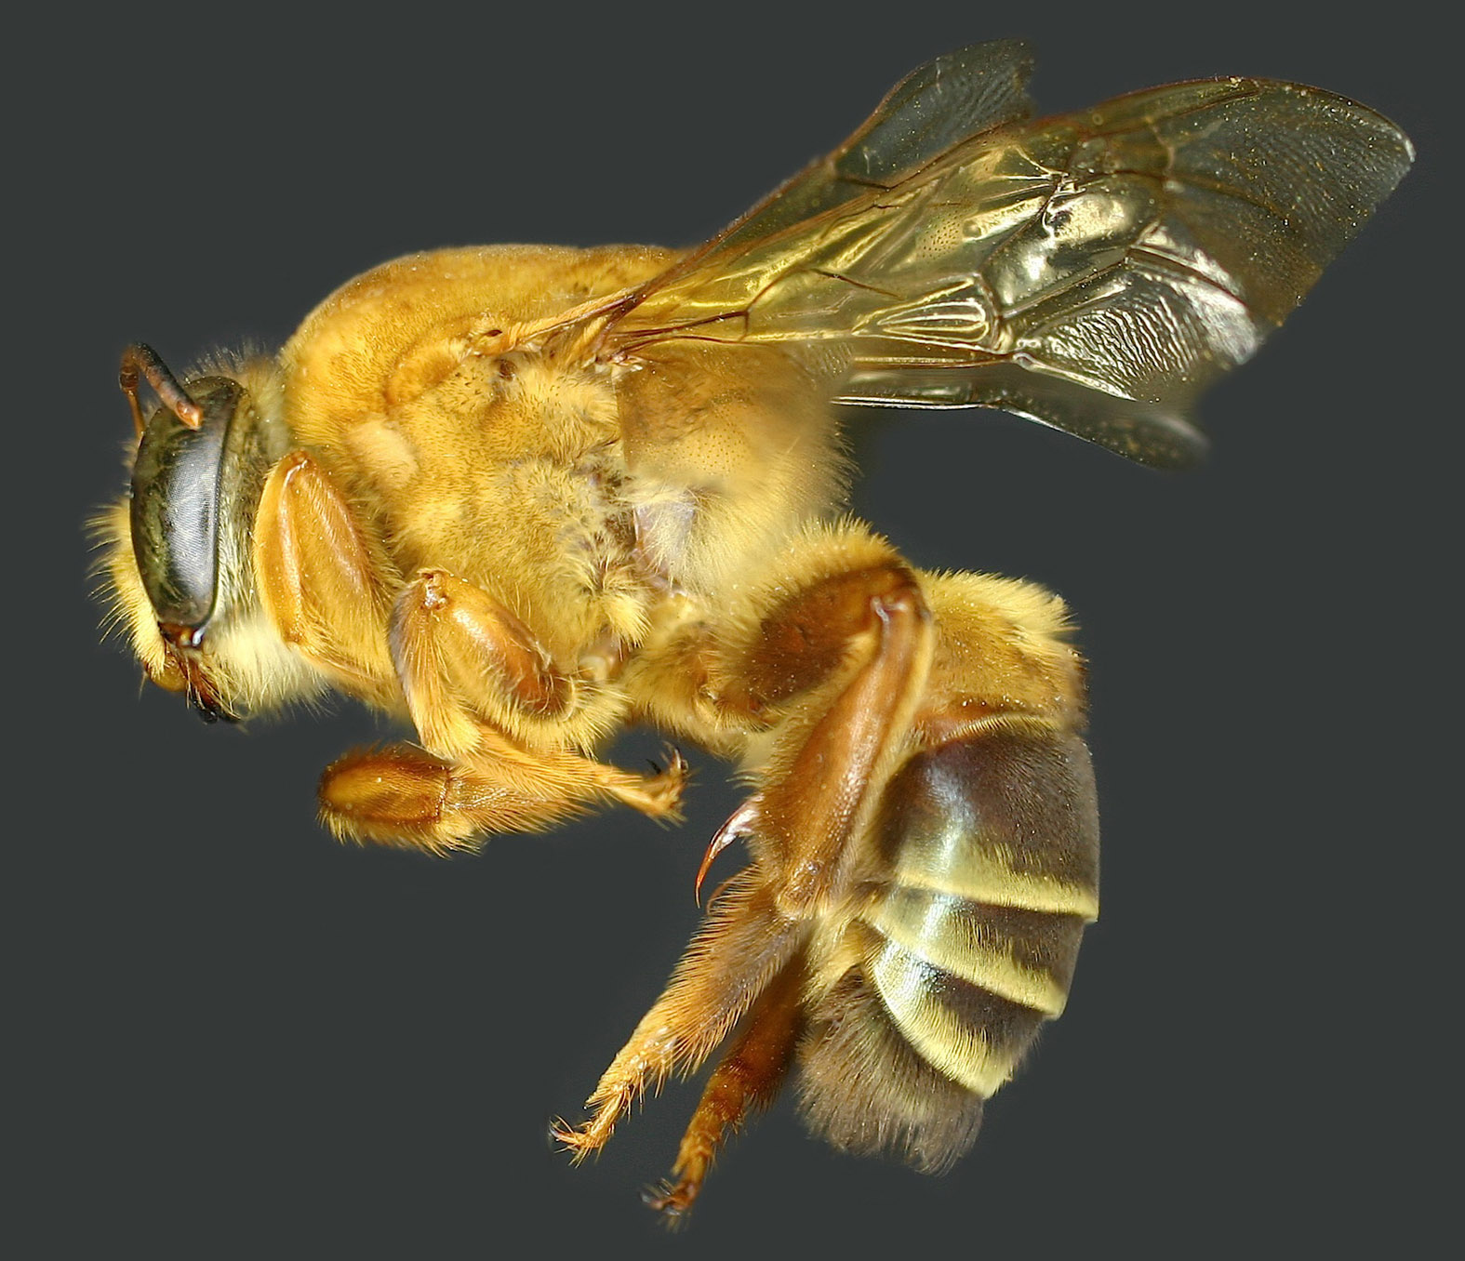

Figures 2–4. Photographs of Ptiloglossa chamelensis, new species, from Mexico. 2. Male facial view. 3. Female facial view. 4. Outer surface of metatibia and metabasitarsus.

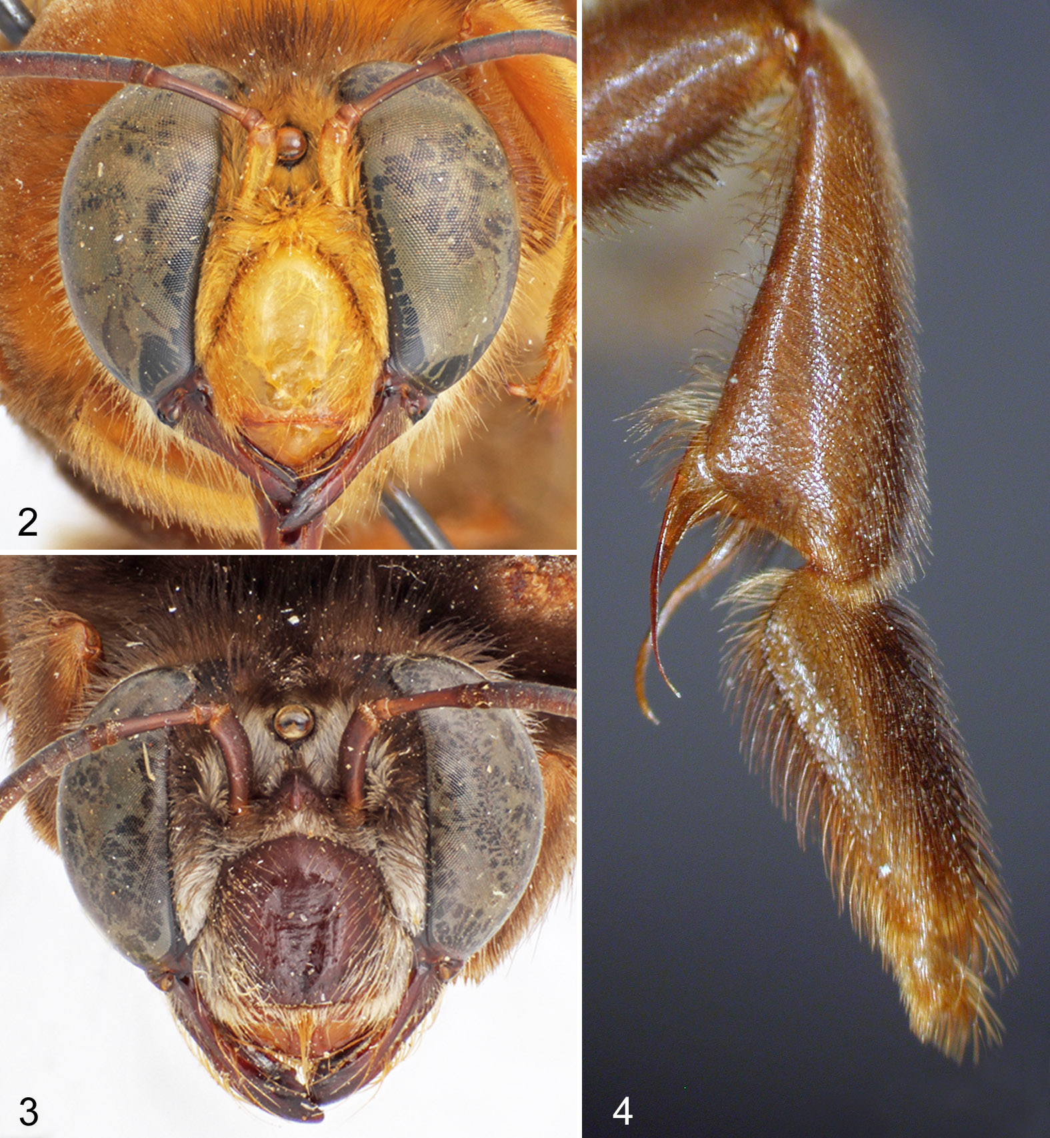

Figures 5–7. Male terminalia of Ptiloglossa chamelensis, new species, from Mexico. 5. Metasomal sternum VII. 6. Metasomal sternum VIII. 7. Ventral view of genital capsule.

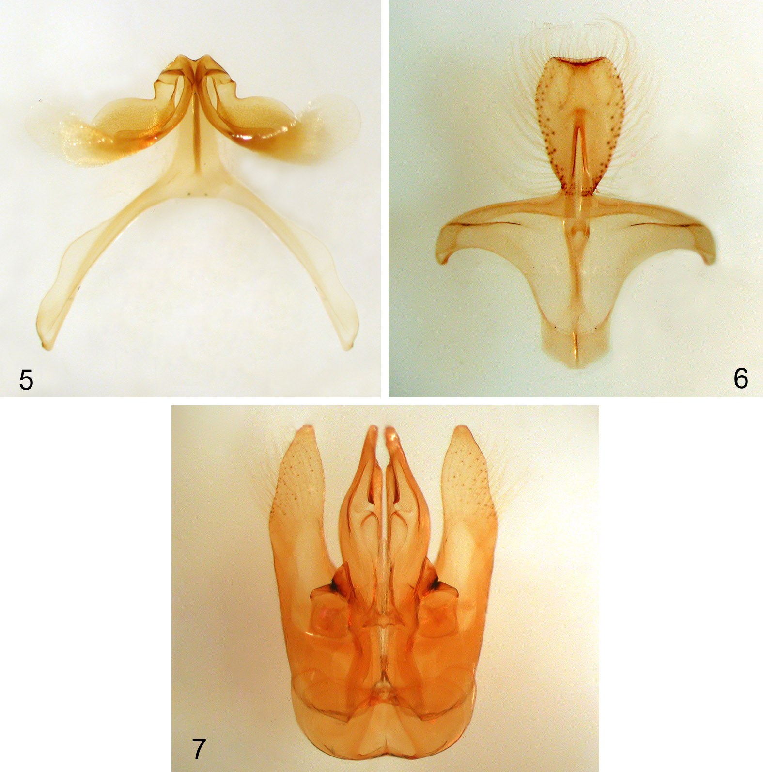

Figure 8. Lateral photograph of female of Ptiloglossa chamelensis, new species, from Mexico.

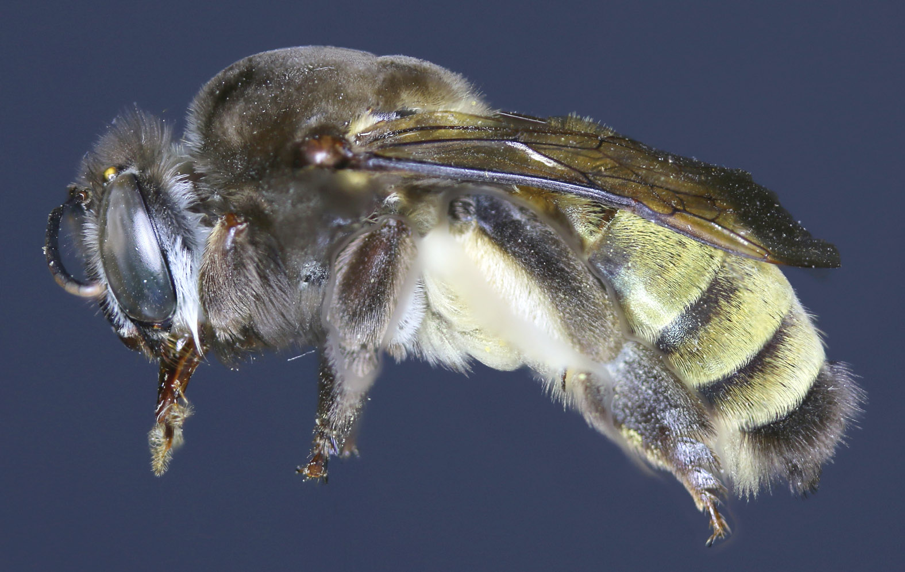

Figure 9. Lateral photograph of a more yellowish male of Ptiloglossa cyaniventris Friese from Panama.

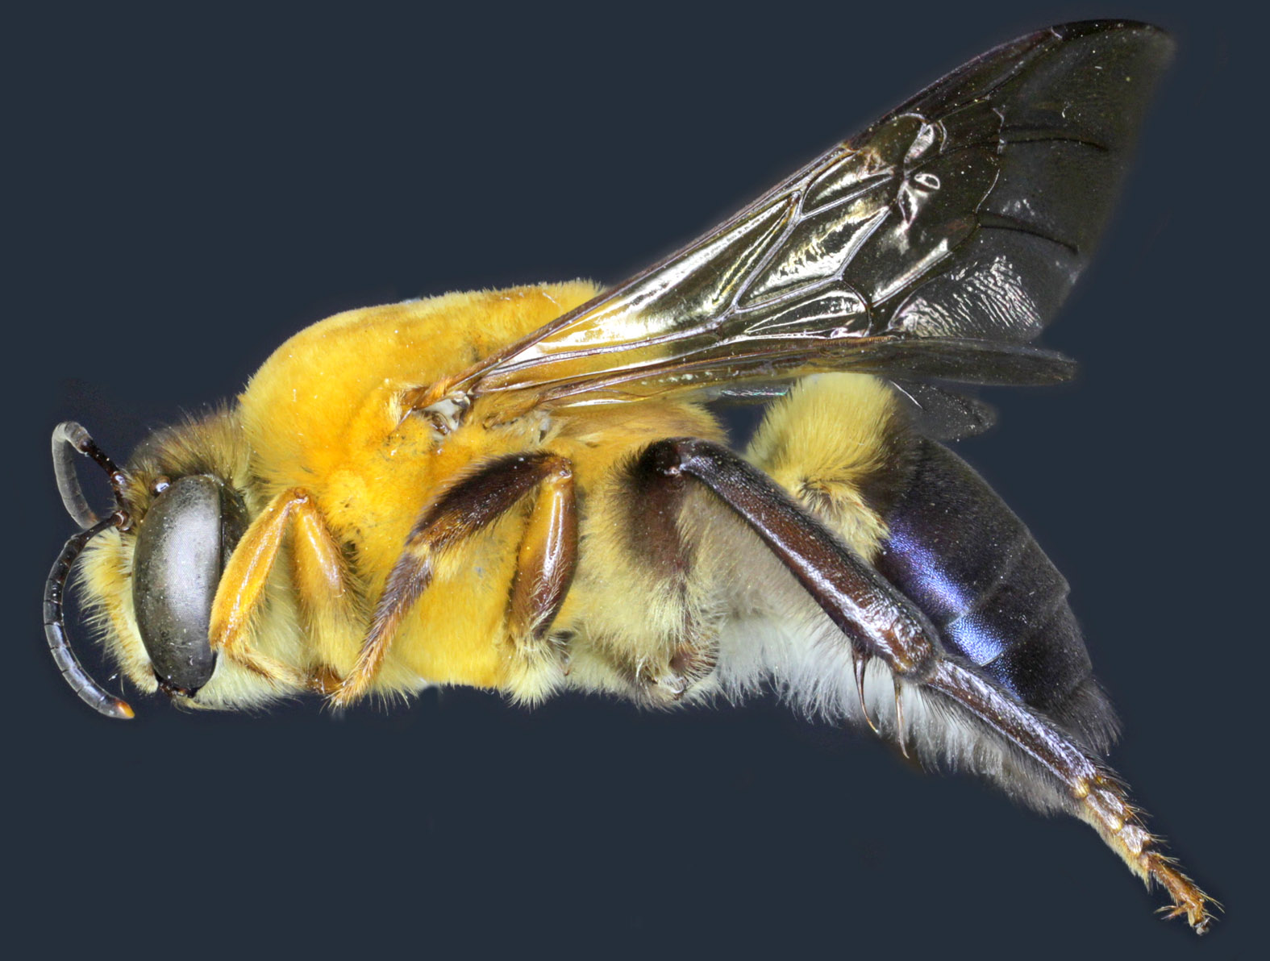

Figures 10–11. Photographs of more yellowish male of Ptiloglossa cyaniventris Friese from Panama. 10. Facial view. 11. Outer surface of metatibia.

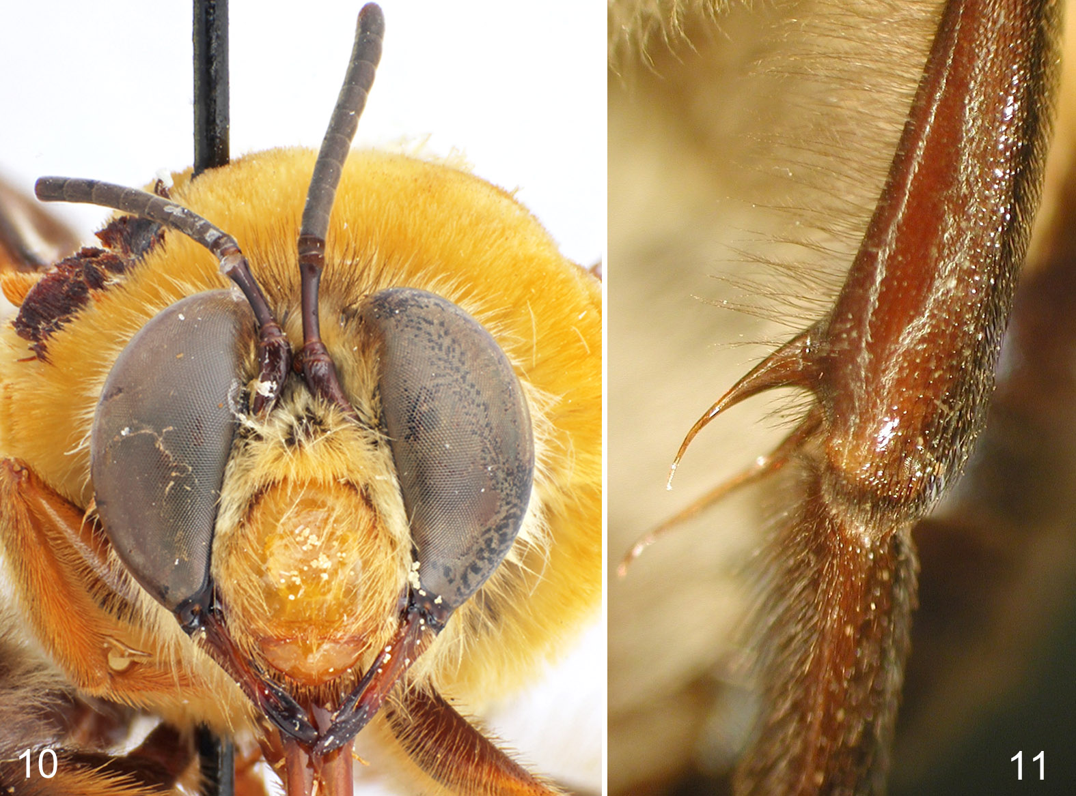

Figures 12–14. Male terminalia of Ptiloglossa cyaniventris Friese from Panama. 12. Metasomal sternum VII. 13. Metasomal sternum VIII. 14. Ventral view of genital capsule.

