Journal of Melittology

A new paracolletine bee from Colombia (Hymenoptera: Colletidae),
with an updated checklist of the tropical Andean bee fauna

Victor H. Gonzalez¹, Rita I. Velez-Ruiz², & Michael S. Engel^{3,4}

¹ Division of Biological Sciences, Haworth Hall, 1200 Sunnyside Avenue, University of Kansas, Lawrence, Kansas 66045-7566, USA (vhgonza@ku.edu).
² South Dakota State University, Plant Sciences Department, Agricultural Hall, 1010 Rotunda Ln, Brookings, South Dakota 57007, USA (ritaisavelez@gmail.com).
³ Division of Entomology, Natural History Museum, and Department of Ecology & Evolutionary Biology, 1501 Crestline Drive – Suite 140, University of Kansas, Lawrence, Kansas 66045-4415, USA (msengel@ku.edu).
⁴ Division of Invertebrate Zoology, American Museum of Natural History, Central Park West at 79th Street, New York, New York 10024-5192, USA (mengel@amnh.org).

Abstract. A new species of the paracolletine genus Lonchropria Vachal, Lonchopria (Biglossa) comforti Gonzalez & Engel, new species, from high elevations in the Central Andes of Colombia is described and figured. A preliminary key to the species of Biglossa Friese is presented. Recent records of bees occurring at altitudes above 2500 m in Colombia and other Andean countries are also summarized.

Introduction

The South American Andean bee fauna remains among the least known in the world. Many areas in this region are largely unexplored and material deposited in collections and available for study is scarce. Gonzalez & Engel (2004) reviewed for the first time the biology, diversity, biogeography, and distribution of the assemblage of bees occurring at high elevations in the Andes from Venezuela to Peru. While recording about 131 species in 33 genera from five extant bee families, Gonzalez & Engel (2004) demonstrated the uniqueness of this fauna, which parallels in its origins and distribution that of the Andean flora. They also stressed the importance of continuing its taxonomic exploration not only to increase our understanding of the biogeography of neotropical bees, but also to promote their conservation and sustainable use given that moderate elevations of the Andes are the center of agriculture in all Andean countries. Since that review, a number of genera and species have been documented from this region, albeit not all occurring at high elevations, but certainly revealing the richness and diversity of bees along the range of the Andes (e.g., Ascher et al., 2006; Celis et al., 2014; Engel, 2007, 2009a, 2010a, 2010b; Engel et al., 2006; Engel & Gonzalez, 2009; Gonçalves & Engel, 2010; Gonzalez, 2004, 2006; Gonzalez & Engel, 2011, in press; Gonzalez & Ruz 2007; Gonzalez et al., 2013a; Smith-Pardo & Gonzalez, 2009). Some of the cited groups do get relatively high and it would not be surprising to find eventually some of these above 2500 m elevation.
The purpose of this paper is two-fold. First, to describe a new species of Paracolletini in the genus Lonchopria Vachal from the Andes of Colombia, and second, to summarize recent records in the literature on the diversity of the Tropical Andean bee fauna. The 17 nominal species of this South American genus occur from the state of Paraná in Brazil, Chile and Argentina, through the Andes of Bolivia, Peru, and Colombia, where it appears to be particularly diverse (Michener, 1989, 2007). The species described herein belongs to the subgenus Biglossa Friese, the largest (nine species) of the five subgenera recognized in Lonchopria (Table 1); it represents the second species of Lonchopria known from Colombia (Gonzalez & Engel, in press). We also provide a preliminary key to the species of the subgenus Biglossa.

Material and methods

Material presented here is deposited in the Museo Entomológico Francisco Luis Gallego, Universidad Nacional de Colombia, Medellín, Colombia (MEFLG) and Division of Entomology, University of Kansas Natural History Museum, Lawrence, Kansas (SEMC). The description is provided in the belief that such accounts refine our hypotheses of specific diversity and taxonomic circumscriptions, and elaborate on the pattern and combination of traits that ultimately provide the foundations for understanding general phenomena among bees (Grimaldi & Engel, 2007; Engel, 2011; Gonzalez et al., 2013b). Morphological terminology follows that of Engel (2001) and Michener (2007), except that the projections from the inner metatibial spur are herein called branches, instead of teeth, and torulus is used instead of antennal socket (vide Engel, 2009b). The format for the description generally follows that used by Gonzalez & Florez (2011) and Gonzalez & Engel (in press). The abbreviations F, S, and T, are used for antennal flagellomere, and metasomal sternum and tergum, respectively. Total body length was estimated by measuring the combined lengths of the head, mesosoma (from the clypeus to the propodeum, in lateral profile), and metasoma, and adding the values. Forewing length was measured from the outer border of the tegula to the tip of the forewing. Intertegular distance was the shortest distance between the inner margins of the tegulae. Photomicrographs were prepared using a Canon EOS 7D digital camera attached to an Infinity K-2 long-distance microscopic lens, and were assembled with CombineZM softwareTM. Final figures were processed with Adobe® Photoshop® 7.0. Measurements were made with an ocular micrometer attached to an Olympus SZX-12 stereomicroscope. To facilitate comparisons, in the appendix we summarize new records of Andean bees following the format of Gonzalez & Engel (2004). As in that work, species were coded as “restricted” when found only at high elevations, “widespread” when found from lowlands to highlands, and “transient” when collected at high elevations even though they clearly belong to other elevations and ecosystems.

systematics

Genus Lonchopria Vachal
Subgenus Biglossa Friese
Lonchopria (Biglossa) comforti Gonzalez & Engel, new species
(Figs. 1‒18)

Diagnosis: The female of this species can be recognized by the following combination of characters: clypeus largely asetose and impunctate except on depressed, mediobasal area (Figs. 3, 5); integument dark brown to black with weak metallic bluish or greenish highlights on face and mesoscutum (Figs. 5, 6); mesoscutum imbricate with punctures separated by at least a puncture width (Fig. 6); and metasomal terga with sparse basal and apical yellowish fasciae (Figs. 1, 2, 8). The male can be recognized by the following combination of characters: clypeus with punctate, depressed median area occupying about basal two-thirds of clypeal length (Fig. 11); legs unmodified; malar area linear; head, mesosoma (excluding legs), and metasomal terga with distinct bluish or greenish highlights (Figs. 9, 10); and metasomal terga with distinct apical yellowish fasciae. The female of L. comforti resembles that of a presently unnamed species of Lonchopria from Norte de Santander, Colombia (Gonzalez & Engel, in press), in the clypeus largely asetose and impunctate except on depressed, mediobasal area, and the body pubescence dark brown to black. It differs from that species in the larger depressed median area of the clypeus (occupying about basal two-thirds of clypeal length in L. comforti; basal half of clypeus in the unnamed species); head and mesosoma with weak metallic bluish or greenish highlights, sometimes on the metasomal terga (absent in the unnamed species); metasomal terga with sparse basal and apical yellowish fasciae (absent in the unnamed species); and metasomal terga dull and strongly imbricate (metasomal terga shinier and weakly imbricate in the unnamed species). Additionally, L. comforti is known from the Central cordillera while the unnamed species occurs from the Eastern cordillera, near the border with Venezuela (Gonzalez & Engel, in press).
Description: ♀: Body length 11.7 mm (10.5–12.7, $\bar{x}$= 11.2, n = 13); forewing length 8.2 mm (8.2–8.8, $\bar{x}$= 8.5, n = 10); head width 3.6 mm (3.4–3.8, $\bar{x}$= 3.6, n = 13), length 2.9 mm (2.6–2.9, $\bar{x}$= 2.8, n = 13). Head 1.2 times wider than long; inner orbits of compound eyes slightly converging below (Fig. 5); intertorular distance about twice as long as median ocellar diameter, 0.7 times of torulorbital distance; torulus diameter about as wide as median ocellar diameter; ocellocular distance 2.5 times median ocellar diameter, about twice as long as ocelloccipital distance; interocellar distance 0.9 times length of ocellocular distance, 2.2 times median ocellar diameter; compound eye about three times longer than broad; gena widest medially, 0.9 times narrower than compound eye in profile; mandible not apically expanded, with small preapical tooth (Fig. 4); clypeus protuberant in profile, disc convex with distinct median depression on basal two-thirds (Figs. 3, 5); scape 5.7 times longer than broad; pedicel about as long as broad, 0.6 times length of first flagellomere; first flagellomere 1.3 times longer than broad, 1.5 times longer than second; second flagellomere broader than long, slightly shorter than third, remaining flagellomeres progressively increasing in length, apical flagellomere longest. Intertegular distance 2.5 mm (2.5–2.7, $\bar{x}$= 2.6, n = 13). Protibial spur with apical portion of rachis long, about as long as malus length, with distinct row of eight elongate branches, not including apical portion of rachis (7–9 branches in some paratypes); inner metatibial spur with distinct row of nine elongate branches, not including apical portion of rachis (10 branches in some paratypes).
Color black, except as follows: F3–10 ventrally yellowish; apex of mandible, pro- and mesofemora, distitarsi, and discs of metasomal sterna dark reddish brown; frons, vertex, and mesoscutum with weak metallic bluish or greenish highlights. Tegula brownish; wing membranes translucent orange, veins and pterostigma dark orange.
Head and mesosoma with mainly yellowish to light reddish brown setae mixed with dark brown to black setae on frons, vertex, mesoscutum, and pleura dorsally; legs with dark brown to gray setae except coxae and femora of all legs with yellowish setae. Metasoma with dark brown setae except distal margins of T1–T4 and basal areas of T2–T5 with yellowish fasciae.
Clypeus largely impunctate, smooth, and shining, except lateral areas and mid-basal depression imbricate, with punctures separated by a puncture width or less; supraclypeal area impunctate, smooth, and shining on center, otherwise with small contiguous punctures; subantennal area impuctate, weakly imbricate to nearly smooth and shining; paraocular area weakly imbricate with punctures separated by 1–2 times a puncture width; frons imbricate with punctures contiguous and forming rows above antennal toruli, punctures sparser (1–2 times a puncture width) below median ocellus; vertex weakly imbricate with punctures separated by less a puncture width or less, sparser behind ocelli; gena imbricate with punctures separated by 1–2 times a puncture width; postgena weakly imbricate with punctures sparser than on gena. Mesoscutum imbricate with punctures separated by 1–2 times a puncture width anteriorly, along lateral and posterior borders, and on central disc, otherwise punctures considerably more sparse (Fig. 6); mesoscutellum imbricate with punctures separated by 1–2 times a puncture width, sparser on disc; metanotum imbricate with punctures smaller and shallower than those on mesoscutum, separated by about a puncture width or less. Pleura imbricate with punctures separated by a puncture width or less; metepisternum transversely striate near wing base. Propodeum with basal area strongly and finely imbricate and impunctate, lateral and posterior surfaces strongly imbricate with punctures separated by 1–2 times a puncture width or less. Metasoma finely imbricate with small punctures separated by 2–4 times a puncture width on T1, those on T2–T4 smaller and denser, T5 with larger punctures than on T1, separated by 2–4 times a puncture width basally, much closer distall; sterna with punctures separated by a puncture width or less.
♂: As described for the female, except for usual secondary sexual characteristics and the following: Body length 8.5–9.7 mm ($\bar{x}$= 9.1, n = 6); forewing length 7.1–7.8 mm ($\bar{x}$= 7.4, n = 5); head width 3.0–3.3 mm ($\bar{x}$= 3.2, n = 6), length 2.4–2.7 mm ($\bar{x}$= 2.6, n = 6). Inner orbits of compound eyes converging below (Fig. 11); intertorular distance 2.4 times median ocellar diameter, about as long as torulorbital distance; ocellocular distance 2.9 times median ocellar diameter, 1.9 times ocelloccipital distance; interocellar distance 0.8 times length of ocellocular distance; compound eye 2.4 times longer than broad; mandible apically expanded, with large preapical tooth (Fig. 12); frontal line carinate, extending from median ocellus to supraclypeal area, abruptly ending at that point as small tooth (better seen in profile) (Fig. 11); scape 8.0 times longer than broad; flagellum in repose reaching mesoscutellum, first flagellomere 1.6 times longer than broad, 1.2 times longer than second; second flagellomere 1.3 times longer than broad, about as long as third. Intertegular distance 2.0–2.2 mm ($\bar{x}$= 2.2, n = 6). Protibial spur with apical portion of rachis long, 0.6 times length of malus, with distinct row of 10–13 elongate branches (not including apical portion of rachis); inner metatibial spur ciliate.
Color as in female but with legs largely dark reddish brown and with more conspicuous metallic bluish or greenish highlights on head, mesosoma, and metasomal terga (Figs. 10, 11).
Pubescence paler, longer, and sparser than in female. Metasoma with denser and longer apical fasciae on T2–T5.
Integument with sculpturing as described for the female, except frons strongly imbricate and with denser punctures, and mesoscutum and mesoscutellum weakly imbricate to nearly smooth. Genital capsule and associated hidden sterna as in Figs. 13–18.
Holotype: ♀, Colombia: Antioquia, Envigado, San Sebastian, Papa-Bosque. Trans. Papa ppal. En: Jama 11:30am. 2459 m.s.n.m., 06°08’04.6”N, 075°32’17”W, 19°C, 65%HR, Enero 22, 2010. Col. Sepúlveda-Cano, P., Osorio, N (MEFLG).
Paratypes: 9♀♀ with same data as holotype except collected on August 28, 2009, January 18, 20, 21, and 22, 2010 (MEFLG); 1♀, Antioquia, 25 km S, Medellin, 21 January 1984, James H. Cane (SEMC); 2♀♀, Antioquia, Retiro, En: Gutifera [Clusiaceae], Febrero de 1975, Col: A. Molina (MEFLG); 5♂♂, Antioquia, Rionegro, En: Eupatorium tinifolium [Ageratina tinifolia (Kunth) R.M.King & H. Rob], Tibouchina lepidota [Tibouchina lepidota (Bonpl.) Baillon], Julio de 1975, Col: J. Cano, R. Añez (MEFLG); 1♂, Antioquia, Rionegro, En: Eupatorium tinifolium [Ageratina tinifolia (Kunth) R.M.King & H. Rob], Tibouchina lepidota [Tibouchina lepidota (Bonpl.) Baillon], Julio de 1975, Col: J. Cano, R. Añez (SEMC); 1♀, Caldas, Pensilvania, VI-25-1978, J.H. Cane (SEMC).
Comments: Unlike the holotype, some female paratypes have lighter body pubescence and the integument largely dark reddish brown with more metallic bluish or greenish highlights on the head, mesosoma, and metasomal terga.
This species has been collected between 2000 and 2500 m elevation in the Central Andes of Colombia. It appears to be present year-round, as specimens have been captured from January through August.
Etymology: This specific epithet honors Mr. Mark Douglas Comfort on the occasion of his 52nd birthday, celebrated on 6 August 2014. Although Doug grew up in Wells, Kansas, he was born in Salina where he lives with his wife Louise and two sons, Kane and Lucas.

Key to species of Biglossa Friese
Females

Note that the females of L. inca Cockerell, L. alopex Cockerell, and L. thoracica (Friese) are not included.

1. Clypeus punctate throughout or nearly so, without distinct mediobasal depressed area ............................................................................................................................... 2
—. Clypeus largely asetose and impunctate except on depressed, mediobasal area (Fig. 3) ....................................................................................................................................... 4
2(1). Mesoscutum imbricate between punctures; terga with weak metallic green or blue highlights (Argentina) .................................................................... L. chalybea (Friese)
—. Mesoscutum smooth and shiny between punctures; terga without weak metallic green or blue highlights .......................................................................................................... 3
3(2). Base of T1 imbricate, with punctures at most slightly larger than those on second and third terga; body pubescence largely whitish, T1–T5 each with complete (transverse across tergal width) white apical fasciae (Argentina) ............. L. longicornis Michener
—. Base of T1 smooth and shiny with punctures distinctly larger than those on second and third terga; body pubescence largely dark brown to black, distal margin of T2, and discs of T3 and T4 medially with yellow fasciae (Argentina) ... L. nivosa (Vachal)
4(1). Mesoscutum imbricate between punctures (sometimes with large impunctate areas on disc) (Fig. 6) ................................................................................................................. 5
—. Mesoscutum largely smooth and shiny between punctures ......................................... 6
5(4). Mesoscutum, mesoscutellum, and T1 with reddish setae; head and mesosoma dark brown to black, without metallic bluish or greenish highlights (Argentina) ................... .............................................................................................................. L. aenea (Friese)
—. Mesoscutum, mesoscutellum, and T1 with dark brown or black setae; head and mesosoma with weak metallic bluish or greenish highlights, sometimes on metasomal terga (Colombia) ................................................................................ L. comforti, n. sp.
6(4). Body pubescence pale, whitish to yellowish; terga densely covered by fasciae, integument barely visible; clypeus with depressed median area with punctures contiguous (Argentina) .................................................................. L. robertsi Michener
—. Body pubescence dark brown to black; terga without fasciae, sparsely covered by erect, mostly-simple setae, integument largely visible; clypeus with depressed median area with punctures scattered [Colombia: Norte de Santander (Gonzalez & Engel, in press)] ..................................................................................................... Lonchopria sp.

Males

The Bolivian species L. alopex is known only from the male. It is not included in this key but, based on the original description, it might run in this key to L. deceptrix (Moure) from Argentina. The male of the undescribed species from Norte de Santander, Colombia, is unknown (Gonzalez & Engel, in press).

1. Clypeus punctate throughout ........................................................................................ 2
—. Clypeus largely asetose and impunctate, except basally .............................................. 4
2(1). Metafemur distinctly swollen; metatibia with distinct carina projecting into a tooth near apex on anterior margin; clypeus dull, coarsely and densely punctate, densely covered by relatively short, minutely-branched setae (integument obscured); clypeus with distinct preapical ridge swollen laterally; terga metallic bluish to greenish ........... ....................................................................................................... L. chalybaea (Friese)
—. Metafemur and metatibia unmodified, not swollen or with carina; clypeus shinier, with sparser punctures, with longer branched setae, without swollen preapical ridge; terga black, without metallic highlights ....................................................................... 3
3(2). Clypeal margin laterally projecting into a tooth; sculpturing of T1 notoriously different from that of second and third terga, strongly imbricate, with punctures sparser and larger than the contiguously punctate second and third terga (Argentina) .. ........................................................................................................... L. nivosa (Vachal)
—. Clypeal margin straight; sculpturing of T1 similar to that of second and third terga, strongly imbricate with minute, very sparse punctures (Peru) ........... L. inca Cockerell
4(1). Terga with metallic bluish or greenish highlights ........................................................ 5
—. Terga dark brown to black, without metallic bluish or greenish highlights ................. 7
5(4). Head and mesosoma (excluding legs) with metallic bluish or greenish highlights as on terga; clypeus with noticeably depressed, punctate, median area occupying about basal two-thirds of clypeal length (Colombia) ................................... L. comforti, n. sp.
—. Head and mesosoma dark brown to black, without metallic bluish or greenish highlights; clypeus with median area punctate, not depressed or scarcely depressed, occupying basal half of clypeus (Argentina) ................................................................ 6
6(5). Malar area linear; metabasitarsus narrow, about half width of metatibia (Argentina) .... ........................................................................................................ L. deceptrix (Moure)
—. Malar area longer, about half width of F1; metabasitarsus broad, about two-thirds of metatibia width (Argentina) ................................................................ L. aenea (Friese)
7(4). F1 long, distinctly longer than broad, about 1.8 times longer than broad (Argentina) ... .................................................................................................. L. longicornis Michener
—. F1 short, about as long as broad or slightly longer ...................................................... 8
8(7). Mandible with small median teeth, thus appearing tridentate; terga without apical fasciae (Argentina) ........................................................................ L. thoracica (Friese)
—. Mandible without small median teeth; T1–T5 with apical fasciae (Argentina) .............. ........................................................................................................ L. robertsi Michener

Discussion

During the last decade, at least 27 species and six genera from the tropical Andes have been documented in the literature. That is, a total of 158 identified species and 39 genera are today known from high elevations of the Andes from Venezuela through Peru (Appendix). Apidae and Halictidae remain as the most diverse families, together accounting for nearly half of the total number of species. The most diverse genera are Neocorynura Schrottky (18 species), Augochlora Smith (16 species), Anthidium Fabricius (16 species), Chilicola Spinola (15 species), and Bombus Latreille (14 species). Although Augochlora is a species-rich lineage, there has been no modern revision of the group and several of the species established by Vachal may prove to be synonyms, thereby considerably reducing its purported diversity in the Andes. Indeed, many of the genera are in need of a modern consideration of species hypotheses. Although some genera, such as Neocorynura and Bombus, appear to be equally diverse across the tropical Andean region, others seem to be more diverse in particular areas or habitats. For example, Anthidium is highly diverse in ecoregions on the western flank of the Andes of Peru and Ecuador, namely the Central Andean dry puna, Sechura Desert, and the Central Andean puna (Gonzalez & Griswold, 2013). A number of other halictine genera get close in elevation to the 2500 m mark set forth herein. For example, species of Ischnomelissa (Engel, 2013), Chlerogas Vachal (Engel, 2009a, 2010a; Engel & Gonzalez, 2009; Engel et al., 2006), Caenaugochlora Michener (Gonçalves & Engel, 2010), and Chlerogella (Engel, 2010b; Engel & Rasmussen, 2013) sometimes meet and exceed 2400 m and it is possible that some of those species, or new species closely related, may eventually be discovered at or above 2500 m.
What the present account emphasizes is that the highest reaches of the Andes are ripe for research, with a continually growing fauna of a unique composition. The biologies and status of these species are in need of considerable study, and some endemic groups may be susceptible to the influences of human-mediated climate change given that there is a fixed, upper-elevational limit to which they and their associated flora can escape. As their ‘island’ peaks become augmented from rising temperatures and environmental degradation, entire ecosystems not represented further down the slopes may disappear. This reality makes it imperative that efforts be undertaken now to survey the highest regions of the Andes and grant us the opportunity to understand this rich bee fauna before it is eroded or even lost.

ACKNOWLEDGEMENTS

We are grateful to two anonymous reviewers for their constructive comments. Partial support was provided by US National Science Foundation grant DBI-1057366 (to M.S.E.), as well as the Engel Illustration Fund of the University of Kansas College of Liberal Arts & Sciences. This is a contribution of the Division of Entomology, University of Kansas Natural History Museum.

References

Ascher, J.S., M.S. Engel, & T.L. Griswold. 2006. A new subgenus and species of Oxaea from Ecuador (Hymenoptera: Andrenidae). Polskie Pismo Entomologiczne 75(4): 539–552.
Bonilla, M.A. 1990. Abejas euglosinas de Colombia (Hymenoptera: Apidae). Undergraduate thesis, Universidad Nacional de Colombia; Bogotá, Colombia; 130 pp.
Brooks, R.W., & M.S. Engel. 1999. A revision of the augochlorine bee genus Chlerogas Vachal (Hymenoptera: Halictidae). Zoological Journal of the Linnean Society 125(4): 463–486.
Celis, C.J., J.R. Cure, & M.L. Aguilar-Benavides. 2014. Two new species of Caenohalictus Cameron, 1903 (Hymenoptera: Halictidae) from Colombia. Zootaxa 3786(5): 574–586.
Chavarría, G. 1996. Systematics and behavior of the neotropical bumble bees (Hymenoptera: Apidae: Bombus). Ph.D. dissertation, Harvard University; Cambridge, MA; 250 pp.
Coloma-Roman, L.A. 1986. Contribución para el conocimiento de las abejas sin aguijón (Meliponinae, Apidae, Hymenoptera) de Ecuador. Undergraduate thesis, Pontificia Universidad Católica del Ecuador; Quito, Ecuador; 146 pp.
Cruz, S. 1996. Abejas carpinteras de Colombia (Hymenoptera: Apidae). Undergraduate thesis, Universidad Nacional de Colombia; Bogotá, Colombia; 223 pp.
Engel, M.S. 1996. Taxonomic and geographic notes on some halictine bee species (Hymenoptera: Halictidae). Journal of the New York Entomological Society 104(1–2): 106–110.
Engel, M.S. 1999. A new species of the bee genus Neocorynura from the Andes of Ecuador (Hymenoptera, Halictidae, Augochlorini). Spixiana 22(2): 173–178.
Engel, M.S. 2000. Classification of the bee tribe Augochlorini (Hymenoptera: Halictidae). Bulletin of the American Museum of Natural History 250: 1–192.
Engel, M.S. 2001. A monograph of the Baltic amber bees and evolution of the Apoidea (Hymenoptera). Bulletin of the American Museum of Natural History 259: 1–192
Engel, M.S. 2007. Two new augochlorine bees from Ecuador (Hymenoptera: Halictidae). Acta Entomologica Slovenica 15(1): 21–29.
Engel, M.S. 2009a. Notes on the augochlorine bee genus Chlerogas (Hymenoptera: Halictidae). Caldasia 31(2): 449–457.
Engel, M.S. 2009b. Revision of the bee genus Chlerogella (Hymenoptera, Halictidae), part I: Central American species. ZooKeys 23: 47–75.
Engel, M.S. 2010a. The bee genus Chlerogas in Bolivia (Hymenoptera, Halictidae). ZooKeys 46: 61–70.
Engel, M.S. 2010b. Revision of the bee genus Chlerogella (Hymenoptera, Halictidae), part II: South American species and generic diagnosis. ZooKeys 47: 1–100.
Engel, M.S. 2011. Systematic melittology: Where to from here? Systematic Entomology 36(1): 2–15.
Engel, M.S. 2013. The bee genus Ischnomelissa in Peru, with a key to the species (Hymenoptera: Halictidae). Journal of Melittology 23: 1–5.
Engel, M.S., & V.H. Gonzalez. 2009. A new species of Chlerogas from the Andes of central Colombia (Hymenoptera: Halictidae). Caldasia 31(2): 441–447.
Engel, M.S., & B.A. Klein. 1997. Neocorynurella, a new genus of the augochlorine bees from South America (Hymenoptera: Halictidae). Deutsche Entomologische Zeitschrift 44(2): 155–163.
Engel, M.S., & C. Rasmussen. 2013. Revision of the bee genus Chlerogella (Hymenoptera: Halictidae), Part III: New records and a new species from Peru. Journal of Melittology 9: 1–8.
Engel, M.S., F.F. de Oliveira, & A.H. Smith-Pardo. 2006. A new species of the bee genus Chlerogas Vachal from Ecuador (Hymenoptera: Halictidae). Entomologist’s Monthly Magazine 142(1703–1705): 103–106.
Gonçalves, R.B., & M.S. Engel. 2010. The bee genus Caenaugochlora (Hymenoptera, Apoidea) and its constituent subgenera, with new species of Caenaugochlora s.str. from Ecuador. ZooKeys 37: 69–80.
Gonzalez, V.H. 2004. A new species of Acamptopoeum from Colombia (Hymenoptera: Andrenidae: Panurginae). Caldasia 26(1): 239–243.
Gonzalez, V.H. 2006. Dos especies nuevas de abejas de la ciudad de Bogotá (Colombia). Revista Colombiana de Entomología 32(1): 93–96.
Gonzalez, V.H., & F. Chávez. 2004. Nesting biology of a new Andean bee, Anthophora walteri Gonzalez (Hymenoptera: Apidae: Anthophorini). Journal of the Kansas Entomological Society 77(4): 36–44.
Gonzalez, V.H., & M.S. Engel. 2004. The tropical Andean bee fauna (Insecta: Hymenoptera: Apoidea), with examples from Colombia. Entomologische Abhandlungen 62(1): 65–75.
Gonzalez, V.H., & M.S. Engel. 2011. Andinopanurgus, a new Andean subgenus of Protandrena (Hymenoptera, Andrenidae). ZooKeys 126: 57–76.
Gonzalez, V.H., & M.S. Engel. In press. A new species of Lonchopria Vachal from Norte de Santander, Colombia (Hymenoptera: Colletidae). In: Aguiar, A.J.C., R.B. Gonçalves, & K.S. Ramos (Eds.), Ensaios sobre as abelhas da região Neotropical: Homenagem aos 80 anos Danuncia Urban. Editora UFPR.
Gonzalez, V.H., & J. Florez. 2011. Leioproctus rosellae sp. n., the first record of the genus from northern South America (Hymenoptera, Colletidae). ZooKeys 141: 71–77.
Gonzalez, V.H., & C. Giraldo. 2009. New Andean bee species of Chilicola Spinola (Hymenoptera: Colletidae, Xeromelissinae) with notes on their biology. Caldasia 31(1): 145–154.
Gonzalez, V.H., & T. Griswold. 2013. Wool carder bees of the genus Anthidium in the Western Hemisphere (Hymenoptera: Megachilidae): Diversity, host plant associations, phylogeny, and biogeography. Zoological Journal of the Linnean Society 168(2): 221‒425.
Gonzalez, V.H., & C.D. Michener. 2004. Applications of specific names and association of sexes in Cadegualina (Hymenoptera, Colletidae, Diphaglossini). Proceedings of the Entomological Society of Washington 106(4): 850–856.
Gonzalez, V.H., & G. Nates-Parra. 1999. Sinopsis de Parapartamona (Hymenoptera: Apidae: Meliponini), un género estrictamente andino. Revista de la Academia Colombiana de Ciencias Exactas, Físicas y Naturales 23(Suplemento especial): 171–179.
Gonzalez, V.H., & L. Ruz. 2007. New enigmatic Andean bee species of Protandrena (Hymenoptera: Andrenidae), with notes on their biology. Revista Brasileira de Entomologia 51(4): 397–403.
Gonzalez, V.H., & D. Vélez. 2007. Una especie nueva de Paratrigona (Hymenoptera, Apidae, Meliponini), con una sinopsis del género en Colombia. Boletín del Museo de Entomología de la Universidad del Valle 8(2): 9–13.
Gonzalez, V.H., & P. Sepúlveda. 2007. Una especie nueva de Geotrigona (Hymenoptera, Apidae, Meliponini), con comentarios del género en Colombia. Acta Biológica Colombiana 12S: 107–112.
Gonzalez, V.H., A.H. Smith-Pardo, & G. Bogotá. 2006. Two new Andean species of Neocorynura (Hymenoptera: Halictidae: Augochlorini) with notes on their biology. Studies on Neotropical Fauna and Environment 41(3): 197–208.
Gonzalez, V.H., C. Rasmussen, & A. Velázquez. 2010. Una especie nueva de Lestrimelitta y un cambio de nombre en Lasioglossum (Hymenoptera: Apidae, Halictidae). Revista Colombiana de Entomología 36(2): 319–324.
Gonzalez, V.H., C. Rasmussen, & M.S. Engel. 2013a. Incasarus garciai, a new genus and species of panurgine bees from the Peruvian Andes (Hymenoptera: Andrenidae). Journal of Melittology 8: 1‒9.
Gonzalez, V.H., T. Griswold, & M.S. Engel. 2013b. Obtaining a better taxonomic understanding of native bees: Where do we start? Systematic Entomology 38(4): 645–653.
Gonzalez, V.H., C. Rasmussen, & M.S. Engel. 2014. A new species of Liphanthus from Peru (Hymenoptera: Andrenidae). Journal of Melittology 31: 1–9.
Grimaldi, D., & M.S. Engel. 2007. Why descriptive science still matters. BioScience 57(8): 646–647.
Hurd, P.D., Jr. 1978. An Annotated Catalog of the Carpenter Bees (Genus Xylocopa Latreille) of the Western Hemisphere (Hymenoptera: Anthophoridae). Smithsonian Institution Press; Washington, DC; [3]+106 pp.
Liévano, A., & R. Ospina. 1984. Contribución al conocimiento de los abejorros sociales de Cundinamarca. Undergraduate thesis, Universidad Nacional de Colombia; Bogotá, Colombia; 163 pp.
Michener, C.D. 1989. Classification of the American Colletinae (Hymenoptera, Apoidea). University of Kansas Science Bulletin 53(1): 622–703.
Michener, C.D. 2000. A high Andean subgenus and species of Hylaeus (Hymenoptera, Colletidae). Journal of the Kansas Entomological Society 73: 1–5.
Michener, C.D. 2002. The bee genus Chilicola in the Tropical Andes, with observations on nesting biology and phylogenetic analysis of the subgenera (Hymenoptera, Colletidae, Xeromelissinae). Scientific Papers, Natural History Museum, University of Kansas 26: 1–47.
Michener, C.D. 2007. The Bees of the World [2nd Edition]. Johns Hopkins University Press; Baltimore, MD; xvi+[i]+953 pp., +20 pls.
Moure, J.S. 1956. Duas espécies de Megachile de grandes altitudes (Hymenopt.-Apoidea). Dusenia 7(2): 103–106.
Moure, J.S., & P.D. Hurd, Jr. 1987. An Annotated Catalog of the Halictid Bees of the Western Hemisphere (Hymenoptera: Halictidae). Smithsonian Institution Press; Washington, DC; vii+405 pp.
Moure, J.S., & D. Urban. 2002. Catálogo de Apoidea da região Neotropical (Hymenoptera, Colletidae). III. Colletini. Revista Brasileira de Zoologia 19(1): 1–30.
Nates-Parra, G., V.H. Gonzalez, & R. Ospina-Torres. 1999. Descripción de los machos y anotaciones sobre la biología de Paratrigona anduzei y P. eutaeniata (Hymenoptera: Apidae: Meliponini) en Colombia. Caldasia 21(2): 174–183.
Packer, L. 1993. Two distinctive new species of halictine bees from high altitude in the New World tropics (Hymenoptera: Halictidae). Canadian Journal of Zoology 71(8): 1653–1662.
Parra-H, A., & G. Nates-Parra. 2007. First record of Eufriesea bare Gonzalez & Gaiani and notes on the distribution of three species of orchid bees pertaining to the genus Euglossa Latreille (Apidae: Euglossini) in Colombia. Revista de la Academia Colombiana de Ciencias Exactas, Físicas y Naturales 31(120): 415‒423.
Raw, A. 2002. New combinations and synonymies of leafcutter and mason bees of the Americas (Megachile, Hymenoptera, Megachilidae). Zootaxa 71: 1–43.
Roig-Alsina, A. 1999. Revisión de las abejas colectoras de aceites del género Chalepogenus Holmberg (Hymenoptera, Apidae, Tapinotaspidini). Revista del Museo Argentino Ciencias Naturales 1: 67–101.
Smith-Pardo, A.H., & V.H. Gonzalez. 2009. A revision of Neocorynura bees of the joannisi group, with new geographical records for other rare Andean species (Hymenoptera: Halictidae, Augochlorini). Studies on Neotropical Fauna and Environment 44(2): 115–129.
Urban, D. 1967. As espécies do genero Thygater Holmberg, 1884. Boletim da Universidade Federal do Paraná (Zoologia) 2: 177–307.
Urban, D. 1971. As espécies do genero Alloscirtetica Holmberg, 1909 (Hymenoptera, Apoidea). Boletim da Universidade Federal do Paraná (Zoologia) 3: 307–370.
Urban, D. 1977. Espécies novas de Alloscirtetica Holmberg, 1909 (Hymenoptera, Apoidea). Dusenia 10(1): 1–14.
Urban, D. 2001. Espécies novas de Anthidium Fabricius do Chile, Argentina e Perú (Hymenoptera, Megachilidae). Revista Brasileira de Zoologia 18(2): 539–550.
Urban, D., & J.S. Moure. 2001. Catálogo de Apoidea da região Neotropical (Hymenoptera, Colletidae). II. Diphaglossinae. Revista Brasileira de Zoologia 18(1): 1–34.
Urban, D., & J.S. Moure. 2002. Catálogo de Apoidea da região Neotropical (Hymenoptera, Colletidae). IV. Hylaeinae. Revista Brasileira de Zoologia 19(1): 31–56.

Table 1. Classification of Lonchopria Vachal (sensu Michener, 1989, 2007). Floral records taken from the literature and museum specimens (vide Gonzalez & Engel, in press).

Taxon | Sexes | Elevation | Distribution | Floral records
Genus Lonchopria Vachal
Subgenus Biglossa Friese
L. aenea (Friese) | ♀♂ | — | Argentina (Salta, Tucumán) | —
L. alopex Cockerell | ♂ | — | Bolivia (La Paz) | —
L. chalybaea (Friese) | ♀♂ | 850–1450 m | Argentina (Catamarca, Mendoza, Salta, Tucumán) | Asteraceae: Baccharis marginalis var. coerulescens, B. serrulata, B. salicifolia, Cyclolepis genistoides, Heterothalamus spartioides, Parchenium hysterophorus. Solanaceae: Lycium gracile, L. chilense, L. longiflorum, Physalis viscosa, Solanum elaeagnifolium, S. atriplicifolium. Tamaricaceae: Tamarix africana
L. comforti, n. sp. | ♀♂ | 2459 m | Colombia (Antioquia) | Asteraceae: Ageratina tinifolia  Clusiaceae: Clusia gutifera  Melastomataceae: Tibouchina lepidota
L. sp. (Gonzalez & Engel, in press) | ♀ | 2640 m | Colombia (Norte de Santander) | —
L. deceptrix (Moure) | ♀♂ | 1450 m | Argentina (Catamarca, Tucumán) | —
L. inca Cockerell | ♂ | 2389 m | Peru (Lima) | —
L. longicornis Michener | ♀♂ | 1450 m | Argentina (Catamarca) | Asteraceae: Baccharis sp.  Solanaceae: Solanum sp.
L. nivosa (Vachal) | ♀♂ | 500–1000 m | Argentina (Salta, Tucumán) | —
L. robertsi Michener | ♀♂ | 2300 m | Argentina (Catamarca, Chubut, Tucumán) | Fabaceae: Prosopis nigra Zygophyllaceae: Bulnesia retama, Larrea divaricata, L. cuneifolia
L. thoracica (Friese) | ♀♂ | 350 m | Argentina (Mendoza, Salta, Tucumán) | Asteraceae: Baccharis serrulata, B. salicifolia, B. subulata, Bidens leucantha, Heterothalamus spartioides, Senecio pinnatus.  Fabaceae: Acacia furcata, Prosopis alpataco, P. campestris,  Glycyrrhiza atragalina, Medicago sativa. Ranunculaceae: Clematis hilarii. Solanaceae: Lycium gracile, L. chilense, L. argentinum, Physalis viscosa, Physalis sp., Solanum elaeagnifolium, S. atriplicifolium. Zygophyllaceae: Bulnesia retama, Larrea divaricata.
Subgenus Ctenosibyne Moure
L. cingulata Moure | ♀♂ | 934 m | Brazil (Paraná, São Paulo) | —
Subgenus Lonchoprella Michener
L. annectens Michener | ♀♂ | — | Argentina (Catamarca, Santiago del Estero) | Fabaceae: Prosopis alba, Zucagnia sp.
Subgenus Lonchopria s.str.
L. luteipes (Friese) | ♀ | — | Chile (Santiago) | —
L. rufitorax Ruiz | ♀ | — | Chile (Chiloe, Concepción) | —
L. similis (Friese) | ♀♂ | — | Chile (Arauco, Atacama, Cauquenes, Coquimbo, Concepción) | Cactaceae: Echinopsis chiloensis ssp. litoralis
L. zonalis (Reed) | ♀♂ | 520 m | Chile (Concepción, Coquimbo, Santiago, Valparaíso) | Rosaceae: Eriobotrya japonica, Quillaja saponaria
Subgenus Porterapis Michener
L. porteri Ruiz | ♀♂ | — | Chile (Coquimbo) | Loranthaceae: Tristerix corymbosus (as Phrygilanthus tetrandrus)

APPENDIX

Checklist of High-Elevation, Andean Bees

Below is an updated checklist of bees at high elevations (over 2500 m) in the Andean region. The original checklist was provided in Gonzalez & Engel (2004).

Table 2. Checklist of bees from high elevations (≥2500 m) in Andean regions. Sociality (Soc.): SC = eusocial; Sm = semisocial; C = communal; S = solitary; P = cleptoparasitic. Geographic distribution (Geogr. distr.): Venezuela (Ve), Colombia (Co), Ecuador (Ec), Peru (Pe). Elevational distribution (Elev. distr.): R = restricted to high elevations; W = widespread; T = transient; ? = insufficient information available.

Taxa | Soc. | Altitude  [m] | Geogr.  distr. | Elev.  distr. | References
ANDRENIDAE
Protandrenini
Incasarus garciai Gonzalez, Rasmussen & Engel | S | 2750 | Pe | R | Gonzalez et al. (2013)
Liphanthus cuscoensis Gonzalez, Rasmussen, & Engel | S | 4167 | Pe | R | Gonzalez et al. (2014)
Protandrena bachue Gonzalez & Ruz | S | 2830–3380 | Co | R | Gonzalez & Ruz (2007)
Protandrena rangeli Gonzalez & Ruz | S | 2600–2830 | Co | R | Gonzalez & Ruz (2007)
Protandrena guarnensis Gonzalez & Ruz | S | 2000–2575 | Co | R | Gonzalez & Ruz (2007)
Protandrena wayruronga Gonzalez & Ruz | S | 3150–3400 | Ec, Co? | R | Gonzalez & Ruz (2007)
APIDAE
Anthophorini
Anthophora andicola Schrottky | S | 2500–4000 | Pe | R | Gonzalez & Engel (2004)
Anthophora arequipensis Brèthes | S | 2400–3300 | Ec, Pe | R | Gonzalez & Engel (2004)
Anthophora paranensis Holmberg | S | 590–2500 | Pe | W | Gonzalez & Engel (2004)
Anthophora pilifrons Packard | S | 1800–3300 | Ec, Pe | R | Gonzalez & Engel (2004)
Anthophora versicolor Friese | S | 2400–3000 | Pe | R | Gonzalez & Engel (2004)
Anthophora walteri Gonzalez | S | 2700–2720 | Co | R | Gonzalez & Chavez (2004)
Apini
Apis mellifera Linneaus | SC | 0–3400 | Ve, Co, Ec, Pe | W | Gonzalez & Engel (2004)
Bombini
Bombus atratus Franklin |  | 150–3500 | Co | W | Liévano & Ospina (1984), Gonzalez & Engel (2004)
Bombus baeri Vachal | SC | 1900–4200 | Pe | R | Chavarría (1996)
Bombus butteli Friese | SC | 1370–3200 | Ec, Pe | R | Chavarría (1996)
Bombus coccineus Friese | SC | 2000–4200 | Ec, Pe | R | Chavarría (1996)
Bombus ecuadorius Meunier | SC | 1300–3500 | Ec, Pe | R | Chavarría (1996)
Bombus funebris Smith | SC | 2000–4750 | Co, Ec, Pe | R | Liévano & Ospina (1984), Chavarría (1996), Gonzalez & Engel (2004)
Bombus handlirschi Friese | SC | 2000–3480 | Pe | R | Chavarría (1996)
Bombus hortulanus Friese |  | 2100–3300 | Co | R | Liévano & Ospina (1984), Gonzalez & Engel (2004)
Bombus opifex Smith | SC | 0–3900 | Ec, Pe | W | Chavarría (1996)
Bombus pullatus Franklin |  | 18–3500 | Co | W | Liévano & Ospina (1984), Gonzalez & Engel (2004)
Bombus robustus Smith | SC | 750–3700 | Ve, Co, Ec, Pe | W | Liévano & Ospina (1984), Chavarría (1996), Gonzalez & Engel (2004)
Bombus rohweri (Frison) | SC | 2300–3300 | Co, Ve | R | Chavarría (1996)
Bombus rubicundus Smith | SC | 2000–3690 | Ve, Co, Ec, Pe | R | Chavarría (1996)
Bombus volucelloides Gribodo | SC | 1000–3000 | Ve, Co, Ec, Pe | W | Chavarría (1996)
Epeolini
Doeringiella hebes Roig-Alsina | P | 2800 | Pe | ? | Roig-Alsina (1989)
Eucerini
Alloscirtetica oliveirae Urban | S | 3700–3800 | Pe | R | Urban (1977)
Alloscirtetica weyrauchi Michener, LaBerge & Moure | S | 3100 | Pe | R | Urban (1971)
Thygater aethiops (Smith) | S | 1400–3400 | Co | R | Urban (1967), Gonzalez & Engel (2004)
Thygater dispar (Smith) | S | 1900–3460 | Ec, Pe | R | Urban (1967)
Thygater melanotrichia Urban | S | 2800 | Pe | R | Urban (1967)
Euglossini
Euglossa ioprosopa Dressler | ? | 2560 | Co | T | Parra-H & Nates-Parra (2007)
Eulaema bombiformis (Packard) | C | 2–2560 | Co | T | Bonilla (1990)
Eulaema boliviensis (Friese) | C | 3900 | Ve | ? | Gonzalez & Engel (2004)
Eulaema cingulata (Fabricius) |  | 100–2800 |  |  | Bonilla (1990), Gonzalez & Engel (2004)
Eulaema nigrita Lepeletier de Saint Fargeau |  | 20–2560 | Co | T | Bonilla (1990)
Eulaema polychroma (Mocsáry) | C | 450–3400 | Co, Ec, Pe, Ve | T | Gonzalez & Engel (2004)
Eulaema polyzona (Mocsáry) |  | 2560 | Co | T | Bonilla (1990)
Meliponini
Geotrigona aff. subgrisea (Cockerell) s.str. | SC | ~1320–3450 | Co | R | Gonzalez & Sepúlveda (2007)
Melipona nigrescens Friese | SC | 1200–3400 | Co | R | Gonzalez & Engel (2004)
Parapartamona brevipilosa (Schwarz) | SC | 1500–3400 | Co | R | Gonzalez & Nates-Parra (1999), Gonzalez & Engel (2004)
Parapartamona caliensis (Schwarz) | SC | 1800–2640 | Co | R | Gonzalez & Nates-Parra (1999), Gonzalez & Engel (2004)
Parapartamona imberbis Moure | SC | 1400–2400 | Co | R | Gonzalez & Nates-Parra (1999)
Parapartamona zonata (Smith) | SC | 2500 | Ec | R | Coloma-Roman (1986)
Paratrigona eutaeniata Camargo & Moure | SC | 1320–3450 | Co | R | Nates-Parra et al. (1999), Gonzalez & Vélez (2007), Gonzalez & Engel (2004)
Partamona peckolti Friese | SC | 1200–2850 | Co | W | Gonzalez & Engel (2004)
Scaptotrigona cf. limae Brèthes | SC | 1400–2600 | Co | W | Gonzalez & Engel (2004)
Trigona amalthea (Olivier) | SC | 0–2640 | Co, Ec | W | Coloma-Roman (1986)
Trigona fulviventris Guérin-Méneville | SC | 0–3450 | Co | W | Gonzalez & Engel (2004)
Trigona silvestriana (Vachal) | SC | 2500 | Ec | W | Coloma-Roman (1986)
Tapinotaspidini
Chalepogenus rasmusseni Roig-Alsina | S | 2770 | Pe | R | Roig-Alsina (1999)
Xylocopini
Xylocopa fimbriata Fabricius | S | 4–2600 | Co, Ec, Pe | W | Hurd (1978), Cruz (1996)
Xylocopa frontalis (Olivier) | S | 0–2500 | Co, Ec, Pe | W | Hurd (1978), Cruz (1996)
Xylocopa lachnea Moure | S | 4–2600 | Co, Ec, Pe | W | Hurd (1978), Gonzalez & Engel (2004)
Xylocopa viridigastra Lepeletier de Saint Fargeau | S | 10–4000 | Ec, Pe | W | Hurd (1978)
COLLETIDAE
Colletinae
Colletes mimincus Cockerell | S | 2801 | Pe | ? | Moure & Urban (2002)
Colletes rubicola Benoist | S | 2600–2760 | Ec | R | Moure & Urban (2002)
Lonchopria comforti Gonzalez & Engel | S | 2000–2500 | Co | R | Herein
Lonchopria sp. | S | 2640 | Co | R | Gonzalez & Engel (in press)
Diphaglossinae
Cadegualina andina (Friese) | S | 2000-2900 | Ec, Ve, Co | R | Urban & Moure (2001), Gonzalez & Michener (2004)
Cadegualina sericata (Friese) | S | 2800–2950 | Co | R
Caupolicana egregia Friese | S | 2500 | Pe | ? | Urban & Moure (2001)
Caupolicana niveofasciata Friese | S | 2430–3155 | Ec | R | Urban & Moure (2001)
Hylaeinae
Hylaeus benoisti Michener | S | 2850 | Ec | R | Michener (2000)
Hylaeus expansus (Vachal) | S | 3300 | Pe | ? | Urban & Moure (2002)
Xeromelissinae
Chilicola aequatoriensis Benoist | S | 1900–2700 | Ec, Pe, Ve, Co | R | Michener (2002)
Chilicola benoistiana Michener | S | 2654 | Co | R | Michener (2002)
Chilicola bigibbosa Michener | S | 3460 | Pe | R | Michener (2002)
Chilicola bochica Gonzalez | S | 2600 | Co | R | Gonzalez & Giraldo (2009)
Chilicola brzoskai Michener | S | 2500 | Ec | R | Michener (2002)
Chilicola colombiana Michener | S | 1630–2972 | Co | R | Michener (2002)
Chilicola deborahae Gonzalez | S | 3170-3600 | Co | R | Gonzalez & Giraldo (2009)
Chilicola espeleticola Michener | S | 3710–4300 | Ve | R | Michener (2002)
Chilicola gibbosa Michener | S | 2500 | Co | ? | Michener (2002)
Chilicola involuta Michener | S | 3150–3200 | Ec | R | Michener (2002)
Chilicola paramo Gonzalez & Michener | S | 3400–3600 | Co | R | Gonzalez & Michener (2004)
Chilicola paramoides Gonzalez | S | 2600–3350 | Co | R | Gonzalez & Giraldo (2009)
Chilicola quitensis Benoist | S | 2850 | Ec | R | Michener (2002)
Chilicola simplex Michener | S | 2907 | Ec | R | Michener (2002)
Chilicola styliventris (Friese) | S | 2300–3800 | Ec, Pe | R | Michener (2002)
HALICTIDAE
Augochlorini
Augochlora atricreis (Vachal) | ? | 3000 | Pe | R? | Moure & Hurd (1987)
Augochlora bogotensis (Vachal) | ? | 2600 | Co | R? | Moure & Hurd (1987)
Augochlora cylix (Vachal) | ? | ~3000 | Pe | ? | Moure & Hurd (1987)
Augochlora dorsualis (Vachal) | ? | 2600 | Co | ? | Moure & Hurd (1987)
Augochlora ectasis (Vachal) | ? | 2600 | Co | ? | Moure & Hurd (1987)
Augochlora esox (Vachal) | ? | 2600 | Co | ? | Moure & Hurd (1987)
Augochlora foxiana Cockerell | ? | 815–2600 | Co | W | Moure & Hurd (1987)
Augochlora jugalis (Vachal) | ? | 3000 | Pe | ? | Moure & Hurd (1987)
Augochlora laenifrons (Vachal) | ? | 2600 | Co | ? | Moure & Hurd (1987)
Augochlora leptis (Vachal) | ? | 900–3000 | Ec, Pe | W | Moure & Hurd (1987)
Augochlora myrrhites (Vachal) | ? | 2600 | Co | ? | Moure & Hurd (1987)
Augochlora pachytes (Vachal) | ? | ~500–3000 | Pe | W | Moure & Hurd (1987)
Augochlora patruelis (Vachal) | ? | ~3000 | Pe | ? | Moure & Hurd (1987)
Augochlora phoenicis (Vachal) | ? | ~2000–3300 | Pe | ? | Moure & Hurd (1987)
Augochlora punctibasis (Vachal) | ? | ~3000 | Pe | ? | Moure & Hurd (1987)
Augochlora repandirostris (Vachal) | ? | 815–2600(?) | Bolivia to Co | W | Moure & Hurd (1987)
Augochloropsis cyclis (Vachal) | ? | ~3000 | Pe | ? | Moure & Hurd (1987)
Augochloropsis holmbergi (Schrottky) | ? | ~3000 | Pe | ? | Moure & Hurd (1987)
Augochloropsis varians (Vachal) | ? | 500–3000 | Pe | W | Moure & Hurd (1987)
Ischnomelissa rhina Brooks & Engel | ? | 2300–2600 | Ec | R | Brooks & Engel (1998)
Caenaugochlora silvicola Engel | ? | 2700 | Ec | R | Engel (2007)
Neocorynura aymara Smith-Pardo & Gonzalez |  | 2800-4000 | Pe |  | Smith-Pardo & Gonzalez (2009)
Neocorynura cicur (Vachal) | ? | 3300 | Pe | ? | Moure & Hurd (1987)
Neocorynura iguaquensis Smith-Pardo & Gonzalez | Sm? | 2150–3000 | Co | R | Gonzalez et al. (2006)
Neocorynura joannisi (Vachal) | ? | 2300–2800 | Ve, Co, Ec, Pe | R | Engel (1996), Smith-Pardo & Gonzalez (2009)
Neocorynura lasipion (Vachal) | ? | 3300 | Pe | ? | Moure & Hurd (1987)
Neocorynura marginans (Vachal) | ? | ~2000–3300 | Pe | ? | Moure & Hurd (1987)
Neocorynura micheneri (Eickwort) |  | 2400–3500 | Ec |  | Smith-Pardo & Gonzalez (2009)
Neocorynura muiscae Smith-Pardo & Gonzalez | Sm? | 2850 | Co | R | Gonzalez et al. (2006)
Neocorynura nossax (Vachal) | ? | ~2000–3300 | Pe | ? | Moure & Hurd (1987)
Neocorynura notoplex (Vachal) | ? | 3300 | Pe | ? | Moure & Hurd (1987)
Neocorynura papallactensis Engel | ? | 3200 | Ec | R | Engel (1999)
Neocorynura pseudobaccha (Cockerell) | ? | 500–3000 | Pe | W | Moure & Hurd (1987)
Neocorynura puruhana Smith-Pardo & Gonzalez | ? | 2789 | Ec |  | Smith-Pardo & Gonzalez, (2009)
Neocorynura riverai (Vachal) | ? | 3300 | Pe | ? | Moure & Hurd (1987)
Neocorynura sequax (Vachal) | ? | 3300 | Pe | ? | Moure & Hurd (1987)
Neocorynura stilborhin (Vachal) | ? | 500–3000 | Pe | W | Moure & Hurd (1987)
Neocorynura triacontas (Vachal) | ? | ~2000–3300 | Pe | ? | Moure & Hurd (1987)
Neocorynura tungurahuana Smith-Pardo & Gonzalez | ? | 2600 | Ec |  | Smith-Pardo & Gonzalez (2009)
Neocorynurella viridis Engel & Klein | ? | 2600 | Ve |  | Engel & Klein (1997), Smith-Pardo & Gonzalez (2009)
Neocorynurella seeleyi Engel & Klein | ? | 2800–4300 | Co, Ve | R | Engel & Klein (1997), Smith-Pardo & Gonzalez (2009)
Neocorynurella cosmetor (Vachal) | ? | ~2300–2700 | Co, Ve | R | Moure & Hurd (1987),  Engel (2000), Smith-Pardo & Gonzalez (2009)
Pseudaugochlora crawfordi (Vachal) | ? | ~3000 | Pe | ? | Moure & Hurd (1987)
Pseudaugochlora praepotens (Vachal) | ? | ~3000 | Pe | ? | Moure & Hurd (1987)
Caenohalictini
Caenohalictus alexandrei Celis, Cure, & Aguilar-Benavides ¹ | ? | 2580–2780 | Co | R | Celis et al. (2014)
Caenohalictus columbus (Vachal) | ? | 2600(?) | Co | ? | Moure & Hurd (1987)
Caenohalictus cuprellus (Vachal) | ? | ~2000–3300 | Pe | ? | Moure & Hurd (1987)
Caenohalictus eberhardorum Michener | ? | 1800–2900 | Co | R | Moure & Hurd (1987), Gonzalez & Engel (2004)
Caenohalictus ecuadorensis (Cameron) | ? | 2740 | Ec | ? | Moure & Hurd (1987)
Caenohalictus lindigi (Vachal) | ? | 2600(?) | Co | ? | Moure & Hurd (1987)
Caenohalictus notares (Vachal) | ? | ~2700 | Ec | ? | Moure & Hurd (1987)
Caenohalictus obnuptus (Vachal) | ? | ~2000–3300 | Pe | ? | Moure & Hurd (1987)
Caenohalictus riveti (Vachal) | ? | ~2700 | Ec | ? | Moure & Hurd (1987)
Caenohalictus robertsi Packer | ? | 4000 | Ec | R | Packer (1993)
Caenohalictus sabanaensis Celis, Cure, & Aguilar-Benavides | ? | 2580–2780 | Co | R | Celis et al. (2014)
Gastrohalictini
Lasioglossum santafensis Gonzalez & Rasmussen, 2010 | ? | ~2500–2600 | Co | ? | Gonzalez (2006), Gonzalez et al. (2010)
Halictini
Sphecodes bogotensis Meyer | P | ~2500–2600 | Co | ? | Moure & Hurd (1987)
MEGACHILIDAE
Anthidiini
Anthidium alsinai Urban | S | 3900 | Pe | R | Urban (2001)
Anthidium cuzcoense Schrottky | S | 2400–3500 | Pe | R | Gonzalez & Griswold (2013)
Anthidium danunciae Gonzalez & Griswold | S | 3200 | Pe | R | Gonzalez & Griswold (2013)
Anthidium deceptum Smith | S | 300–3500 | Pe | W | Gonzalez & Griswold (2013)
Anthidium funereum Schletterer | S | 1500–4200 | Pe, Ec | R | Gonzalez & Griswold (2013)
Anthidium igori Urban | S | 2800–3200 | Pe | R | Gonzalez & Griswold (2013)
Anthidium luizae Urban | S | 3400 | Pe | R | Urban (2001)
Anthidium masunariae Urban | S | 3500–4100 | Pe | R | Gonzalez & Griswold (2013)
Anthidium nigerrimum Schrottky | S | 3500–4400 | Pe | R | Gonzalez & Griswold (2013)
Anthidium peruvianum Schrottky | S | 2400–4000 | Pe | R | Gonzalez & Engel (2004), Gonzalez & Griswold (2013)
Anthidium rafaeli Urban | S | 2800–3400 | Pe | R | Gonzalez & Griswold (2013)
Anthidium rozeni Urban | S | 2800 | Pe | R | Urban (2001)
Anthidium rubripes Friese | S | 400–4200 | Pe | W | Gonzalez & Griswold (2013)
Anthidium tarsoi Urban | S | 2800 | Pe | R | Urban (2001)
Anthidium vigintiduopunctatum Friese | S | 0–3100 | Pe, Ec | W | Gonzalez & Griswold (2013)
Anthidium weyrauchi Schwarz | S | 3052 | Pe | R | Gonzalez & Griswold (2013)
Megachilini
Megachile amparo Gonzalez | S | 2600–3000 | Co | R | Gonzalez (2006)
Megachile eumelanotricha Moure | S | 3900–4700 | Pe | R | Moure (1956)
Megachile remigata Vachal | S | 3000 | Pe | ? | Raw (2002)
Megachile spp. | S | 2500–3000 | Ec, Pe | ? | Gonzalez & Engel (2004)
Coelioxys spp. | P | 2700 | Co | ? | Gonzalez & Engel (2004)

¹ Note that this species is likely a junior synonym of Caenohalictus cuprellus (Vachal), a species that has been misidentified widely in the recent literature.

Figures 1–2. Female holotype of Lonchopria (Biglossa) comforti, new species. 1. Lateral habitus. 2. Dorsal habitus.

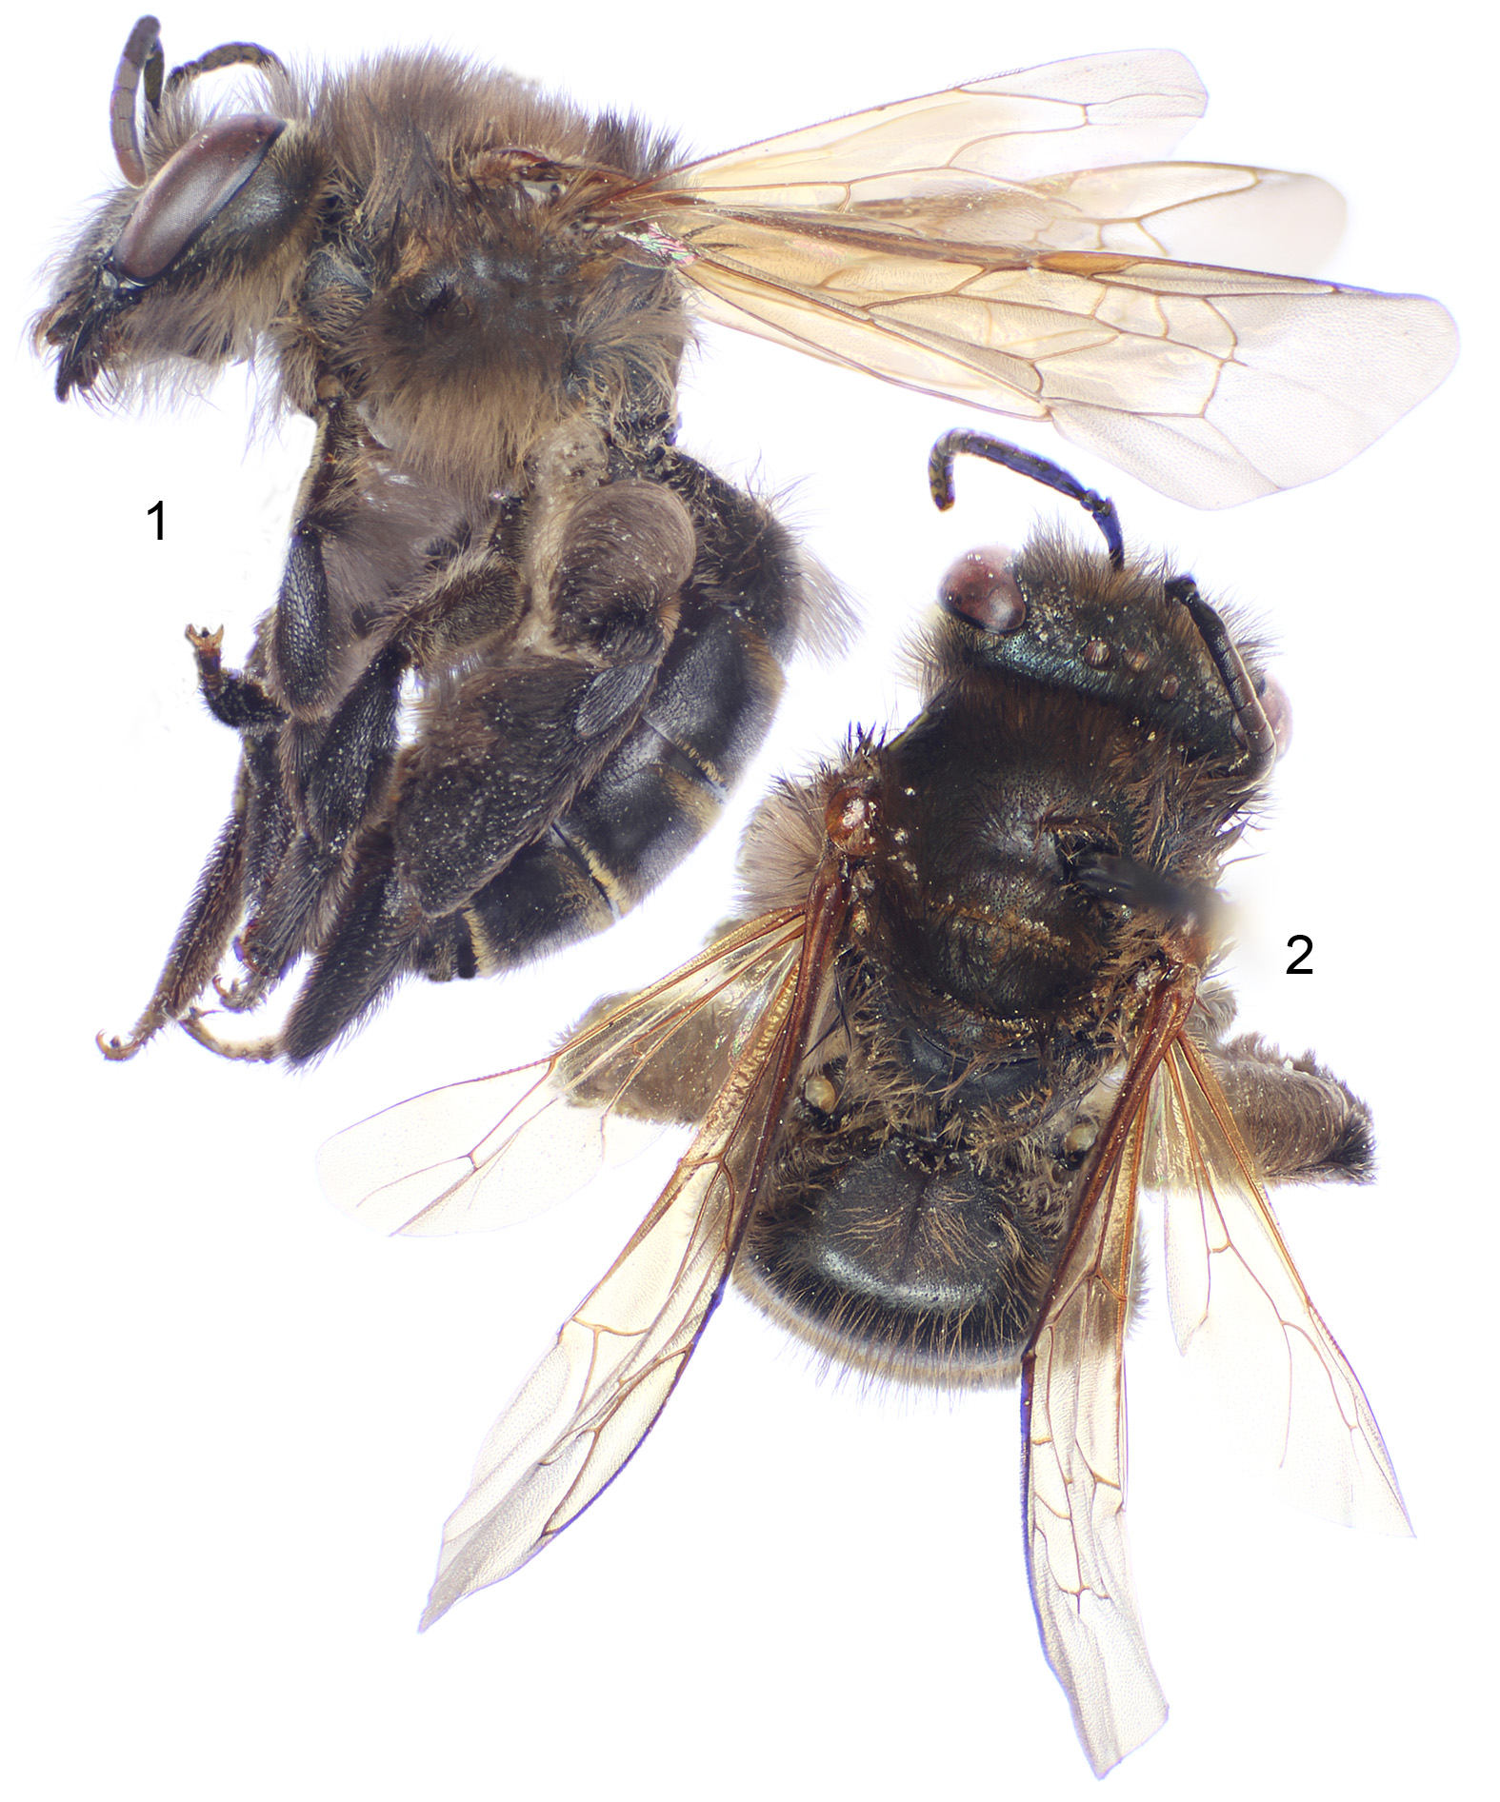

Figures 3‒5. Female holotype of Lonchopria (Biglossa) comforti, new species (except paratype in figure 4). 3. Lower three-quarters of head detailing clypeal structure and sculpturing. 4. Outer surface of mandible. 5. Full facial view.

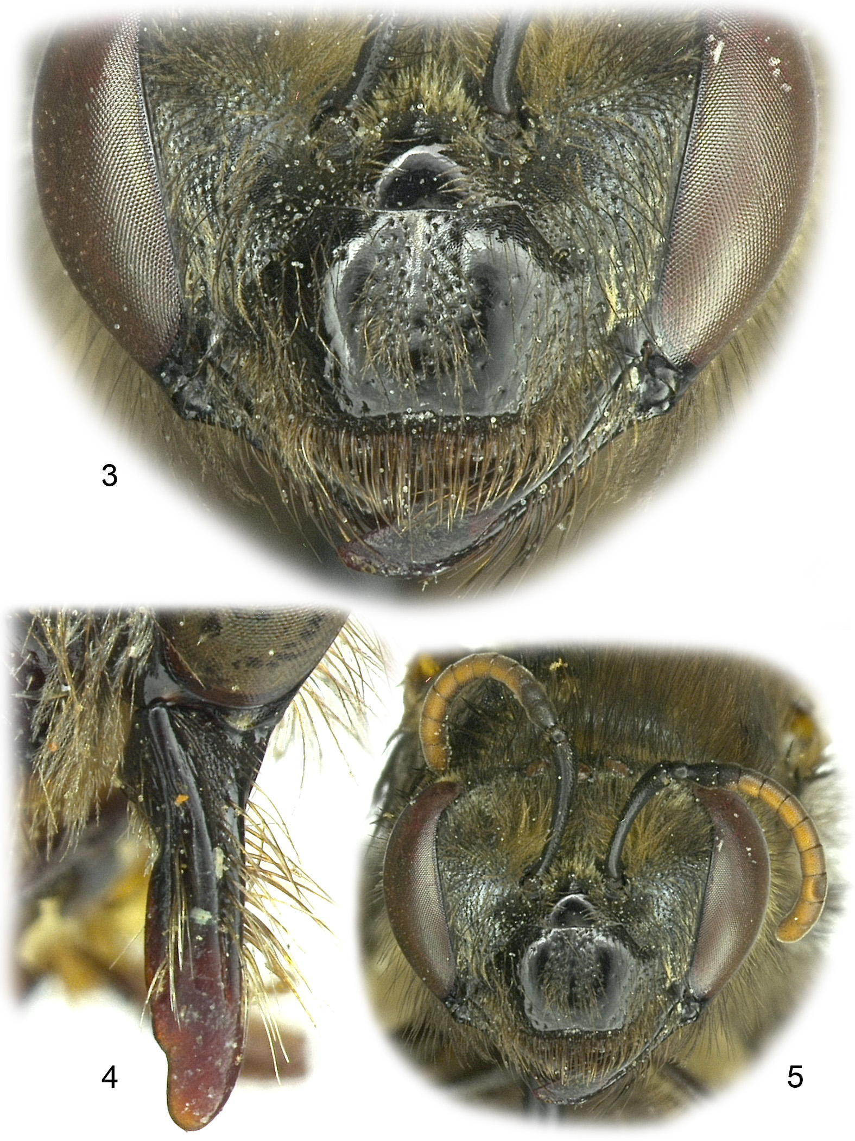

Figures 6‒8. Female holotype of Lonchopria (Biglossa) comforti, new species (except paratype in figure 6). 6. Left half of mesoscutum and mesoscutellum. 7. Metatibia and metabasitarsus. 8. Detail of metasomal terga.

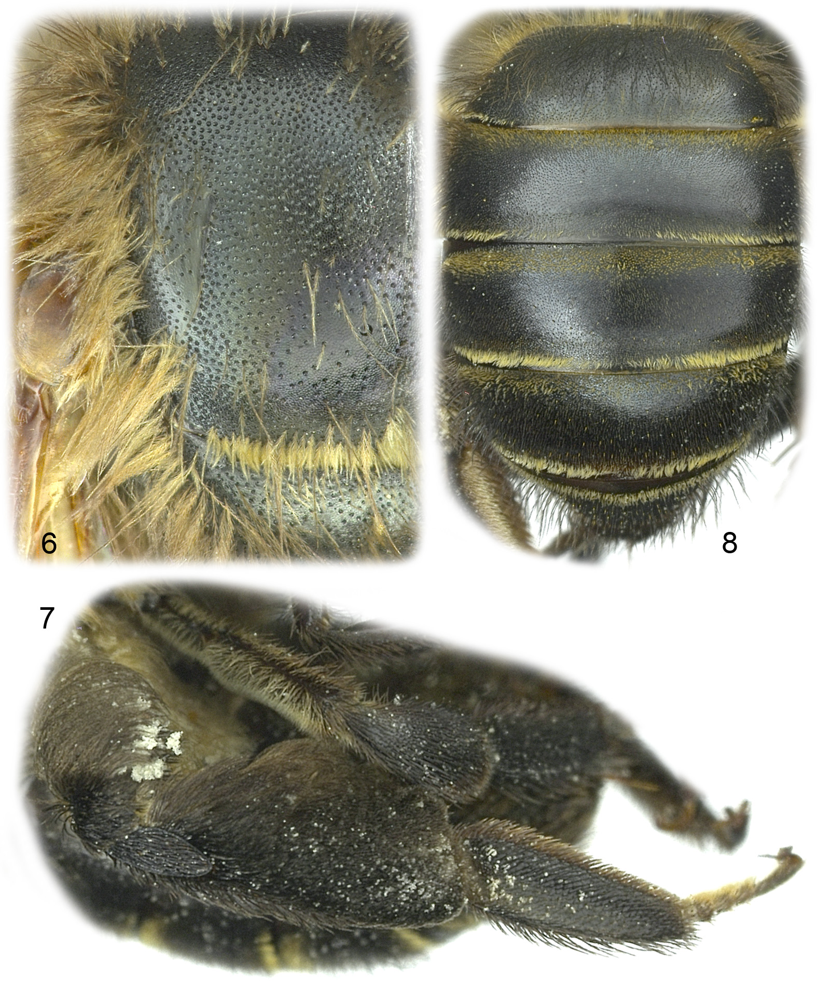

Figures 9‒11. Male paratype of Lonchopria (Biglossa) comforti, new species. 9. Lateral habitus. 10. Dorsal habitus. 11. Facial view.

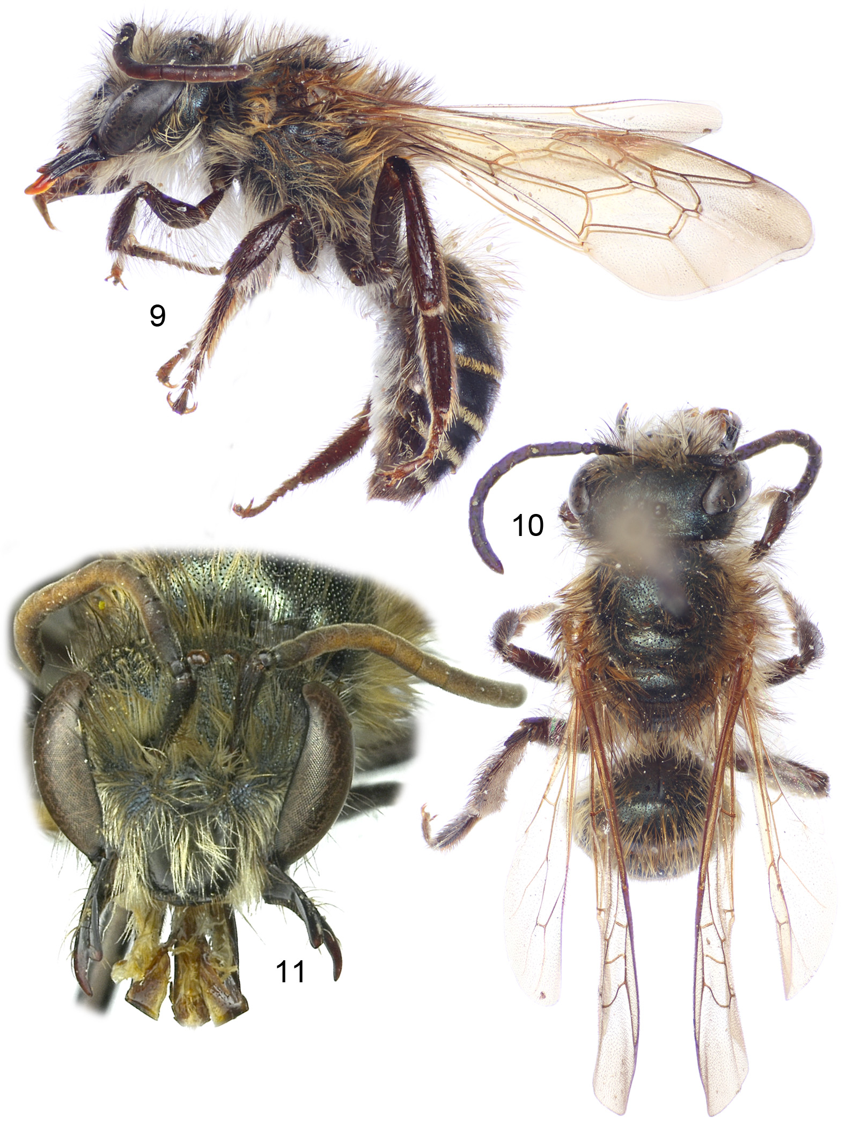

Figures 12‒18. Male paratype of Lonchopria (Biglossa) comforti, new species. 12. Outer surface of mandible. 13. Left half of metasomal sternum seven. 14. Right half of sternum eight. 15. Lateral view of sternum eight. 16. Genital capsule, ventral view. 17. Genitalia, lateral view. 18. Genitalia, dorsal view.

