Journal of Melittology

A review of the genera and subgenera of Oxaeinae (Hymenoptera: Andrenidae)

Michael S. Engel^{1,2}

¹ Division of Entomology, Natural History Museum, and Department of Ecology & Evolutionary Biology, 1501 Crestline Drive – Suite 140, University of Kansas, Lawrence, Kansas 66045, USA (msengel@ku.edu).
² Division of Invertebrate Zoology, American Museum of Natural History, Central Park West at 79th Street, New York, New York 10024-5192, USA.

Abstract. The supraspecific groups of the bee subfamily Oxaeinae are briefly reviewed and a revised classification proposed. The following new groups are established: Mesoxaea (Heteroxaea) Engel, new subgenus; Oxaea (Rhodoxaea) Engel, new subgenus; and Oxaea (Percnoxaea) Engel, new subgenus. A key to the genera and subgenera of Oxaeinae is provided.

INTRODUCTION

The subfamily Oxaeinae is perhaps one of the more distinctive groups of bees in Andrenidae, comprising 22 robust species distributed from the United States south to northern Argentina (Michener, 2007). The considerable differences between oxaeines and other andrenids have seemed at times so dramatic that some previous authors accorded them familial rank (e.g., Popov, 1941, 1945; Rozen, 1964, 1965, 1993; Hurd & Linsley, 1976), but their placement as nested within Andrenidae and even close to Panurginae is well established (e.g., Michener, 1944; Graf, 1966, 1972; Alexander & Michener, 1995; Engel, 2001). There is a general homogeneity to oxaeine species, yet where differences are present they are significant (e.g., structure of the genitalia, maxillary palpi, mandibles, pubescence). Hurd & Linsley (1976) classified the various species known at that time into four genera – Oxaea Klug, Protoxaea Cockerell & Porter, Notoxaea Hurd & Linsley, and Mesoxaea Hurd & Linsley. A fifth genus, Alloxaea Ascher, Engel, & Griswold, was recognized initially as a subgenus and for an Ecuadorian species that possessed derived features of Oxaea but retained maxillary palpi (Ascher et al., 2006). The North American fauna is comparatively well understood thanks to the monograph of Hurd & Linsley (1976), although much about the biology of these species remains to be studied in depth. By contrast, the South American fauna is in need of revision, although before such a work is undertaken further surveys are needed as the isolated collecting events at present highlight only how little is available for comprehensive studies. There are undoubtedly undescribed species awaiting further attention and the circumscriptions of even seemingly well-known taxa require testing, as well as the geographic distribution of those species. The discovery of Alloxaea, known still from only a single locality at the transition from the mesic Choco region and the xeric Tumbesian region, also emphasizes the need for field work throughout the Andean region so as to better document the occurrence of oxaeines.
Here is provided a brief overview of the suprageneric groupings within Oxaeinae so that these names may be made available for a forthcoming work on neotropical oxaeines. Diagnoses are modified from those of Hurd & Linsley (1976) and Michener (2007). Although purely descriptive, such descriptions provide the foundation for hypotheses of circumscription and patterns of evolution (Grimaldi & Engel, 2007), and allow for new revisionary works at the specific level (Gonzalez et al., 2013) along with the exploration of new character systems (Engel, 2011). Thus, it is hoped that the keys provided herein will aid future work on the evolutionary history and biology of these bees, particularly those species, or species complexes, within what is here considered Oxaea s.str. Table 1 summarizes the current classification of the subfamily.

MATERIAL AND METHODS

Specimens of all the groups considered herein were examined from the collections of the Division of Entomology, University of Kansas Natural History Museum and the Division of Invertebrate Zoology, American Museum of Natural History. Morphological terminology generally follows that used by Hurd & Linsley (1976), Engel (2001), and Michener (2007). Photographs used in the plates were prepared using a Canon EOS 7D digital camera affixed to an Infinity K-2 long-distance microscope lens, and were then arranged in Adobe Photoshop®.

SYSTEMATICS

Subfamily Oxaeinae Ashmead

Oxaeinae Ashmead, 1899: 70. Type genus: Oxaea Klug, 1807a.

Diagnosis: Moderately large (13–26 mm), robust, setose bees (Figs. 1–4, 7–10, 13–15, 18–21, 25, 26, 28–31, 34, 35). Head with clypeus protuberant; labrum as long as or longer than broad; lacinia composed of reduced sclerites hidden on inner side of stipes at base of galea; mentum and submentum fused into a single plate; basal labial palpomere flattened and elongate; malar area linear; facial foveae absent; ocelli low on face, near antennal toruli (Figs. 5, 6, 11, 12, 16, 17, 22, 23, 27, 32, 33, 36); orbits of compound eyes in males converging above (Figs. 5, 12, 17, 23, 27, 33); antennal toruli separated from epistomal sulcus by less than torular diameter; two subantennal sulci, outer sulcus arched; first flagellomere as long as or longer than scape (Figs. 5, 6, 11, 12, 16, 17, 22, 23, 27, 32, 33, 36); preepisternal sulcus absent below scrobal sulcus; forewing with pterostigma virtually absent; marginal cell narrow and elongate, longer than distance from apex to wing tip, apex bent away from margin and appendiculate (resembling to some degree a narrowly truncate marginal cell analogous to Panurginae) (Figs. 2, 4, 14, 21, 24, 31); three submarginal cells; distal portion of wing papillate; female metafemoral apex enlarged and flattened to form a plate associated with metabasitibial plate (Figs. 2, 8, 19, 34); scopa abundant from metacoxa to metabasitarsus; pretarsal claws cleft, arolia reduced; female pygidial plate present; male metasomal sterna VII and VIII with large discs; male genital capsule tapering basally, gonobase small; volsella elongate, digitus and cuspis fused; penis valve and aedeagus fused. A complete description of the subfamily is provided by Hurd & Linsley (1976).
Included genera: Oxaea Klug, 1807a; Protoxaea Cockerell & Porter, 1899; Mesoxaea Hurd & Linsley, 1976; Notoxaea Hurd & Linsley, 1976; and Alloxaea Ascher, Engel, & Griswold, 2006.

Genus Protoxaea Cockerell & Porter

Protoxaea Cockerell & Porter, 1899: 410. Type species: Megacilissa gloriosa Fox, 1893, by original designation.

Diagnosis: Male without pale maculations on clypeus, labrum, mandible, and antenna (Fig. 5); mandible simple apically; maxillary palpi present, composed of six palpomeres; metasomal terga brownish black or black, not partly or largely reddish (Figs. 1–4); metasomal tergum VI (male) and tergum V (female) without long, conspicuous tufts of white setae at sides; apical margin of male metasomal sternum VIII entire, convex, not emarginate medially; gonobase elongate, not ringlike, much longer than wide, tapering basally; gonostylus partially differentiated from gonocoxae, with setae apically; outer lateral apex of volsella with dorsal lobed extension, outer margin from narrow ventral apex to widest point apicad apodeme shallowly concave before mediolateral process, process not protrudent; penis valve not elongate, only slightly surpassing gonostylar apices, with prominent ventral subapical ridge with apicolateral setae, not extending to thin lateral process.
Included species: Protoxaea australis Hurd & Linsley, 1976; P. gloriosa (Fox, 1893); and P. micheneri Hurd & Linsley, 1976. A key to species was provided by Hurd & Linsley (1976).

Genus Mesoxaea Hurd & Linsley

Diagnosis: Male without pale maculations on clypeus, labrum, mandible, and antenna (Figs. 12, 17); mandible simple apically (Fig. 12); maxillary palpi present, composed of six palpomeres; metasomal terga brownish black or black, not partly or largely reddish (Figs. 7–10, 13–15); metasomal tergum VI (male) and tergum V (female) with long, conspicuous tufts of white setae at sides (Figs. 8, 10, 14); apical margin of male metasomal sternum VIII deeply emarginate medially; gonobase greatly reduced, ringlike, much wider than long, not tapering basally; gonostylus partially differentiated from gonocoxae, with setae apically; outer lateral apex of volsella with dorsal lobed extension, outer margin from narrow ventral apex to widest point apicad apodeme frequently deeply concave before mediolateral process, process frequently protrudent; penis valve not elongate, only slightly surpassing gonostylar apices, with prominent ventral subapical ridge with apicolateral setae, not extending to thin lateral process.

Subgenus Mesoxaea Hurd & Linsley

Mesoxaea Hurd & Linsley, 1976: 41. Type species: Oxaea nigerrima Friese, 1912, by original designation.

Diagnosis: Mesosomal dorsum of female with dark brown to black pubescence (Fig. 7); metafemoral scopa brown or reddish brown to black, or largely white; forewing darkly infuscate, at most nearly hyaline basally (Fig. 6).
Included species: Mesoxaea (Mesoxaea) arizonica (Cockerell, 1936); M. (M.) clypeata Hurd & Linsley, 1976; and M. (M.) nigerrima (Friese, 1912). A key to species was provided by Hurd & Linsley (1976).

Heteroxaea Engel, new subgenus

Type species: Mesoxaea rufescens Hurd & Linsley, 1976.
Diagnosis: Mesosomal dorsum of female with pale pubescence (Fig. 13); metafemoral scopa largely white (Fig. 14); forewing nearly hyaline in basal half to two thirds, apically darkly infuscate (Fig. 14).
Etymology: The new subgeneric name is a combination of heteros (Greek, meaning “different”) and Oxaea, type genus of the subfamily. The gender of the name is feminine.
Included species: Mesoxaea (Heteroxaea) rufescens Hurd & Linsley, 1976; M. (H.) tachytiformis (Cameron, 1901); M. (H.) texana (Friese, 1898); and M. (H.) vagans (Fox, 1893). Hurd & Linsley (1976) provide a key to the species as part of their key to all Mesoxaea s.l.

Genus Notoxaea Hurd & Linsley

Notoxaea Hurd & Linsley, 1976: 21. Type species: Oxaea ferruginea Friese, 1898, by original designation.

Diagnosis: Male with pale maculations on clypeus and mandible (Fig. 23); mandible with preapical tooth on inner margin; maxillary palpi present, composed of six palpomeres; metasomal terga I–III and sometimes IV at least partly or largely reddish (Figs. 18–21); metasomal tergum VI (male) and tergum V (female) with long, conspicuous tufts of white setae at sides; apical margin of male metasomal sternum VIII deeply emarginate medially; gonobase greatly reduced, ringlike, much wider than long, not tapering basally; gonostylus partially differentiated from gonocoxae, with setae apically; outer lateral apex of volsella without dorsal lobed extension, outer margin from narrow ventral apex to widest point apicad apodeme weakly concave before mediolateral process, process not protrudent; penis valve not elongate, only slightly surpassing gonostylar apices, with strong ventral subapical ridge extending to thin lateral process bearing setae.
Included species: Notoxaea ferruginea (Friese, 1898).

Penis valve with

Genus Alloxaea Ascher, Engel, & Griswold

Oxaea (Alloxaea) Ascher, Engel, & Griswold, 2006: 542. Type species: Oxaea (Alloxaea) brevipalpis Ascher, Engel, & Griswold, 2006, by original designation. Graf & Moure, 2007: 16 [elevated to generic rank].

Diagnosis: Male without pale maculations on clypeus, labrum, mandible, and antenna (Fig. 27); mandible simple apically (Fig. 27); maxillary palpi present, composed of three palpomeres; metasomal terga brownish black or black with faint metallic highlights, not partly reddish (Figs. 25, 26); metasomal tergum VI with long, conspicuous tufts of brown to yellow brown setae at sides; apical margin of male metasomal sternum VIII deeply emarginate medially; gonobase greatly reduced, ringlike, much wider than long, not tapering basally; gonostylus partially (albeit weakly) differentiated from gonocoxae, with setae apicolaterally; outer lateral apex of volsella without dorsal lobed extension, outer margin from broadly-rounded ventral apex to widest point apicad apodeme deeply concave before protrudent mediolateral process; penis valve not elongate, not surpassing gonostylar apices, without ventral subapical ridge or process. Female remains unknown.
Included species: Alloxaea brevipalpis (Ascher, Engel, & Griswold, 2006).

Genus Oxaea Klug

Diagnosis: Male often with pale maculations on clypeus, labrum, mandible, and basal antennal articles (Fig. 33); mandible simple apically (Fig. 36); maxillary palpi absent; metasomal terga brownish black, black (Figs. 28, 29, 34, 35), or partly or largely reddish; metasomal tergum VI (male) and tergum V (female) with long, conspicuous tufts of white or black setae at sides (Figs. 30, 31); apical margin of male metasomal sternum VIII deeply emarginate medially; gonobase greatly reduced, ringlike, much wider than long, not tapering basally; gonostylus not differentiated from gonocoxae, apex without setae; outer lateral apex of volsella without dorsal lobed extension, apex and outer margin variable; penis valve sometimes elongate, slightly to greatly surpassing gonostylar apices, without ventral subapical ridge or process.

Subgenus Oxaea Klug

Oxaea Klug, 1807a: 261. Type species: Oxaea flavescens Klug, 1807a, monobasic.
Dasyglossa Illiger in Klug, 1807b: 217 [no valid species included]. Klug, 1810: 44 [first included valid species]. Type species: Oxaea flavescens Klug, 1807a, by designation of Sandhouse, 1943: 544.

Diagnosis: Metasomal terga with bright metallic coloration, frequently as metallic green or bluish-green bands (Figs. 28–31, 35); male mandible without basal tooth (Fig. 36); outer lateral margin of volsella from narrow apex to widest point apicad apodeme straight, mediolateral angle not pronounced; penis valve elongate, slender, greatly surpassing gonostylar apices.
Included species: Oxaea (Oxaea) austera Gerstäcker, 1867; O. (O.) festiva Smith, 1854; O. (O.) flavescens Klug, 1807a; O. (O.) fuscescens Sichel, 1865; and O. (O.) stenocoryphe Moure, 1947.

Rhodoxaea Engel, new subgenus

Type species: Oxaea rufa Friese, 1899.
Diagnosis: Metasomal terga largely red. Male remains undescribed. This is an enigmatic oxaeine from Bahia and Pará in Brazil, and is in need of greater investigation.
Etymology: The new subgeneric name is a combination of rhodon (Greek, meaning “red”) and Oxaea, type genus of the subfamily. The gender of the name is feminine.
Included species: Oxaea (Rhodoxaea) rufa Friese, 1899.

Percnoxaea Engel, new subgenus

Type species: Oxaea schwarzi Moure & Seabra, 1962.
Diagnosis: Metasomal terga brownish black or black, at most weakly metallic, never bright metallic green; male mandible with basal tooth or at least basal high-arched ridge present; outer lateral margin of volsella from broadly-rounded apex to widest point apicad apodeme deeply concave before protrudent mediolateral process; penis valve not elongate, only slightly surpassing gonostylar apices.
Etymology: The new subgeneric name is a combination of perknos (Greek, meaning “dark-colored”) and Oxaea, type genus of the subfamily. The gender of the name is feminine.
Included species: Oxaea (Percnoxaea) alvarengai Moure & Urban, 1963; O. (P.) mourei Graf, 1992; O. (P.) schwarzi Moure & Seabra, 1962; and O. (P.) sooretama Graf & Urban, 2008. Graf & Urban (2008) provide a key to the species.

Practical Key to Genera and Subgenera of Oxaeinae
(modified from Hurd & Linsley, 1976)

1. Maxillary palpus present, with six or three palpomeres; male gonostylus partly differentiated from gonocoxa, sometimes only weakly so, and setose .............................. 2
—. Maxillary palpus absent; male gonostylus not recognizable, apex without setae (Oxaea Klug s.l.) ............................................................................................................................. 6
2(1). Maxillary palpus with six palpomeres; mesosomal dorsum with pubescence variously colored, but never as below ............................................................................................... 3
—. Maxillary palpus with three palpomeres; mesoscutum and mesoscutellum with strongly contrasting dark versus pale pubescence (Fig. 26) [Ecuador] .............................................. .................................................................................... Alloxaea Ascher, Engel, & Griswold
3(2). Mandible simple apically (e.g., Fig. 36); clypeus and mandible of male without pale maculations ........................................................................................................................ 4
—. Mandible with preapical tooth on inner margin; clypeus and mandible of male with pale maculations (Fig. 23) [Argentina, Paraguay, Brazil] ................. Notoxaea Hurd & Linsley
4(3). Metasomal sternum VIII of male emarginate medially on apical margin; tergum VI of male and tergum V of female with lateral tufts of long white setae (Mesoxaea Hurd & Linsley s.l.) ......................................................................................................................... 5
—. Metasomal sternum VIII of male with apical margin convex, not emarginate; tergum VI of male and tergum V of female without conspicuous lateral tufts of long white setae (Figs. 2, 4) [USA & Mexico] ............................................... Protoxaea Cockerell & Porter
5(4). Mesosomal dorsum of female with dark brown to black pubescence (Figs. 7, 8); male with forewing heavily infuscate throughout [USA & Mexico] ............................................ ........................................................................................... Mesoxaea Hurd & Linsley s.str.
—. Mesosomal dorsum of female with pale pubescence (Figs. 13, 14); male forewing hyaline clear in basal two-thirds, only infuscate in apical third [USA & Mexico] ........................... ........................................................................................................... Heteroxaea n. subgen.
6(1). Metasomal terga dark with weak or bright metallic coloration ......................................... 7
—. Metasomal terga largely red [Brazil] ................................................ Rhodoxaea n. subgen.
7(6). Metasomal terga with bright metallic coloration, frequently as metallic green or bluish-green bands (Figs. 28, 29, 35) [South America] ...................................... Oxaea Klug s.str.
—. Metasomal terga dark, at most weakly metallic, never bright metallic green [Brazil, Argentina] ........................................................................................ Percnoxaea n. subgen.

ACKNOWLEDGEMENTS

This work has been supported by U.S. National Science Foundation grant DBI-1057366. Production of photographs and their arrangement was supported by the Engel Illustration Fund of the University of Kansas College of Liberal Arts & Sciences, and by Laura C.V. Breitkreuz. This is a contribution of the Division of Entomology, University of Kansas Natural History Museum.

REFERENCES

Alexander, B.A., & C.D. Michener. 1995. Phylogenetic studies of the families of short-tongued bees (Hymenoptera: Apoidea). University of Kansas Science Bulletin 55(11): 377–424.
Ascher, J.S., M.S. Engel, & T.L. Griswold. 2006. A new subgenus and species of Oxaea from Ecuador (Hymenoptera: Andrenidae). Polskie Pismo Entomologiczne 75(4): 539–552.
Ashmead, W.H. 1899. Classification of the bees, or the superfamily Apoidea. Transactions of the American Entomological Society 26: 49–100.
Cameron, P. 1901. Description of a new genus and five new species of aculeate Hymenoptera from the Santa Fé Mountains, New Mexico. Transactions of the American Entomological Society 27: 311–316.
Cockerell, T.D.A. 1936. Records of western bees. American Museum Novitates 831: 1–6.
Cockerell, T.D.A., & W. Porter. 1899. Contributions from the New Mexico Biological Station. VII. Observations on bees, with descriptions of new genera and species. Annals and Magazine of Natural History, Series 7 4(24): 403–421.
Engel, M.S. 2001. A monograph of the Baltic amber bees and evolution of the Apoidea (Hymenoptera). Bulletin of the American Museum of Natural History 259: 1–192.
Engel, M.S. 2011. Systematic melittology: Where to from here? Systematic Entomology 36(1): 2–15.
Fox, W.J. 1893. Synopsis of the N. American species of Megacilissa. Psyche 6(203): 421–422.
Friese, H. 1898. Monographie der Bienengattungen Megacilissa, Caupolicana, Diphaglossa, und Oxaea. Annalen des kaiserlich-königlichen naturhistorischen Hofsmuseum, Wien 13(1): 59–86.
Friese, H. 1899. Monographie der Bienengattungen Megacilissa, Caupolicana, Diphaglossa, und Oxaea. Annalen des kaiserlich-königlichen naturhistorischen Hofsmuseum, Wien 14(3): 239–246.
Friese, H. 1912. Neue und wenig bekannte Bienenarten der neotropischen Region. Archiv für Naturgeschichte, Abtheilung A 78(6): 198–226.
Gerstäcker, C.E.A. 1867. Bericht über die wissenschaftlichen Leistungen im Gebiete der Entomologie während der Jahre 1865–66, zweite Hälfte: Hymenoptera. Archiv für Naturgeschichte 33: 305–345.
Gonzalez, V.H., T. Griswold, & M.S. Engel. 2013. Obtaining a better taxonomic understanding of native bees: Where do we start? Systematic Entomology 38(4): 645–653.
Graf, V. 1966. A posição systemática de Oxaeinae (Hymenoptera-Apoidea). Ciência e Cultura 18(2): 137–138.
Graf, V. 1972. Contribuição ao estudo da anatomia da cabeça dos Apoidea II — A musculatura do complexo lábio-maxilar. Boletim da Universidade Federal do Paraná, Zoologia 5(3): 139–173.
Graf, V. 1992. Uma nova espécie de Oxaea Klug (Oxaeinae, Andrenidae, Hymenoptera) do sul do Brasil. Revista Brasileira de Zoologia 9(1–2): 153–155.
Graf, V., & J.S. Moure. 2007. Oxaeini Ashmead, 1899. In: Moure, J.S., D. Urban, & G.A.R. Melo (Eds.), Catalogue of Bees (Hymenoptera, Apoidea) in the Neotropical Region: 16–19. Sociedade Brasileira de Entomologia; Curitiba, Brazil; xiv+1058 pp. [updated online at: http://www.moure.cria.org.br/catalogue; last accessed 10 March 2015].
Graf, V., & D. Urban. 2008. Uma espécie nova de Oxaea Klug (Hymenoptera, Apidae, Andreninae) do Espírito Santo, Brasil e notas complementares. Revista Brasileira de Entomologia 52(3): 407–410.
Grimaldi, D., & M.S. Engel. 2007. Why descriptive science still matters. BioScience 57(8): 646–647.
Hurd, P.D., Jr., & E.G. Linsley. 1976. The bee family Oxaeidae with a revision of the North American species (Hymenoptera: Apoidea). Smithsonian Contributions to Zoology 220: 1–75.
Klug, J.C.F. 1807a. Oxaea, eine neue Gattung aus der Ordnung der Piezaten. Gesellschaft Naturforschender Freunde zu Berlin, Magazin für neuesten Entdeckungen in der gesammten Naturkunde 1: 261–263.
Klug, J.C.F. 1807b. Kritische Revision der Bienengattungen in Fabricius neuem Piezatensysteme, mit Berüksichtigung der Kirbyschen Bienenfamilien und Illiger’s Monographie im fünften Bande des Magazins. Magazin für Insektenkunde 6: 200–228.
Klug, J.C.F. 1810. Einige neue Piezatengattungen. Gesellschaft Naturforschender Freunde zu Berlin, Magazin für neuesten Entdeckungen in der gesammten Naturkunde 4: 31–45, +1 pl.
Michener, C.D. 1944. Comparative external morphology, phylogeny, and a classification of the bees (Hymenoptera). Bulletin of the American Museum of Natural History 82(6): 151–326.
Michener, C.D. 2007. The Bees of the World [2nd Edition]. John Hopkins University Press; Baltimore, MD; xvi+[i]+953 pp., +20 pls.
Moure, J.S., & C.A.C. Seabra. 1962. A new species of the genus Oxaea from Brazil (Hymenoptera: Apidae). Journal of the New York Entomological Society 70(4): 235–238.
Moure, J.S. 1947. Notas sobre algunas abejas de la Provincia de Salta (Hymen. Apoidea). Revista de la Sociedad Entomológica Argentina 13: 218–253.
Moure, J.S., & D. Urban. 1963. Uma nova espécie de “Oxaea” de Mato Grosso, Brasil (Hymenoptera, Apoidea). Revista Brasileira de Biologia 23(4): 361–364.
Popov, V.V. 1941. Family Oxaeidae and processes of morphological reduction in bees (Hymenoptera, Apoidea). Comptes Rendus de l’Académie des Sciences de l’URSS [Doklady Akademii Nauk SSSR] 30(1): 82–85.
Popov, V.V. 1945. On the morphological reduction in the male genitalia of bees (Hymenoptera, Apoidea). Zoologichezkii Zhurnal 24(6): 329–336. [In Russian, with English summary]
Rozen, J.G., Jr. 1964. Phylogenetic-taxonomic significance of last instar of Protoxaea gloriosa Fox, with descriptions of first and last instars (Hymenoptera: Apoidea). Journal of the New York Entomological Society 72(4): 223–230.
Rozen, J.G., Jr. 1965. The biology and immature stages of Melitturga clavicornis (Latreille) and of Sphecodes albilabris (Kirby) and the recognition of the Oxaeidae at the family level (Hymenoptera, Apoidea). American Museum Novitates 2224: 1–18.
Rozen, J.G., Jr. 1993. Phylogenetic relationships of Euherbstia with other short-tongued bees (Hymenoptera: Apoidea). American Museum Novitates 3060: 1–17.
Sandhouse, G.A. 1943. The type species of the genera and subgenera of bees. Proceedings of the United States National Museum 92(3156): 519–619.
Sichel, J. 1865. Études hyménoptérologiques: Essai d’une monographie du genre Oxaea Klug. Annales de la Société Entomologique de France, Série 4 5: 331–334.
Smith, F. 1854. Catalogue of Hymenopterous Insects in the Collection of the British Museum, Part 2, Apidae. British Museum; London, UK; 199–465 pp., pls. vii–xii.

Table 1. Hierarchical classification of subfamily Oxaeinae (updated from Ascher et al., 2006).

Genus Protoxaea Cockerell & Porter
Protoxaea australis Hurd & Linsley
Protoxaea gloriosa (Fox)
Protoxaea micheneri Hurd & Linsley
Genus Mesoxaea Hurd & Linsley
Subgenus Mesoxaea Hurd & Linsley s.str.
Mesoxaea (Mesoxaea) arizonica (Cockerell)
Mesoxaea (Mesoxaea) clypeata Hurd & Linsley
Mesoxaea (Mesoxaea) nigerrima (Friese)
Subgenus Heteroxaea n. subgen.
Mesoxaea (Heteroxaea) rufescens Hurd & Linsley
Mesoxaea (Heteroxaea) tachytiformis (Cameron)
Mesoxaea (Heteroxaea) texana (Friese)
Mesoxaea (Heteroxaea) vagans (Fox)
Genus Notoxaea Hurd & Linsley
Notoxaea ferruginea (Friese)
Genus Alloxaea Ascher, Engel, & Griswold
Alloxaea brevipalpis (Ascher, Engel, & Griswold)
Genus Oxaea Klug
Subgenus Rhodoxaea n. subgen.
Oxaea (Rhodoxaea) rufa Friese
Subgenus Percnoxaea n. subgen.
Oxaea (Percnoxaea) alvarengai Moure & Urban
Oxaea (Percnoxaea) mourei Graf
Oxaea (Percnoxaea) schwarzi Moure & Seabra
Oxaea (Percnoxaea) sooretama Graf & Urban
Subgenus Oxaea Klug s.str.
Oxaea (Oxaea) austera Gerstaecker
Oxaea (Oxaea) festiva Smith
Oxaea (Oxaea) flavescens Klug
Oxaea (Oxaea) fuscescens Sichel
Oxaea (Oxaea) stenocoryphe Moure

Figures 1–6. Photographs of Protoxaea gloriosa (Fox). 1. Dorsal habitus of female. 2. Lateral habitus of female. 3. Dorsal habitus of male. 4. Lateral habitus of male. 5. Facial view of male. 6. Facial view of female.

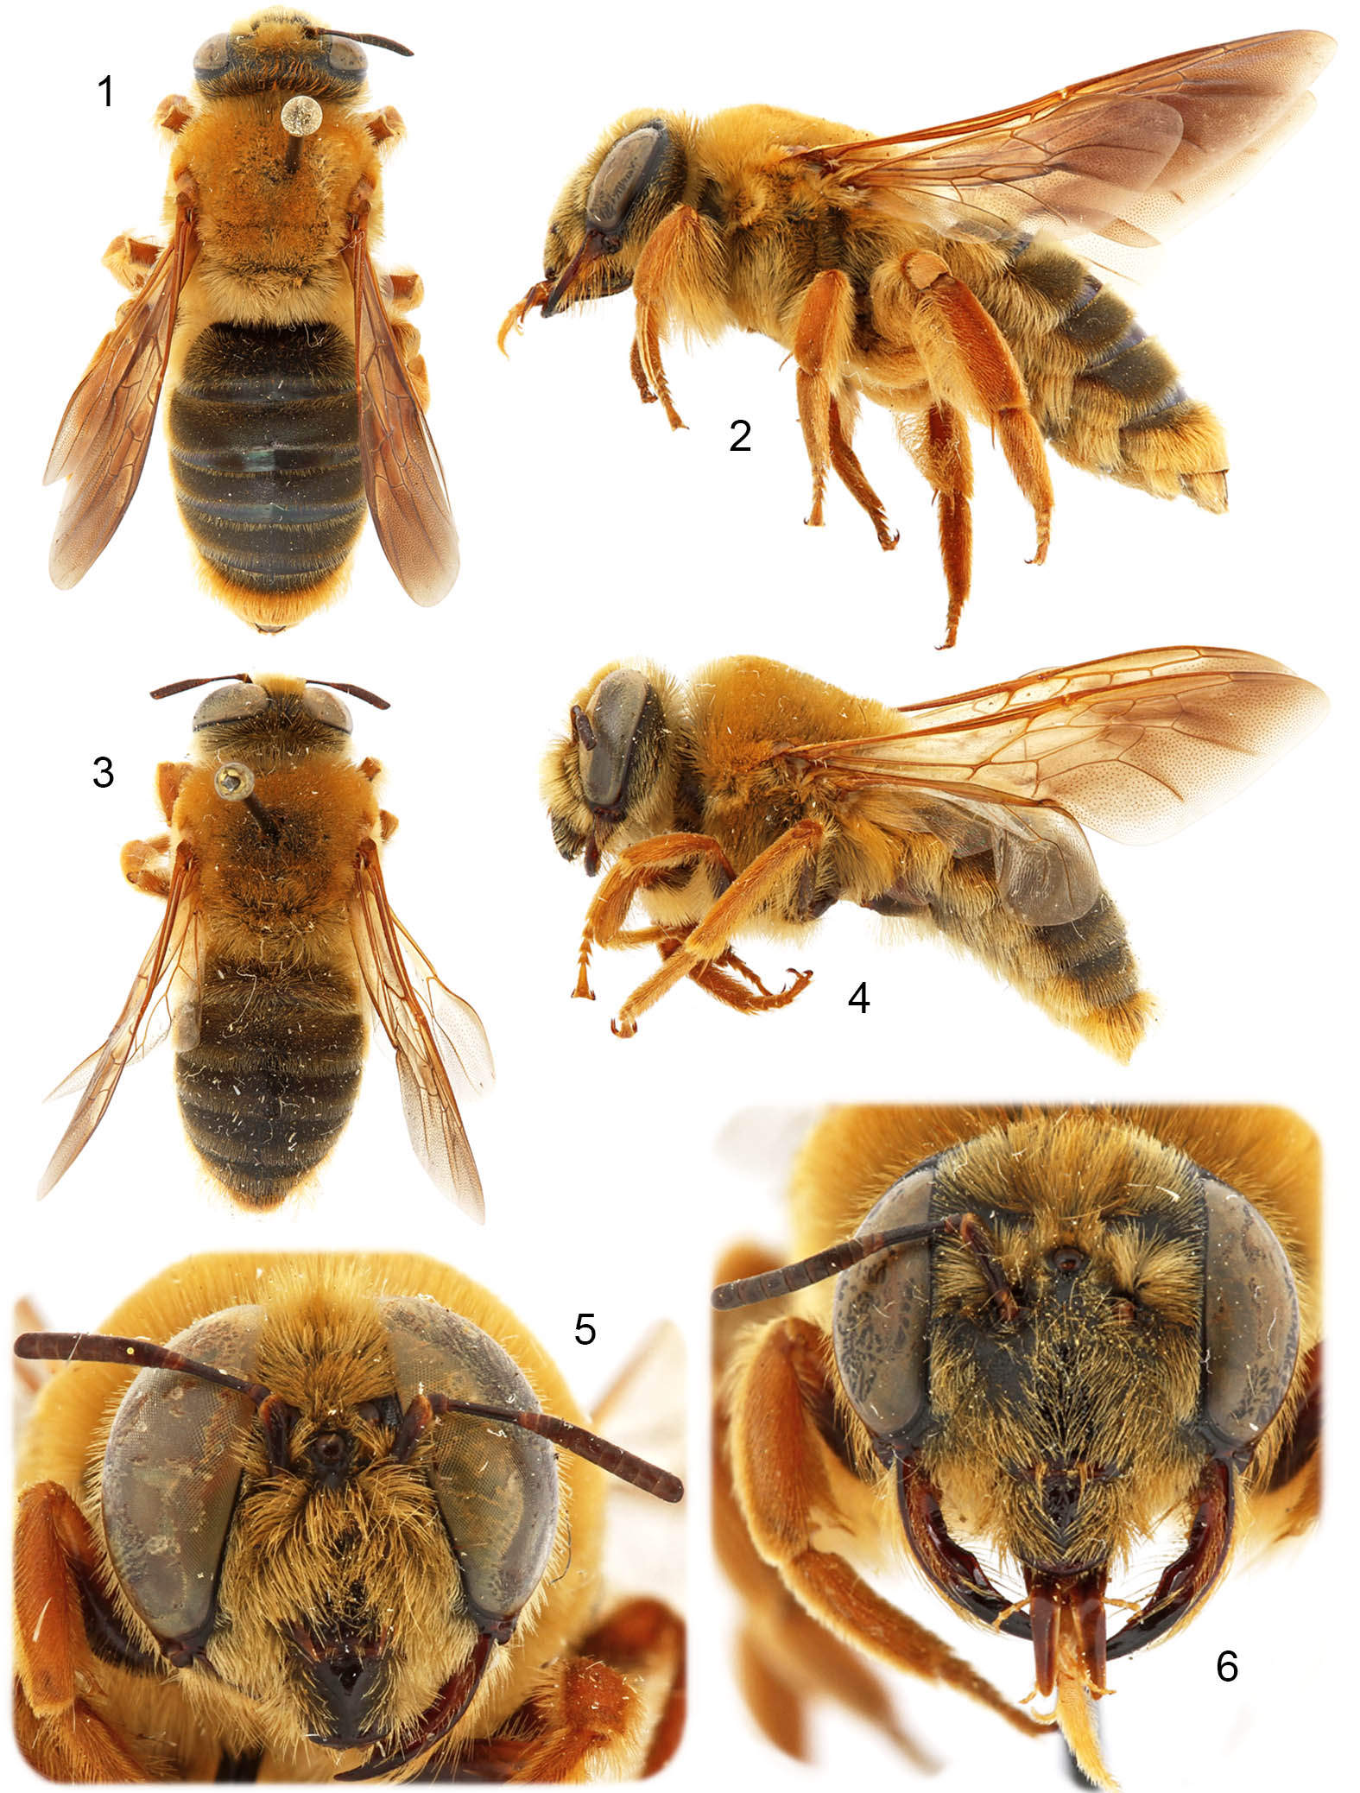

Figures 7–12. Photographs of Mesoxaea (Mesoxaea) nigerrima (Friese). 7. Dorsal habitus of female. 8. Lateral habitus of female. 9. Dorsal habitus of male. 10. Lateral habitus of male. 11. Facial view of female. 12. Facial view of male.

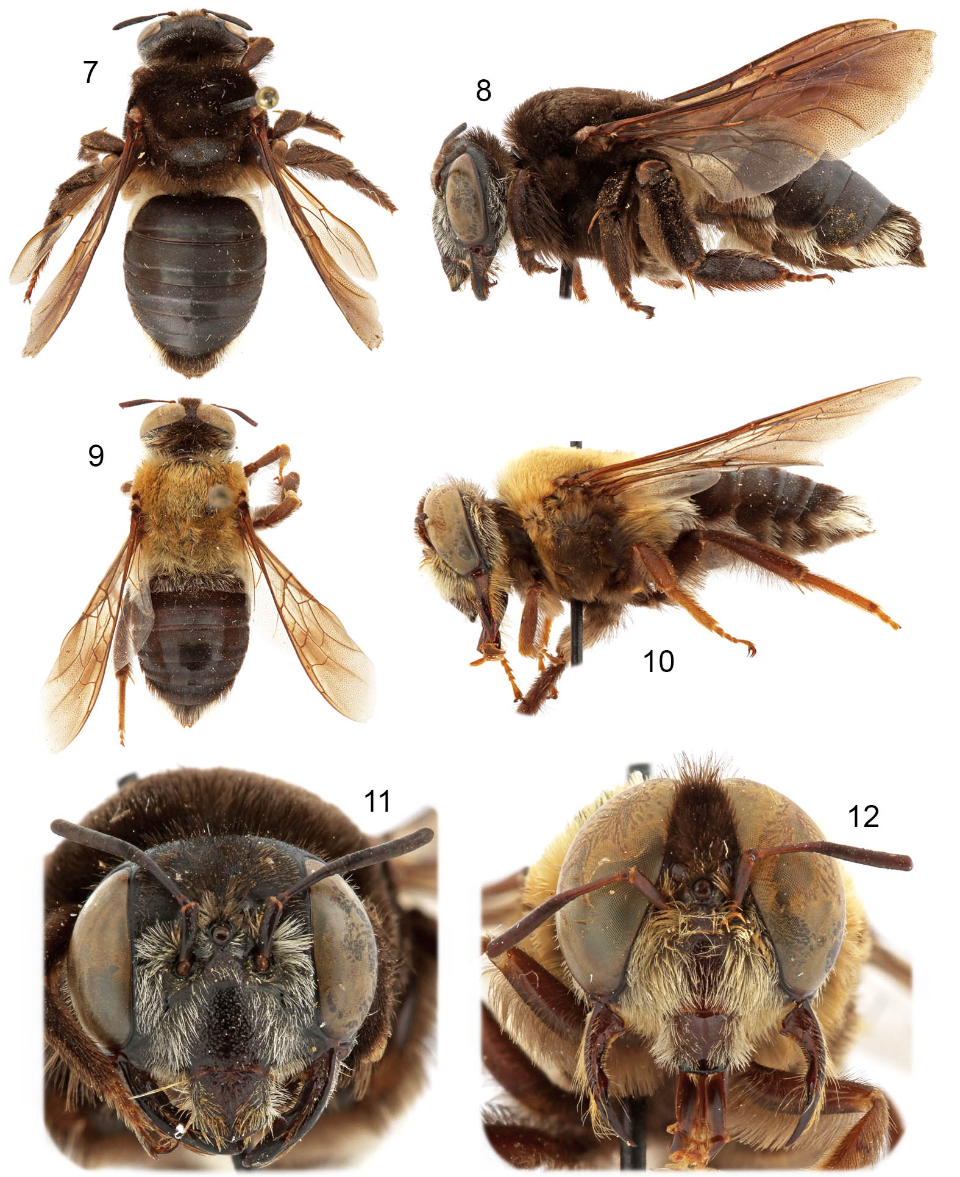

Figures 13–17. Photographs of Mesoxaea (Heteroxaea) rufescens Hurd & Linsley. 13. Dorsal habitus of female. 14. Lateral habitus of female. 15. Dorsal habitus of male. 16. Facial view of female. 17. Facial view of male.

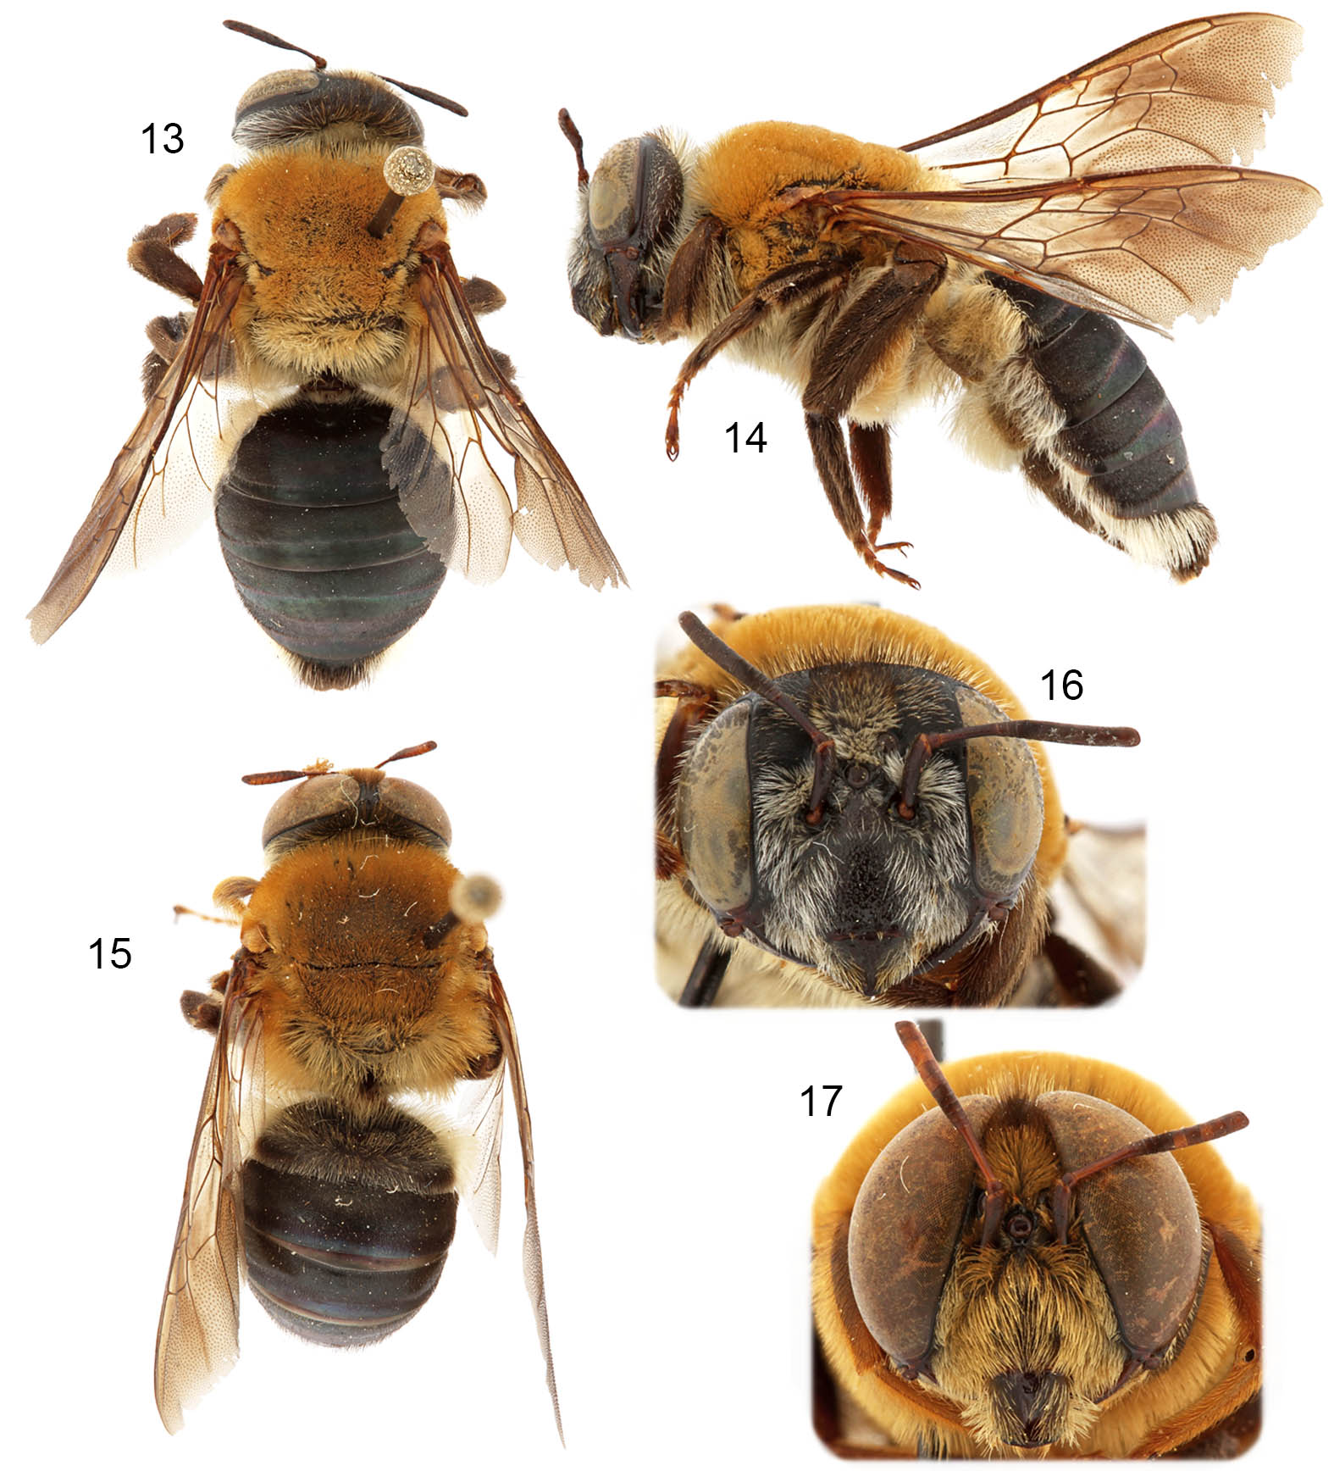

Figures 18–23. Photographs of Notoxaea ferruginea (Friese). 18. Dorsal habitus of female. 19. Lateral habitus of female. 20. Dorsal habitus of male. 21. Lateral habitus of male. 22. Facial view of female. 23. Facial view of male.

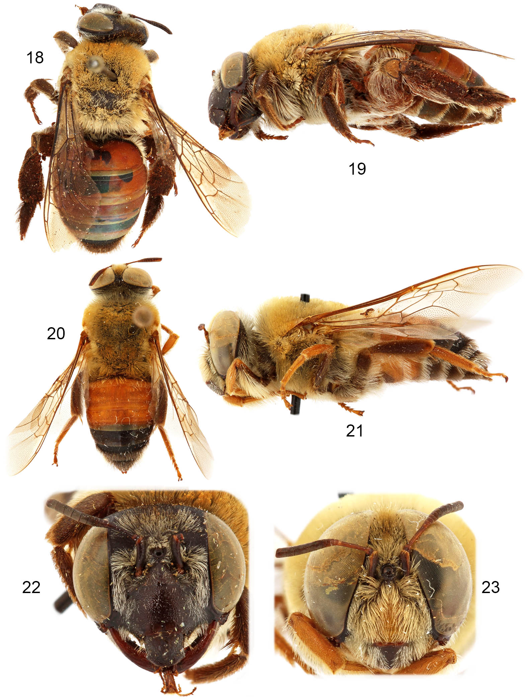

Figure 24. Photographs of wing venation of Notoxaea ferruginea (Friese).

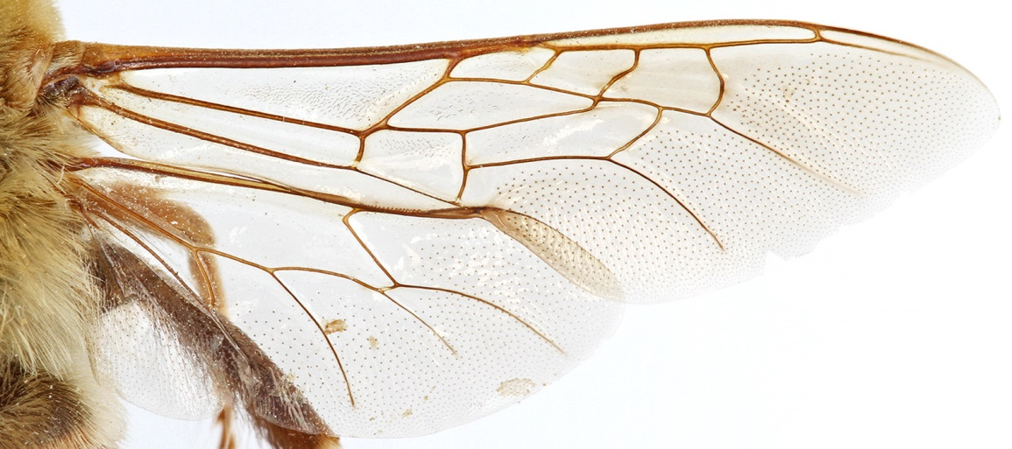

Figures 25–27. Photographs of male of Alloxaea brevipalpis (Ascher, Engel, & Griswold). 25. Lateral habitus. 26. Dorsal habitus. 27. Facial view.

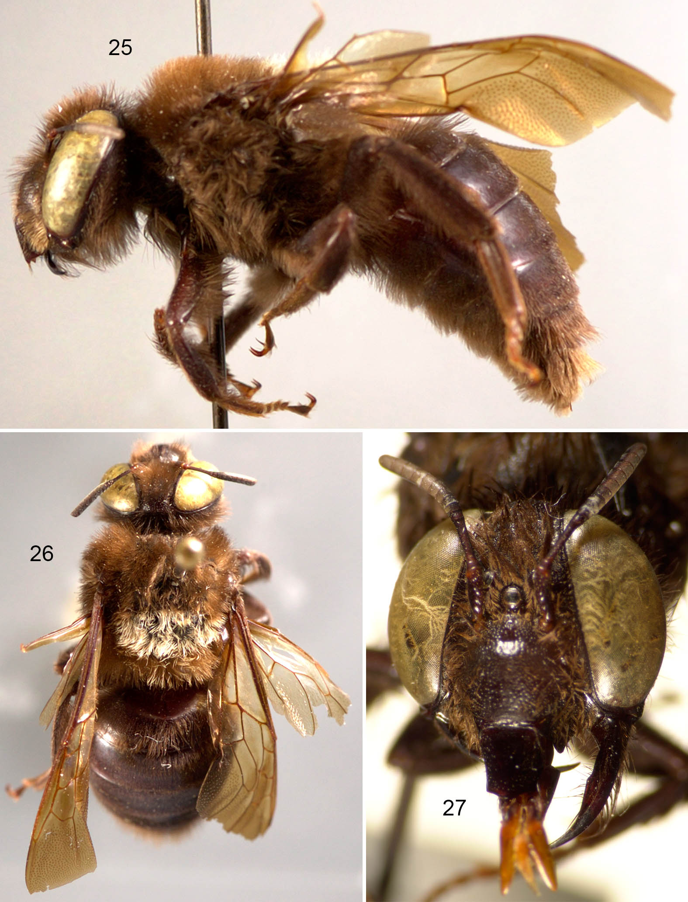

Figures 28–33. Photographs of Oxaea (Oxaea) flavescens Klug. 28. Dorsal habitus of female. 29. Dorsal habitus of male. 30. Lateral habitus of female. 31. Lateral habitus of male. 32. Facial view of female. 33. Facial view of male.

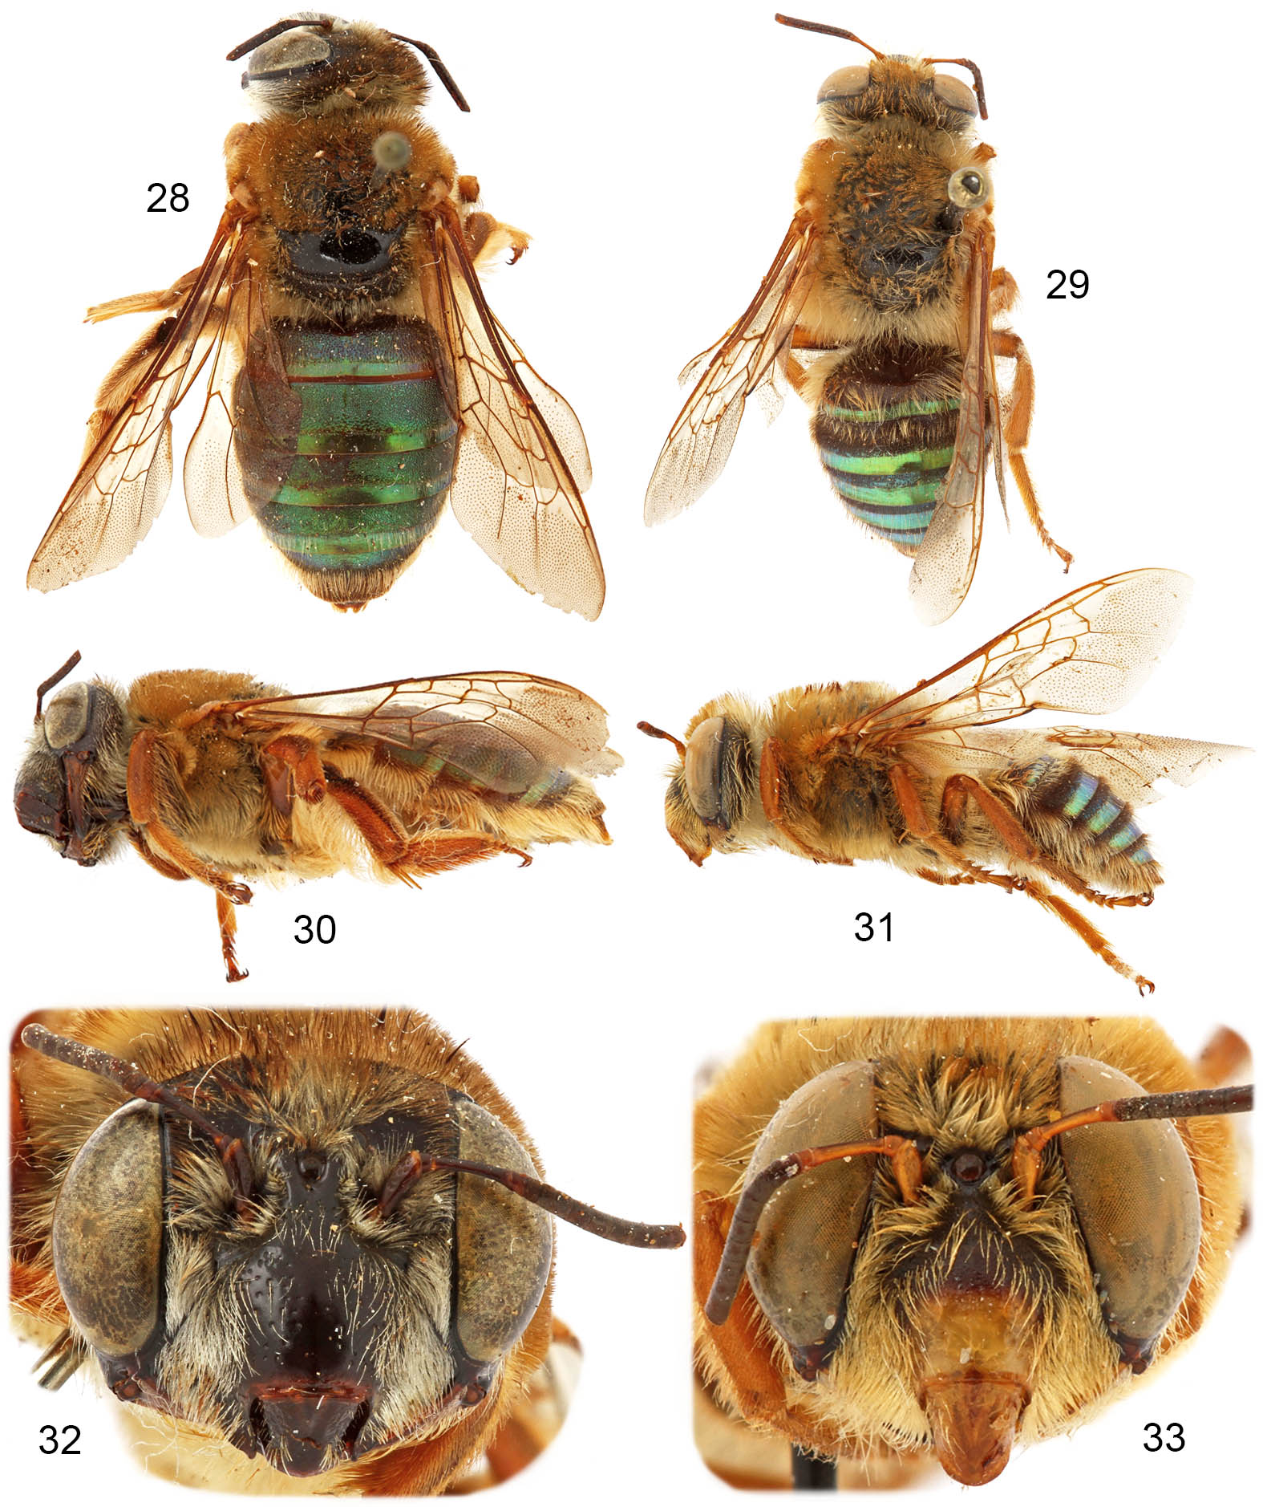

Figures 34–36. Photographs of female of Oxaea (Oxaea) stenocoryphe Moure. 34. Lateral habitus. 35. Dorsal habitus. 36. Facial view.

