Journal of Melittology

A new species of Mermiglossa from Kenya,
with comments on the arrangement of Old World Panurginae
(Hymenoptera: Andrenidae)

John S. Ascher¹ & Michael S. Engel²

¹ Department of Biological Sciences, National University of Singapore, 14 Science Drive 4, Singapore 117543 (dbsajs@nus.edu.sg).
² Division of Entomology, Natural History Museum, and Department of Ecology & Evolutionary Biology, 1501 Crestline Drive – Suite 140, University of Kansas, Lawrence, Kansas 66045-4415, USA (msengel@ku.edu).

Abstract. A new species of the panurgine bee genus Mermiglossa Friese (Panurginae) is described and figured from females captured near Voi in the southern part of the former Coast Province, Kenya, a historical type locality for several bee species. Mermiglossa voicola sp. n., is distinguished from the only other species of the genus, M. rufa Friese from central Namibia. The new species is readily identified due to its black rather than red metasoma and compound eyes slightly convergent above rather than parallel-sided. This extends the known distribution of the genus and its subtribe from the Namib Desert of southwestern Africa to East Africa and provides further evidence of extensive biogeographic connections between these. Recent changes in the family-group classification of Old World Panurginae are discussed in relation to recognition of Mermiglossina as a valid subtribe within an expanded tribe Panurgini also including the New World perditines.

INTRODUCTION

The Old World panurgine genera Mermiglossa Friese from Namibia and Plesiopanurgus Cameron from xeric regions of the Palearctic in Morocco and from eastern Turkey to western Pakistan, share several strong apomorphies including absence of facial foveae in females (Ruz, 1986; Patiny, 1999; Michener, 2007), and have been considered to be rare and enigmatic bees. The first to be discovered was Plesiopanurgus cinerarius Cameron in the deserts around Quetta, Balochistan in eastern Pakistan (Cameron, 1907). Its describer misinterpreted some of its remarkable apomorphies as plesiomorphic resulting in an inapt name. Soon after, Friese (1912) described Mermiglossa and its type species, Mermiglossa rufa Friese, from central Namibia. Mermiglossa remained obscure until it was redescribed by Eardley (1991), with photographs and illustrations of the male and female, in a review of the southern African Panurginae that also treated Melitturga Latreille and Meliturgula Friese.
Among African Panurginae, Mermiglossa can be recognized by the strong medial concavity of the clypeus in which the medial length of the clypeus is shorter than that of the medial length of the labrum, the absence of yellow maculations, the presence of only two submarginal cells in the forewing (as opposed to three in sympatric Melitturga and Meliturgula), and the structure of the first metasomal tergum and tergal graduli. The genus is closely related to Plesiopanurgus, the latter comprising four species with modified male antennae distributed in northern Africa from Morocco east to Pakistan (Baker, 1972, 1997). Keys to the genera of southern Africa Panurginae by Eardley (1991) and keys to tribe Melitturgini Michener (2007) will readily permit recognition of the genus. Unfortunately, little is known of the biology of Mermiglossa other than a published association with Merremia Dennst. ex Endl. (Convolvulaceae) (Eardley, 1991). Nest and immature stages remain unknown for Mermiglossa, as well as the related Plesiopanurgus.
Herein we provide the description of the first Mermiglossa discovered in Kenya, thereby extending the range of the genus from central Namibia to central East Africa. By documenting this species we hope to encourage melittologists in the region to seek these bees on their potential host plants (in family Convolvulaceae), so as to discover the unknown males, locate nests, and otherwise obtain information on their life history. In addition, we provide systematic details for the subtribe Mermiglossina and its constituent genera, and discuss briefly the classification of Old World panurgines.

MATERIAL AND METHODS

Morphological terminology follows that of Engel (2001) and Michener (2007). Measurements were made using an ocular micrometer on an Olympus SZX-12 stereomicroscope and are provided for the holotype, with those of the paratype in parentheticals. Photomicrographs were taken using a Canon 7D digital camera attached to an Infinity K-2 long-distance microscope lens. Material is deposited in the Department of Entomology, California Academy of Sciences, San Francisco, California, and the Division of Entomology, University of Kansas Natural History Museum, Lawrence, Kansas.

SYSTEMATICS

Tribe Panurgini Leach

Subtribe Mermiglossina Patiny

Mermiglossini Patiny, 1999a: 270. Type genus: Mermiglossa Friese, 1912.

Diagnosis: Yellow integumental markings absent. Labial palpomere III about twice as long as IV; mentum elongate, about one-third length of prementum; galeal comb absent. Facial fovea of female absent; clypeus short, strongly concave apically. Labrum of male flat, fully pilose, setae long; of female with basal area glabrous. Mandible of male strongly curved, apex attenuate, equipped with strong prebasal tooth on upper margin. Outer subantennal sulcus of male indistinct, represented by a shiny impunctate strip. Forewing with 1rs-m absent. Pretarsal claws of female simple. Metasoma of male wider than mesosoma; metasomal sternum VII with elongate setae arising from medial projection of apicolateral lobes; sternum VIII with broad proximal truncate or emarginate spiculum, widening distally towards lateral arms of sternum.
Included genera: The subtribe includes only Mermiglossa and Plesiopanurgus. Ruz (1986) redescribed and illustrated both genera and demonstrated many synapomorphies uniting them.
Distribution: Six species occur in deserts in central Namibia, coastal Kenya, North Africa (Morocco), and the Middle and Near East.
Life history: Where known, host plants are all in the family Convolvulaceae.

Key to Genera of Mermiglossina

1. Pronotum without strong dorsolateral lamella or protuberance; antenna of male unmodified (male known only for type species) (Namibia, Kenya) ......................... ................................................................................................... Mermiglossa Friese
—. Pronotum with strong dorsolateral lamella or protuberance; scape and flagellum of male thickened; last flagellomere tapered at apex (Palearctic including North Africa) ...............................…………………………...... Plesiopanurgus Cameron

Genus Plesiopanurgus Cameron

Plesiopanurgus Cameron, 1907: 130. Type species: Plesiopanurgus cinerarius Cameron, 1907, monobasic.
Neopanurgus Schwammberger, 1971: 2. Type species: Neopanurgus richteri Schwammberger, 1971, by original designation.
Plesiopanurgus (Zizopanurgus) Patiny & Rasmont, 1999: 78. Type species: Panurgus (Plesiopanurgus) zizus Warncke, 1985 [1987], by original designation.

Diagnosis: Clypeus strongly protuberant; scape and flagellum of male thickened; distal flagellomere strongly tapered at apex. Pronotum with strong dorsolateral lamella or protuberance. Mesobasitarsus of male longer than metabasitarsus; mesobasitarsus with a patch of small, dense setae apically on inner surface. Pubescence of male elongate, profuse. Metasomal sternum IV of male with distal margin convex, pectinate medially; apical process of sternum VIII with elongate apicolateral projections, base of apical process laterally expanded; base of sternum VIII emarginate.
Distribution: Four species are known from deserts of North Africa (Morocco) and the Near East (eastern Turkey, Iran, Balochistan in northwestern Pakistan). The more western species from Morocco (P. zizus Warncke) and Turkey (P. ibex Baker) were placed in Zizopanurgus by Patiny & Rasmont (1999).
Life history: Species of Plesiopanurgus are known or suspected to be oligoleges of Convolvulus L. (Convolvulaceae) and have been collected during April–June (Patiny, 1998a; vide etiam Warncke, 1985 [1987]; Baker, 1997; Patiny & Rasmont, 1999).
Comments: Both Baker (1997: who apparently failed to consider Warncke, 1985 [1987]), Patiny (1998a), and Patiny & Rasmont (1999) disputed Warncke’s (1983 [1985]) conclusion that P. ibex and P. richteri Schwammberger are subspecies of P. cinerarius. Patiny (1998c) recognized P. hanno Baker, from Morocco as a junior synonym of P. zizus.

Genus Mermiglossa Friese

Mermiglossa Friese, 1912: 188. Type species: Mermiglossa rufa Friese, 1912, monobasic.

Diagnosis: Head conspicuously broader than mesosoma. Glossa extraordinarily elongate, approximately three times as long as prementum; maxillary palpus pentamerous. Metasomal tergum I with dorsal and anterior surfaces nearly right angulate, of male strongly concave anteriorly; terga II and III with gradulus conspicuous, strongly carinate laterally; sterna I–V of female with setae mostly appressed; sternum VII with basal apodemal arms broadly fused to quadrate central disc of sternum.
Distribution: The single described species is endemic to central Namibia (Eardley, 1991), whereas the second species described here is from coastal Kenya.

Mermiglossa voicola, new species
(Figs. 1–6)

Diagnosis: The new species can be distinguished from its congener by the overall black to dark brown coloration of the metasoma (versus largely orange to reddish orange in M. rufa) and the compound eyes slightly convergent below (parallel-sided in M. rufa).
Description: ♀: Total body length 7.75 mm (7.58 mm); forewing length 5.08 mm (5.00 mm). Head wider than long, length 2.17 mm (2.04 mm), width 2.71 mm (2.71 mm), about as wide as, or slightly wider than, mesosoma; upper interorbital distance 1.83 mm (1.79 mm); lower interorbital distance 1.46 mm (1.42 mm). Clypeus strongly concave medioventrally; clypeal medial length 0.50 mm (0.50 mm); labral medial length 0.56 mm (0.52 mm). Mandible long, gently curved, without apical teeth, with small, obtuse, indistinct tooth near base of inner surface. Galea and glossa elongate, extending to metacoxae. Occipital carina present. Medial and parapsidal lines distinct, strongly impressed; intertegular distance 1.88 mm (1.88 mm). Forewing with marginal cell broadly truncate and appendiculate; with two submarginal cells of approximately equal lengths; nine distal hamuli on hind wing. Anterior-facing and dorsal surfaces of first metasomal tergum nearly orthogonal in profile; lateral portions of graduli particularly pronounced, particularly on second through fourth terga.
Clypeus with coarse, shallow punctures, punctures separated by less than a puncture width, although more widely spaced medioapically, integument between smooth; labrum largely impunctate, a few scattered setigerous punctures in lateral quarters, wrinkled basally, medially and apically smooth, medioapically with distinct, semi-circular carina, carina with lateral portions curving back onto labral surface but ending shortly thereafter. Face with contiguous punctures; medial line terminating in impunctate spot at about lower tangent of antennal toruli; vertex with punctures becoming more indistinct and irregular, blending to shallow, larger, faint indications of coarse punctures by occipital region and gena; postgena impunctate and imbricate. Mesoscutum and mesoscutellum with distinct punctures separated by less than a puncture width, integument between smooth; metanotum with coarse, irregular, contiguous punctures; pleura with large, coarse, irregular, contiguous punctures, giving integument a roughened appearance, except metepisternum imbricate with close smaller punctures; propodeum basally as on metanotum, lateral surface as on metepisternum, posterior surface as on lateral surface except medially around pit becoming smooth. Metasoma imbricate; anterior-facing surface of first tergum impunctate, dorsal surface with punctures separated by a puncture width or less; punctures of remaining terga contiguous or nearly so; broad brown marginal zones impunctate.
Integument of head, mesosoma, and metasoma largely black to dark brown; antenna, mandible, and labiomaxillary complex dark brown; tegula and legs dark brown; wing venation brown except Sc+R and pterostigmal margins dark brown, membrane hyaline; metasomal terga with broad dark brown margins. Pygidial plate black, with acutely rounded apex.
Pubescence typical for genus; generally white to silvery except somewhat tawny on labral apex, apical half of ventral margin of mandible, margins of basitarsi, apexes of tibiae, and apex of metafemur (overhanging base of basimetatibial plate); pygidial fimbria and apical fimbria of fifth tergum rufous and composed of dense, plumose setae.
♂: Unknown.
Holotype: ♀; Kenya: [Taita-Taveta County], Coast Province [former], 2 km S. Voi, 3°24.7’S, 38°32.3’E, 16 December 2002, M.A. Prentice; deposited in the Department of Entomology, California Academy of Sciences, San Francisco, California, USA.
Paratype: 1♀; same data as holotype; deposited in the Division of Entomology, University of Kansas Natural History Museum, Lawrence, Kansas, USA.
Etymology: The specific epithet pertains to Voi, the largest town in Taiti-Taveta County of the former Coast Province.

Key to Species of Mermiglossa
(females only)

1. Metasomal terga largely orange to reddish orange; inner margins of compound eyes parallel (central Namibia) ......................................................... M. rufa Friese
— Metasoma terga entirely black to dark brown; inner margins of compound eyes slightly convergent ventrally (southern Kenya) ............................ M. voicola sp. n.

DISCUSSION

The new Mermiglossa is one of several bee species recently described from Kenya that further document its richness in bees, delimit endemic areas for these, and establish biogeographic connections between East and southwestern Africa. The total of described bee species from Kenya now stands at 344 (Eardley & Urban, 2010; Ascher & Pickering, 2017), and almost identical to totals for Tanzania (350, including records from Zanzibar), but far higher than totals for the neighboring countries of Uganda (only 210 species reliably recorded; much higher reported totals are unreliable), Ethiopia (approximately 200 species; the precise total is uncertain as some historical records may pertain to modern Eritrea), Sudan (141 species, most that can be traced precisely are from North Sudan), or Somalia (69 species). Although totals of described bee species for Kenya (and Tanzania) are impressive as compared with those of other East and West African countries and those of the Sahel, they are far lower than the 1152 species recorded from South Africa, an area of exceptional bee diversity and home to the region’s leading taxonomic specialist.
The type locality of the new Mermiglossa is from Voi, from which other interesting bee species have been described recently; i.e., Lipotriches (Armatriches) voiensis Pauly, Hylaeus (Deranchylaeus) venustus Dathe, and Cellariella inexpectata Pesenko & Pauly (Pesenko & Pauly, 2005; Pauly, 2014; Dathe, 2014); and historically, e.g., Megachile (Pseudomegachile) voiensis Cockerell (Cockerell, 1937). In all, at least six valid bee species (including the new species) and three additional names now in synonymy have been described from Voi or its immediate vicinity, and at least two additional valid and five invalid names were described from Taita-Taveta County [the type locality of Coelioxys lepidospila Cockerell, cited by its author as “Kenya Colony: Luni (sic) River, Taveta” (Cockerell, 1933), is from the Lumi River]. In all, the new Mermiglossa brings the total number of currently valid bee species described from Kenya to 109, and 63 additional names now in synonymy have also been described from the country, making it an important and ongoing center of species discovery. In addition to the described fauna, many undescribed species have recently been discovered in Kenya (pers. obs.), some of which have been photographed in life (e.g., Martins, 2012), or are represented in the BOLD systems molecular diagnostic and image database (L. Packer, pers. comm.). Ongoing studies are also advancing knowledge of pollinator diversity, function, and conservation in Kenya and disseminating practical information to the public (Martins, 2014).
Mermiglossa, a genus previously thought strictly endemic to the Namib desert, is now known to extend to East Africa. Other recently described bees have strengthened this biogeographic connection, such as Samba (Samba) ascheri Michez & Patiny and S. (S.) turkana Packer, Kenyan species belonging to a group best known from xeric areas of southwestern Africa (Michez et al., 2010; Packer & Martins, 2015). Most species of another primarily southern African group, the Scraptrini (genus Scrapter Lepeletier de Saint Fargeau & Audinet-Serville), are known from South Africa (39 of 42 species; the other three are Namibian endemics), but remarkably one of these, Scrapter nitidus (Friese), extends to Kenya. Distributions of bee taxa that span Kenya and southern Africa are now increasingly well known, through ongoing revisionary studies including description of species such as the Kenyan Systropha (Austrosystropha) oti Patiny, Baldock, & Michez (Patiny et al., 2013). It is now clear that what might be assumed to be quite distinct bee faunas, those of East Africa and southwestern Africa, actually share a large number of genera and even species. Remarkably, no fewer than 82 species are shared between Namibia and Kenya.

Comments on the Classification of Old World Panurginae

The Old World Panurginae include genera with two submarginal cells; i.e., Panurgus Panzer, Panurginus Nylander, Camptopoeum Spinola; which have been traditionally placed in tribe Panurgini, and also Melitturga with three submarginal cells, which has been placed in a separate tribe Melitturgini along with Meliturgula, and which is best known from Africa. Of these “Old World” panurgine genera, only Panurginus also occurs in the New World. Warncke (1972, 1983, 1985) described additional subspecies, species, and subgenera thereby expanding the known diversity of Old World panurgines, but this was somewhat obscured by the low ranks he gave to his new taxa. Patiny (1999a, 1999b) elevated most of Warncke’s taxa in rank, treating the latter’s subspecies as species and his subgenera as genera. Patiny also described many species as new, the genera Gasparinhala Patiny and Borgatomelissa Patiny (the latter of which had been labeled in collections previously as a new genus by the late D.B. Baker), and additional subgenera of Panurgus (e.g., Patiny, 1998b, 1999c, 2000, 2001), He also partitioned the traditional Panurgini and Melitturgini into multiple tribes to accommodate these new taxa and bring the system into accordance with his own phylogenetic results which contradicted the traditional two-tribe system (Table 1). Four of Patiny’s tribes were established as new at that time: Paramelitturgini, Camptopoeumini (sic), Mermiglossini, and Panurginini. The name Paramelitturgini was unavailable since it was not based on an available genus-group name, so Engel (2001) proposed the name Meliturgulini for this group. Engel placed Patiny's Mermiglossini in synonymy with Melitturgini and the other tribes in synonymy with Panurginini, an arrangement followed by Michener (2007), who maintained the traditional two-tribe system (Michener, 2007; vide Table 1), but noted that the phylogenetic position of the sister genera Mermiglossa and Plesiopanurgus, i.e. of the Mermiglossina, was uncertain and that, “Recognition of subtribes may be appropriate.”
Ascher (2004) found Patiny’s tribes to be useful taxa but did not endorse his conclusions about their phylogenetic relationships due in part to problematic character coding, weighting, and choice of outgroups. He therefore reduced them in rank to subtribes within an expanded tribe Panurgini, also including the new world perditines (Perdita Smith and Macrotera Smith) as a subtribe. This revised classification, outlined here, was based on lack of substantial evidence for reciprocal monophyly of the two traditional tribes and strong evidence from the nuclear gene EF-1α that Perdita s.l., traditionally classified as tribe Perditini and thought to be closely related to the New World Calliopsini (Ruz, 1986, 1991), was instead sister to the Old World genus Panurgus Panzer. Thus, perditines are a New World member of this assemblage, with calliopsines comprising the sister group of all other panurgines excepting Nolanomelissa Rozen (Ascher, 2003). This novel placement for perditines results in a revised interpretation of biogeographic affinities for the largest single diversification known among bees. Classification of Perditina as a subtribe of Panurgini has not been fully documented, but does appear in some published works (e.g., Scott et al., 2011), and is consistent with subsequent phylogenetic results (Hedtke et al., 2013; Ramos, 2011).
Although the family-group taxa now recognized for Old World Panurginae (Table 1) are believed to be monophyletic if the well-known genera are considered, the placement of Avpanurgus Warncke and Simpanurgus Warncke remains somewhat uncertain due to inadequate material available for study. In addition, more work is needed to resolve phylogenetic relationships among the constituent lineages of Panurgini.

ACKNOWLEDGEMENTS

Partial support was provided by a startup grant from the National University of Singapore, Department of Biological Science (to J.S.A.); and earlier on by U.S. National Science Foundation grants EF-0341724 and DBI-1057366 (to M.S.E.), a Guggenheim Fellowship from the John Simon Guggenheim Memorial Foundation (to M.S.E.), and R.G. Goelet, chairman emeritus of the American Museum of Natural History Board of Trustees. This is a contribution of the Division of Entomology, University of Kansas Natural History Museum. We dedicate this paper to Jerome G. Rozen, Jr., a leading authority on the biology of Panurginae and bees generally, and dear friend and mentor to the authors. Jerry’s friendship, generosity, and guidance have greatly shaped our careers.

REFERENCES

Ascher, J.S. 2003. Appendix: Evidence for the phylogenetic position of Nolanomelissa from nuclear EF-1α sequence data. In: Melo, G.A.R., & I. Alves dos Santos (eds.), Apoidea Neotropica: Homenagem aos 90 Anos de Jesus Santiago Moure: 107–108. Editora UNESC [Universidade do Extremo Sul Catarinense]; Criciúma, Brazil; xvi+320 pp.
Ascher, J.S. 2004. Systematics of the Bee Family Andrenidae (Hymenoptera, Apoidea). Doctoral dissertation, Cornell University; Ithaca, NY; 333 pp.
Ascher, J.S., & J. Pickering. 2017. Discover Life bee species guide and world checklist (Hymenoptera: Apoidea: Anthophila). [http://www.discoverlife.org/mp/20q?guide=Apoidea_species, last accessed 6 October 2017]
Baker, D.B. 1972. A revision of the genus Plesiopanurgus Cameron, with notes on some Arabian and African Panurginae (Hymenoptera: Apoidea). Journal of Entomology, Series B, Taxonomy and Systematics 41(1): 35–43.
Baker, D.B. 1997. A new species of Plesiopanurgus Cameron from Morocco (Hymenoptera: Apoidea, Andrenidae). Entomologist’s Gazette 48(3): 199–203.
Cameron, P. 1907. On a new genus and some new species of aculeate Hymenoptera collected by Lieut.-Col. C.G. Nurse in Baluchistan. Journal of the Bombay Natural History Society 18(1): 130–136.
Cockerell, T.D.A. 1933. African bees of the genus Coelioxys. Annals and Magazine of Natural History, Tenth Series 11(65): 547–557.
Cockerell, T.D.A. 1937. African Bees of the Genera Ceratina, Halictus and Megachile. British Museum; London, UK; xvi+254 pp.
Dathe, H.H. 2014. Studies on the systematics and taxonomy of the genus Hylaeus F. (8) Revision of the Afrotropic subgenus Hylaeus (Deranchylaeus) Bridwell (Hymenoptera: Anthophila, Colletidae). Zootaxa 3874(1): 1–84.
Eardley, C.D. 1991. The southern African Panurginae (Andrenidae: Hymenoptera). Phytophylactica 23: 115–136.
Eardley, C.D., & R. Urban. 2010. Catalogue of Afrotropical bees (Hymenoptera: Apoidea: Apiformes). Zootaxa 2455: 1–548
Engel, M.S. 2001. A monograph of the Baltic amber bees and evolution of the Apoidea (Hymenoptera). Bulletin of the American Museum of Natural History 259: 1–192.
Friese, H. 1912. Neue und wenig bekannte Bienen Süd-Afrikas (Hym.). Archiv für Naturgeschichte, Abteilung A 78(5): 181–189.
Hedtke, S.M., S. Patiny, & B.N. Danforth. 2013. The bee tree of life: A supermatrix approach to apoid phylogeny and biogeography. BMC Evolutionary Biology 13: 138 [1–13].
Martins, D.J. 2012. Rare parasitic bee genus discovered in Kenya. Swara, Journal of the East African Wildlife Society 33(2): 52–54.
Martins, D.J. 2014. Our Friends the Pollinators. A Handbook of Pollinator Diversity and Conservation in East Africa. Nature Kenya, The East Africa Natural History Society; Nairobi, Kenya; 102 pp.
Michener, C.D. 2007. The Bees of the World [2nd Edition]. Johns Hopkins University Press; Baltimore, MD; xvi+[i]+953 pp., +20 pls.
Michez, D., C. Eardley, M. Kuhlmann, K. Timmermann, & S. Patiny. 2010. The bee genera Haplomelitta and Samba (Hymenoptera: Anthophila: Melittidae): Phylogeny, biogeography and host plants. Invertebrate Systematics 24(4): 327–347.
Packer, L., & D.J. Martins. 2015. A new species of Samba s. str. (Hymenoptera: Melittidae) from the Turkana Basin, Kenya with observations on the function of the metatibial spur in females. Zootaxa 3918(2): 261–272.
Patiny, S. 1998a. Mise en synonymie de l’espèce récemment décrite, Plesiopanurgus hanno Baker, 1997 et considérations sur la position subgénérique des Plesiopanurgus Cameron, 1907 (Hymenoptera: Andrenidae). Bulletin et Annales de la Société Royale belge d’Entomologie 134(3): 247–252.
Patiny, S. 1998b. Description d’un sous-genre nouveau de Melitturga Latreille, 1809 (Hymenoptera, Apoidea, Andrenidae). Bembix 10: 29–33.
Patiny, S. 1999a. Etude phylogénétique des Panurginae de l’ancien monde (Hymenoptera, Andrenidae). Linzer Biologische Beiträge 31(1): 249–275.
Patiny, S. 1999b. Révision des Panurginae ouest-paléarctiques n’appartenant pas à la tribu des Melitturgini Michener, 1944. Partie 1: Panurgus Panzer, 1806 et Camptopoeum Spinola, 1843 (Hymenoptera, Andrenidae). Entomofauna 20(19): 309–328.
Patiny, S. 1999c. Description d’une nouvelle espècie de Flavipanurgus Warncke, 1972 (Hymenoptera, Andrenidae, Panurginae). Notes Fauniques de Gembloux 37: 57–61.
Patiny, S. 2000. Description d’un genre nouveau de Panurginae: Borgatomelissa g. nov. (Hymenoptera, Andrenidae). Notes Fauniques de Gembloux 41: 101–104.
Patiny, S. 2001. A new Panurginae genus from Iran: Gasparinahla g. nov. described on base of a new species: Gasparinahla megapalpae sp. nov. (Hymenoptera: Apidae: Panurginae). Linzer Biologische Beiträge 33(1): 309–313.
Patiny, S., & P. Rasmont. 1999. Description d’un nouveau sous-genre de Plesiopanurgus Cameron, 1907 (Hymenoptera, Andrenidae, Panurginae). Notes Fauniques de Gembloux 37: 77–80.
Patiny, S., D. Baldock, & D. Michez. 2013. Systematics of the bee subgenus Systropha (Austrosystropha) (Hymenoptera: Halictidae): Description of a new species and proposal of a new sex association. Zootaxa 3647: 577–584.
Pauly, A. 2014. Les abeilles de Graminées ou Lipotriches Gerstaecker, 1858, sensu stricto (Hymenoptera: Apoidea: Halictidae: Nomiinae) de l’Afrique subsaharienne. Belgian Journal of Entomology 20: 1–393.
Pesenko, Y.A., & A. Pauly. 2005. Monograph of the bees of the subfamily Nomioidinae (Hymenoptera: Halictidae) of Africa (excluding Madagascar). Annales de la Société Entomologique de France 41(2): 129–236.
Ramos, K.S. 2011. Relações Filogenéticas entre as Abelhas da Subfamília Andreninae com Ênfase has Tribos Calliopsini, Protandrenini e Protomelitturgini (Hymenoptera, Apidae). Doctoral dissertation, Universidade Federal do Paraná; Curitiba, Brazil; xiv+156 pp.
Ruz, L. 1986. Classification and phylogenetic relationships of the panurgine bees (Hymenoptera - Andrenidae). Doctoral dissertation, University of Kansas; Lawrence, KS; iii+312 pp.
Ruz, L. 1991. Classification and phylogenetic relationships of the panurgine bees: The Calliopsini and allies (Hymenoptera: Andrenidae). University of Kansas Science Bulletin 54(7): 209–256.
Schwammberger, K.-H. 1971. Zwei neue Bienen-Arten aus Iran (Hymenoptera Apoidea). Stuttgarter Beiträge zur Naturkunde 225: 1–4.
Scott, V.L., J.S. Ascher, T.L. Griswold, & C.R. Nufio. 2011. The bees of Colorado (Hymenoptera: Apoidea: Anthophila). Natural History Inventory of Colorado 23: i–vi, 1–100.
Warncke, K. 1972. Westpaläarktische Bienen der Unterfamilie Panurginae (Hym., Apidae). Polskie Pismo Entomologiczne 42(1): 53–108.
Warncke, K. 1983 [1985]. Beiträge zur Bienenfauna des Iran 19.–20. Die Gattungen Panurgus Pz. und Meliturgula Fr. (Hymenoptera, Apidae). Bollettino del Museo Civico di Storia Naturale di Venezia 34: 221–235.
Warncke, K. 1985 [1987]. Ergänzende Untersuchungen an Bienen der Gattungen Panurgus und Melitturga / Andreninae, Apidae, vor allem aus dem türkischen Raum. Bolletino del Museo Civico di Storia naturale di Venezia 36: 75–107.

FIGURE CAPTIONS

Figures 1–3. Female holotype of Mermiglossa voicola, new species. 1. Lateral habitus. 2. Dorsal habitus. 3. Facial aspect.

Figures 4–6. Female holotype of Mermiglossa voicola, new species. 4. Dorsal view of vertex, mesoscutum, and mesoscutellum. 5. Dorsal view of metanotum and propodeum. 6. Dorsal view of metasoma.

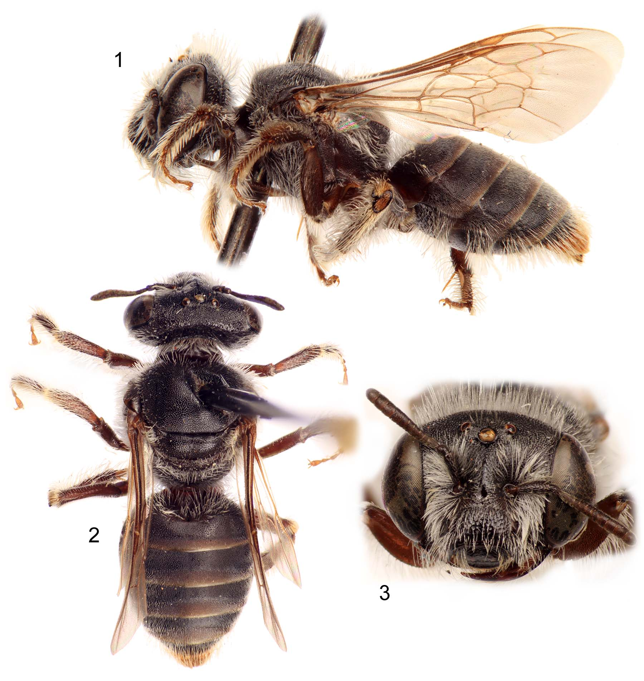

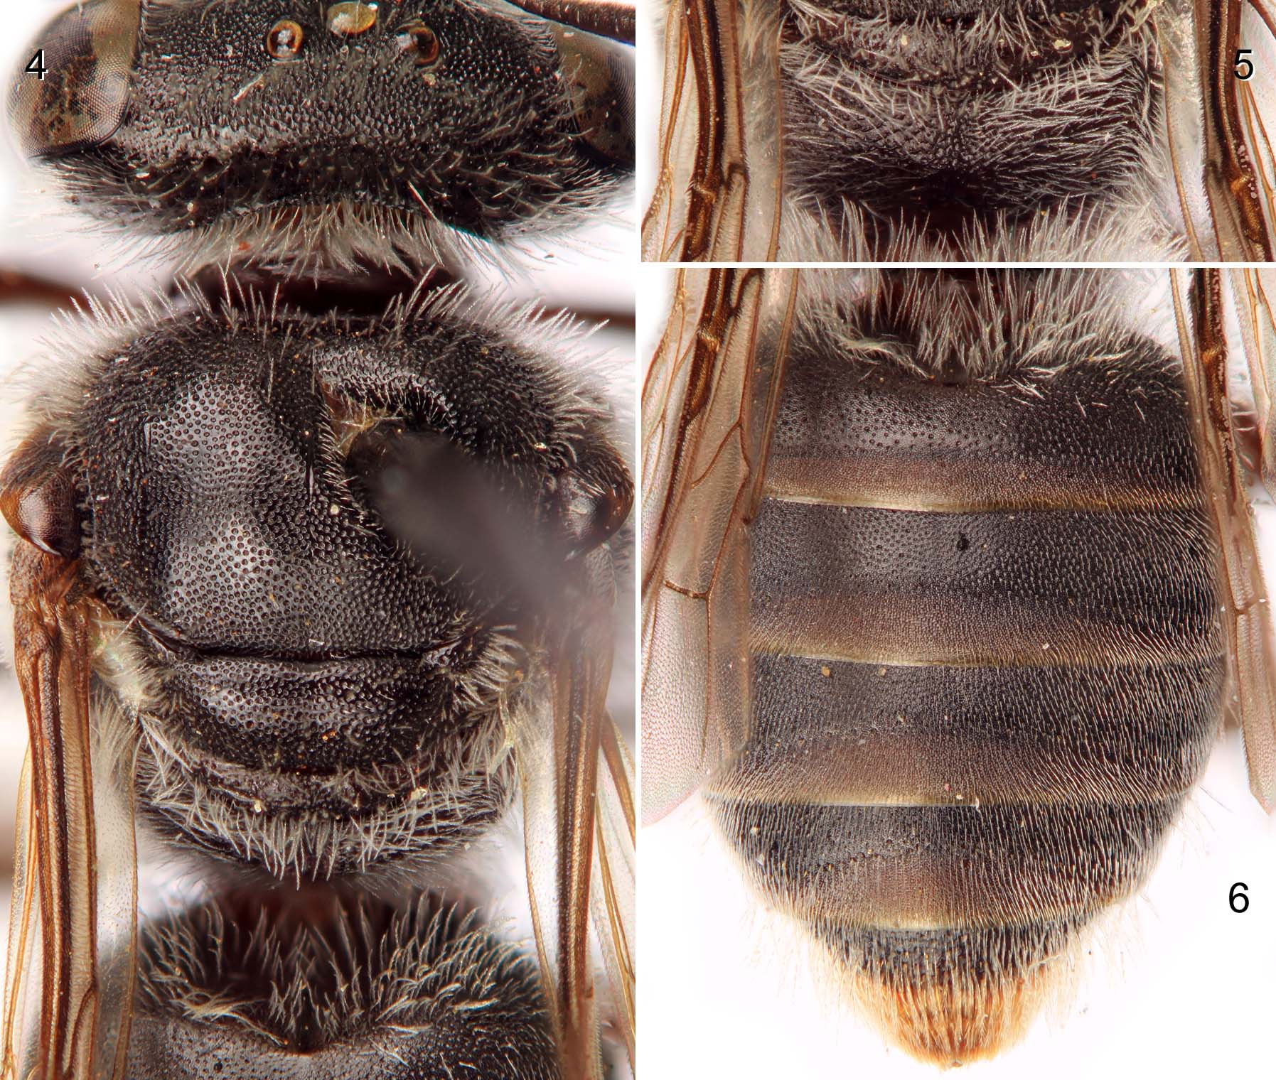

Table 1. A comparison of tribal and subtribal treatments for three recent panurgine classifications. Michener’s (2007) classification is based in large part on that of Ruz (1986, 1991), and although acknowledging the potential utility of some elements of Patiny’s (1999a) arrangement, held on to the two-tribe system. Patiny (1999a) regarded Avpanurgus Warncke, Simpanurgus Warncke, and Flavipanurgus Patiny as incertae sedis within Panurginae (these were included in Panurgini by Michener, 2007). In the present arrangement Flavipanurgus would be placed in Panurgina, Avpanurgus in Camptopoeina, and Simpanurgus as incertae sedis within Panurgini.

Michener (2007) | Patiny (1999a) | Herein (# of species)
Nolanomelissini | then undescribed | Nolanomelissini (1)
Calliopsini | Calliopsini | Calliopsini (138)
Protandrenini, partim | Protandrenini | Protandrenini (411)
Protandrenini, partim | not treated | Neffapini (1)
Panurgini, partim | Panurgini | Panurgini: Panurgina (41)
Panurgini, partim | Camptopoeumini (sic) | Panurgini: Camptopoeina (32)
Panurgini, partim | Panurginini | Panurgini: Panurginina (64)
Melitturgini, partim | Melitturgini | Panurgini: Melitturgina (19)
Melitturgini, partim | “Paramelitturgini”, nomen invalidum | Panurgini: Meliturgulina (20)
Melitturgini, partim | Mermiglossini | Panurgini: Mermiglossina (6)
Protomeliturgini | not treated | Protomeliturgini (2)
Perditini | Perditini | Panurgini: Perditina (672)

