Journal of Melittology

A new genus of anthophorine bees from Brunei
(Hymenoptera: Apidae)

Michael S. Engel^{1,2}

¹ Division of Entomology, Natural History Museum, and Department of Ecology & Evolutionary Biology, 1501 Crestline Drive – Suite 140, University of Kansas, Lawrence, Kansas 66045-4415, USA (msengel@ku.edu).
² Division of Invertebrate Zoology, American Museum of Natural History, Central Park West at 79th Street, New York, New York 10024-5192, USA.

Abstract. A new genus of anthophorine bees (Apinae: Anthophorini) is described and figured from a remarkable female collected in eastern Brunei (northern Borneo). Varthemapistra edentata Engel, new genus and species, is most similar to species of Habrophorula Lieftinck, which occur in southeastern China, and Elaphropoda Lieftinck, found broadly across Southeast Asia. Habrophorula and the new genus both have the third submarginal cell broad anteriorly and posteriorly. Unique among anthophorines, V. edentata has a simple mandible, while other Anthophorini have bidentate or tridentate mandibles. The genus is described and figured, and a revised key to the genera of Anthophorini provided.

INTRODUCTION

The tribe Anthophorini (Apinae) includes nearly 750 species of robust, fast-flying, soil-nesting bees found throughout the world (Figs. 1–2, 16–27) (Michener, 2007). Their classification has drawn the attention of several researchers (e.g., LaBerge & Michener, 1963; Lieftinck, 1966, 1974; Brooks, 1988; Leijs et al., 2017), and although there has been a tendency among some to divide the group into two separate tribes, Habropodini and Anthophorini (e.g., Brooks, 1988; Wu, 1991), recent phylogenetic studies have demonstrated that the former is paraphyletic to the latter (Dubitzky, 2007). Seven genera have been recognized, with the diverse Amegilla Friese and Anthophora Latreille at times subdivided into numerous subgenera (e.g., Brooks, 1988; Michener, 2007) (Table 1). For considerable time a single female has been known of an unusual new genus of anthophorines from northern Borneo (Figs. 1–2). A description was delayed for more than a decade in the hope of obtaining further material, particularly the male. Unfortunately, no further specimens have been forthcoming and the species is described herein in order to bring it to the attention of melittologists in the hopes of learning more about this peculiar bee, and to provide a revised key to the genera that permits its identification. The genus highlights the need for extensive studies of the Southeast Asian fauna of Anthophorini.

MATERIAL AND METHODS

The holotype of the new species and comparative material of other Anthophorini used in the study are housed in the Division of Entomology, University of Kansas Natural History Museum, Lawrence, Kansas. Photographs were taken with a Canon 7D digital camera using an Infinity K-2 lens and Xenon-flash illumination system, and measurements of the holotype prepared with an ocular micrometer in an Olympus SZX-12 stereomicroscope. Morphological terminology is adapted from Engel (2001) and Michener (2007).

SYSTEMATICS

Tribe Anthophorini Dahlbom

Varthemapistra Engel, new genus

Type species: Varthemapistra edentata Engel, new species.
Diagnosis: The new genus can be distinguished from other anthophorines by the simple mandible, lacking any preapical teeth (Fig. 4). In addition the combination of a weakly protuberant clypeus, linear malar space, metatibia with setae on outer surface distinctly fuscous medially, and forewing with the anterior border of the third submarginal cell only slightly shorter than the posterior border further serve to characterize the genus among other Anthophorini.
Description: Medium-sized anthophorines (total length approximately 11.2 mm), with broad areas of yellow maculation on face (refer to species description, infra) (Fig. 3). Mandible simple, without preapical teeth (Fig. 4); malar space linear (Figs. 3, 6); labrum broader than long, margin not thickened; clypeus weakly protuberant so that, in profile, lower anterior surface is in front of lower inner compound eye orbit by a distance of about one-half compound eye width in profile (Fig. 6) [similar to Habrophorula Lieftinck (Fig. 20), while Elaphropoda Lieftinck has clypeus greatly protuberant, with lower anterior surface in front of compound eye by compound eye width or more (Fig. 18)]; surface of clypeus weakly and gently rounded; anterior margin of clypeus extending to base of mandible; first flagellomere slightly less than one-half length of scape; first flagellomere length about twice apical width; ocelli arranged in broad isosceles triangle, lateral ocelli closer to median ocellus than to each other; proboscis reaching beyond metacoxae in repose; galea longer than head but not twice as long as head (Fig. 6); maxillary palpus short, with five palpomeres; maxillary palpomere II rounded in cross-section, with scattered setae (lacking setal fringe); maxillary palpomere III about one-half length of palpomere II; glossa with flabellum present at apex (absent in Habropoda Smith). Mesoscutellum slightly overhanging metanotum. Legs slender; coxae not spined; protrochanter with longitudinal row of hooked bristles ventrally along posterior length; metabasitibial plate well-developed and comparatively short, about as long as wide (similar to Habrophorula), apical margin pointed (Fig. 5); scopa rather short and sparse, setae simple, white except medially fuscous; pretarsal claws cleft, arolia present. Forewing with 1cu-a confluent with basal vein; pterostigma twice as long as wide (Fig. 7); marginal cell moderately elongate, about 4.5 times as long as wide; distance from marginal cell apex to wing tip shorter than marginal cell (Fig. 7); free part of marginal cell shorter than bounded portion of marginal cell, about as long as anterior border of third submarginal cell (Figs. 7, 15); first submarginal cell shorter than combined lengths of second and third submarginal cells (as measured along posterior borders); second submarginal cell shorter than either first or third submarginal cells, slightly narrowed anteriorly; 1m-cu terminating near apex of second submarginal cell (Fig. 7); third submarginal cell broad anteriorly, with anterior border slightly shorter than posterior border (anterior border about three-quarters length of posterior border: Figs. 7, 15) (borders subequal in Habrophorula and more distinctly narrowed anteriorly in other Asiatic genera); 2rs-m gently arched but not sinuate (sinuate form results in anteriorly narrowed third submarginal cell) (Figs. 7, 15); hind wing cu-a about half as long as 2M+Cu, oblique relative to M+Cu; 2M+Cu slightly less than one half as long as 1M. Metasomal terga II–V with lateral longitudinal parts of graduli present and strong; pygidial plate margins slightly converging apically, lateral margins weakly carinate, apex broadly blunt.
Etymology: The new generic name is a combination of Varthema; after Ludovico di Varthema (1470–1517), the Italian explorer who, among other things, was apparently the earliest to record accounts of Brunei based on his visit to the then Empire in 1505; and the Latin apis (meaning, “bee”), and –istra, the diminutive suffix referencing “wild resemblance”. The gender of the name is feminine.

Varthemapistra edentata Engel, new species
(Figs. 1–7, 15)

Diagnosis: As for the genus (vide supra).
Description: ♀: Total body length 11.2 mm, forewing length 8.7 mm. Head wider than long, length (to clypeal apex) 2.55 mm, width 4.17 mm; upper interorbital distance 2.08 mm, lower interorbital distance 2.19 mm; compound eye length 2.4 mm, width in profile 0.78 mm; labrum wider than long, greatest width 1.30 mm, medial length 0.97 mm, with paramedial semi-circular callosities along basal margin, each smooth, semi-transparent, and appearing as amber-colored windows, individual callus reaching to slightly more than one-third labral length; clypeus weakly protuberant, clypeal protuberance in profile 0.36 mm or slightly less than one half compound eye width; mandible simple, without preapical teeth of any kind; malar space linear; first flagellomere 1.5× as long as second flagellomere; second flagellomere slightly shorter than third flagellomere. Intertegular distance 3.02 mm; pretarsal claws deeply cleft, inner ramus nearly as long as outer ramus; small arolium present. Forewing venation as in figures 7, 15. Pygidial plate of tergum VI broad, with margins slightly converging apically, apex broadly blunt, margins weakly carinate.
Integument throughout largely dark brown to black except labiomaxillary complex amber brown, mandible with yellow maculation on outer basal half; labrum entirely yellow; clypeus with yellow mediolongitudinal stripe that expands slightly in width in apical half, and with yellow on lateral areas in line with yellow on lower parocular area; supraclypeal area with small apicomedial spot of yellow in line with mediolongitudinal line of clypeus and immediately ventral to supraclypeal tubercle; lower face, from tangent at about midlength of antennal toruli yellow; scape with yellow on majority of lower surface except at extreme apex and in proximal sixth. Legs amber brown to brown except darker on metatibia and metabasitarsus. Wing membrane hyaline, colored as light parchment except more fuscous in anterior half of marginal cell; veins dark brown. Metasomal terga largely dark brown; anterior-facing and lateral surfaces of tergum I amber brown, dorsal-facing surface of tergum I blending from reddish brown to dark brown; terga I–IV with yellow-brown apical margins; tergum VI dark brown without yellow-brown apical margin; tergum VII largely reddish brown; sterna largely dark brown except sternum I amber brown, sternum II amber brown on pregradular area and reddish brown on remainder of sternum; sternum III largely reddish brown, becoming darker apically; sterna I–IV with yellow-brown apical margins.
Labrum smooth on paramedial callosities, otherwise coarsely punctate, punctures contiguous and appearing irregular medially, except a small medial depression at medioapical margin without punctures, integument otherwise finely imbricate laterally and somewhat smooth within irregular punctures medially. Clypeus with coarse, shallow punctures, punctures somewhat elongate ventrally, separated by less than a puncture width except medially shallower, fainter, and nearly contiguous, giving surface roughened appearance near faint, thin mediolongitudinal ridge extending from basal margin to near clypeal midlength, integument otherwise imbricate; supraclypeal area with smaller punctures similar to those laterally on clypeus, punctures as on clypeus near epistomal sulcus then becoming more defined and spaced dorsally, centrally separated by about a puncture width, centrally with a small tubercle between antennal toruli, tubercle width about 1.5 times a puncture width and elevated to about 2.25 puncture widths, integument otherwise imbricate. Lower face with punctures similar to those laterally on clypeus except impunctate around antennal toruli; upper face with smaller, well-defined, contiguous to nearly contiguous punctures, punctures more spaced in ocellocular area and around ocelli, separated by less than a puncture width, integument between punctures smooth. Vertex posterior to ocelli with punctures contiguous, integument faintly imbricate, vertex posterior to ocellocular area with punctures separated by a puncture width or less, integument between punctures smooth. Gena with contiguous punctures, integument apparently faintly imbricate (largely obscured by pubescence); postgena apparently as on gena. Pronotum imbricate; mesoscutum and mesoscutellum with small, contiguous to nearly contiguous punctures, integument between punctures, where evident, smooth; metanotum as on mesoscutellum except punctures coarser, weaker, and integument finely imbricate; mesepisternum with small, contiguous to nearly contiguous punctures, integument between punctures smooth; metepisternum largely imbricate with coarse, faint punctures; propodeum with coarse, contiguous to nearly contiguous punctures, integument imbricate. Metasomal terga with small punctures separated by a puncture width or frequently less, punctures more spaced anteriorly on tergum I, with anterior-facing surface impunctate, punctures on more apical terga denser, apical margins of terga narrowly impunctate, integument between matt and smooth to faintly imbricate; pygidial plate of tergum VI imbricate; sterna with small shallow punctures increasing in density apically, pregradular areas impunctate and imbricate, postgradular areas with punctures separated by a puncture width or more blending to punctures separated by much less than a puncture width, integument between punctures imbricate, apical margins of sterna narrowly impunctate; sternum VI strongly imbricate and largely impunctate.
Pubescence of head largely white; mandible with elongate, erect, simple, white setae ventrally and similar but yellow setae dorsally, albeit somewhat shorter; labrum with long, branched setae, a few medioapically slightly yellow, and a few simple yellow setae on disc; clypeus with largely white, simple or with few branches, semierect setae intermixed with a few fuscous setae; lower face as on clypeus although setae with more branches and lacking fuscous setae; scape with long, yellow, largely simple setae; face around antennal toruli with abundant long, white, plumose setae; upper face with largely simple, long, fuscous setae; vertex with long, erect, largely simple or with few branches, fuscous setae; occiput with abundant, elongate, erect, plumose, white setae; gena with largely decumbent, short, plumose, white setae largely obscuring integument, intergrading to posteriorly to elongate setae of occiput; lower gena and postgena with elongate white setae like that of occiput. Pubescence of mesosoma largely yellowish, dense, erect to suberect, and plumose; mesoscutum, mesoscutellum, and upper part of mesepisternum with such setae intermixed with fuscous, erect, plumose setae. Legs with largely elongate, plumose, yellow setae, intermixed with a few fuscous setae; setae on outer surfaces of meso- and metatibiae fuscous and simple, those anteriorly on metatibia simple and white, inner metatibial surface with abundant shorter, simple, white setae; metabasitarsus similar to setation of metatibia; metafemur with few setae ventrally, such setae largely short, thin, simple, and yellow, blending to slightly longer setae dorsally on anterior and posterior surfaces, with a few branches. Metasomal terga with largely fine, simple, decumbent to suberect, fuscous setae; setae longer laterally, with some branches, and lighter in color, tending toward yellow; dorsal-facing surface of tergum I with such setae intermixed with more erect, longer, yellowish setae; apical margins with dense, short, yellow to white setae forming narrow apical fimbria, only present laterally on tergum I and interrupted medially on terga II–IV, interruptions narrowing on more apical terga; tergum V with abundant, long, thicker, black setae with a few branches or simple; tergum VI with setae like those of tergum V except on pygidial plate; sterna with scattered short, largely simple, fine, yellow setae; such setae becoming more numerous, longer, and more branched on succeeding sterna; sterna III and IV with such setae numerous, elongate, and with numerous branches apically; sternum V with similar setae as those on sternum IV except entire fuscous; sternum VI with setae apically similar to those on sternum V.
♂: Latet.
Holotype: ♀, Brunei, L.P. 283 [presumably a locality in Temburong District of eastern Brunei], 4.x.73 [4 October 1973], T.W. Harman (SEMC).
Etymology: The specific epithet refers to the absence of preapical teeth on the female mandible.

Key to Genera of Anthophorini
(modified from Michener, 2007)

1. Forewing with 1m-cu meeting second submarginal cell near middle (Figs. 8, 9); third submarginal cell subquadrate, with anterior and posterior margins of about equal length, and basal and distal margins of about equal length; male gonostylus usually less than one-third as long as gonocoxa, often not double, sometimes reduced to almost nothing ......... 2
—. Forewing with 1m-cu terminating at or near apex of second submarginal cell (Figs. 10–15); third submarginal cell (except in Habrophorula and Varthemapistra) with anterior margin much shorter than posterior margin because of curvature of 2rs-m (Figs. 10–13), such that posterior margin of cell is longer than basal margin; male gonostylus double, dorsal and ventral gonostylar processes usually both one-third as long as gonocoxa or more ................................................................................................................................... 3
2(1). Arolia present (worldwide except Australian Region) ....................... Anthophora Latreille
—. Arolia absent (Eastern Hemisphere) ........................................................... Amegilla Friese
3(1). Pterostigma almost absent, represented by minute area broader than long (Fig. 12); terga II–V or at least to tergum III with lateral, longitudinal parts of graduli strong, sometimes reaching posterior marginal zones of terga; pygidial plate of male present as a well-defined apical process of tergum VII, margined by carinae across apex and at sides, at least apically (Africa, Madagascar) ....................................................... Pachymelus Smith
—. Pterostigma at least as long as broad, usually much longer than broad (Figs. 13–14); terga II–V commonly without lateral longitudinal parts of graduli (Habropoda), with such parts weakened (Deltoptila), or sometimes distinct (Elaphropoda, Habrophorula, Varthemapistra); pygidial plate of male absent or indicated by smooth bare area margined by carina only across apex ................................................................................. 4
4(3). Malar space at least twice as long as antennal pedicel (Fig. 26–27); crossvein cu-a of hind wing nearly transverse, at angle of 50° or more to first abscissa of M+Cu (Mesoamerica) ........................................................................................... Deltoptila LaBerge & Michener
—. Malar space linear to about as long as antennal pedicel (Figs. 19, 21); vein cu-a of hind wing usually conspicuously oblique, at angle of 45° or less to first abscissa of M + Cu (except nearly transverse in Habrophorula) (Holarctic, Oriental) .................................... 5
5(4). Female first flagellomere length 2.75× apical width or frequently more, three-quarters length or longer than scape; mandible with one preapical tooth, thus bidentate; sternum VII of male strongly sclerotized, disc giving rise to large apical process, base of which often bears transverse ridge; flabellum absent (Holarctic, Oriental) ...... Habropoda Smith
—. Female first flagellomere length about 2× apical width or less, distinctly shorter than scape, often one-half length of scape; mandible with two preapical teeth or without teeth; sternum VII of male weakly sclerotized, if apical process present, then without transverse ridge at base of narrow apical process; flabellum present ................................................. 6
6(4). Mandible simple, without preapical teeth (Fig. 4); metatibia with setae on outer surface distinctly fuscous medially; third submarginal cell with anterior border only slightly shorter than posterior border (Fig. 7) (Borneo) .............................. Varthemapistra, n. gen.
—. Mandible with two preapical teeth, thus tridentate (second preapical tooth in Habrophorula in more proximal position, nearer to midlength on dorsal surface, often worn); metatibia with setae on anterior and outer surfaces uniformly light in color (white, yellow, tawny); third submarginal cell with anterior border either distinctly shorter than posterior border (Fig. 11) (Elaphropoda) or with borders nearly equal (Fig. 14) (Habrophorula) .................................................................................................................. 7
7(6). Third submarginal cell with anterior margin much shorter than posterior margin (Fig. 11); clypeus greatly protuberant, extending anteriorly about as far as compound eye width in profile (Fig. 18); hind leg of male enlarged, metatrochanter with broad rounded projection; tergum VII and sternum VI of male somewhat attenuate apically, apices rounded or pointed; sternum VII of male with disc somewhat broader than long, with apical process (without transverse ridge at base of process) (Oriental) ................................ .......................................................................................................... Elaphropoda Lieftinck
—. Third submarginal cell about as wide on anterior margin as on posterior margin (Fig. 14); clypeus not greatly protuberant, extending anteriorly by about one-half compound eye width or less in profile (Fig. 20); hind leg of male not enlarged, metatrochanter lacking rounded projection; tergum VII and sternum VI of male not attenuate, apex of tergum VI nearly always bidentate or with emarginate apical truncation; sternum VII of male transverse, disc much broader than long, without apical process (Oriental) ........................ ........................................................................................................ Habrophorula Lieftinck

DISCUSSION

The new genus described herein is unique among Anthophorini in the absence of mandibular teeth, as there are otherwise one or two preapical teeth. This feature alone serves to distinguish the species from all other members of the tribe. The genus is clearly most similar to Elaphropoda and Habrophorula, both occurring in the same general region. The form of the third submarginal cell is most similar to that of species in the continental Asiatic genus Habrophorula, in which both the anterior and posterior borders are broad and nearly equal. The borders are not quite equal in V. edentata, but more closely approximate the condition found in Habrophorula than in Elaphropoda. Indeed, it seems likely that V. edentata is a relative of Habrophorula, the latter of which is known from four species occurring in southeastern China (Lieftinck, 1974; Wu, 1991, 2000). The marginal cell is distinctly longer in Habrophorula, such that the free portion beyond the submarginal cells is longer than the anterior border of the third submarginal cell, while it is only about as long as the anterior border of the third submarginal cell in V. edentata. The discovery of the male would presumably clarify much regarding the placement of V. edentata, particularly in regards to the form of the male terminalia and whether or not the hind legs are modified as among the species of Elaphropoda or more simplified as in Habrophorula. Regardless, the diversity of anthophorines across Borneo and the entirety of Southeast Asia’s archipelagos is in dire need of extensive surveys and a comprehensive revision. Once such initial faunistic and systematic work is completed, the historical biogeography of these species and populations can be explored as they likely relate to vicariance events relating to the change in sea levels across the Sunda Shelf during the late Neogene.

ACKNOWLEDGEMENTS

I am grateful to Jennifer C. Thomas for her assistance with the photographic equipment used to compose the plates; to Jennifer and Victor H. Gonzalez for testing the key to genera; and to two anonymous reviewers for their comments on the manuscript. This is a contribution of the Division of Entomology, University of Kansas Natural History Museum.

REFERENCES

Dubitzky, A. 2007. Phylogeny of the world Anthophorini (Hymenoptera: Apoidea: Apidae). Systematic Entomology 32(4): 585–600.
Brooks, R.W. 1988. Systematics and phylogeny of the anthophorine bees (Hymenoptera: Anthophoridae; Anthophorini). University of Kansas Science Bulletin 53(9): 436–575.
Engel, M.S. 2001. A monograph of the Baltic amber bees and evolution of the Apoidea (Hymenoptera). Bulletin of the American Museum of Natural History 259: 1–192.
LaBerge, W.E., & C.D. Michener. 1963. Deltoptila, a Middle American genus of anthophorine bees (Hymenoptera, Apoidea). Bulletin of the University of Nebraska State Museum 4(9): 211–226.
Leijs, R., M. Batley, & K. Hogendoorn. 2017. The genus Amegilla (Hymenoptera, Apidae, Anthophorini) in Australia: A revision of the subgenera Notomegilla and Zonamegilla. ZooKeys 653: 79–140.
Lieftinck, M.A. 1966. Notes on some anthophorine bees, mainly from the Old World (Apoidea). Tijdschrift voor Entomologie 109(6): 125–161.
Lieftinck, M.A. 1974. Review of Central and East Asiatic Habropoda F. Smith, with Habrophorula, a new genus from China (Hymenoptera, Anthophoridae). Tijdschrift voor Entomologie 117(5): 157–224.
Michener, C.D. 2007. The Bees of the World [2nd Edition]. Johns Hopkins University Press; Baltimore, MD; xvi+[i]+953 pp., +20 pls.
Wu, Y.-R. 1991. Studies on Chinese Habropodini with descriptions of new species (Apoidea: Anthophoridae). In: Zhang, G.-X. (Ed.), Scientific Treatise on Systematic and Evolutionary Biology [Volume 1]: 215–233. Science and Technology Press; Beijing, China; 239 pp., +4 pls. [In Chinese, with English summary]
Wu, Y.-R. 2000. Fauna Sinica. Insecta. Volume 20. Hymenoptera. Melittidae, Apidae. Science Press; Beijing, China; xiv+442 pp., +9 pls. [In Chinese, with English summary]

Table 1. Current diversity of bees in the tribe Anthophorini (Apinae).

Tribe Anthophorini Dahlbom
Anthophora-group
Genus Amegilla Friese 233
Genus Anthophora Latreille 412
Genus Deltoptila LaBerge & Michener 6
Genus Habropoda Smith 55
Genus Pachymelus Smith
Subgenus Pachymelus Smith 16
Subgenus Pachymelopsis Cockerell 5
Elaphropoda-group
Genus Elaphropoda Lieftinck 11
Genus Habrophorula Lieftinck 4
Genus Varthemapistra Engel, n. gen. 1

FIGURES

Figures 1–2. Holotype female of Varthemapistra edentata, new genus and species, from Brunei. 1. Lateral habitus. 2. Dorsal habitus.

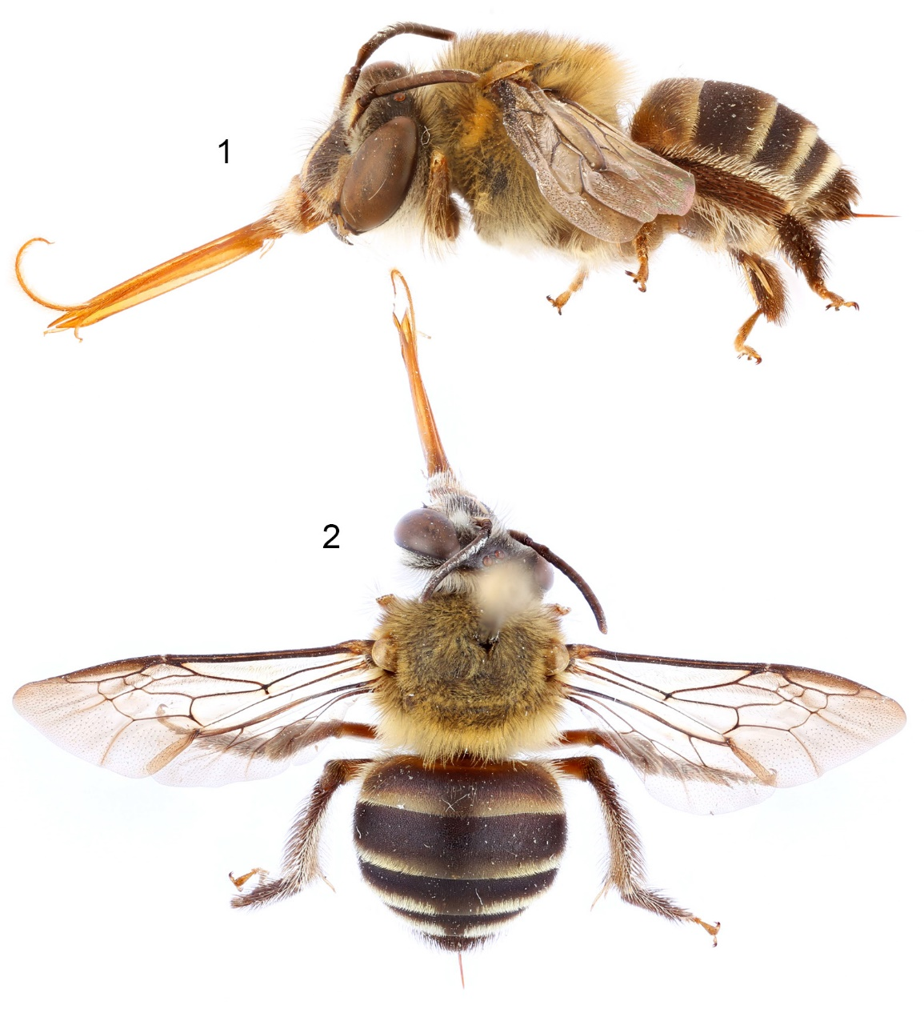

Figures 3–6. Holotype female of Varthemapistra edentata, new genus and species, from Brunei. 3. Facial view. 4. Mandible. 5. Metabasitibial plate. 6. Profile of head.

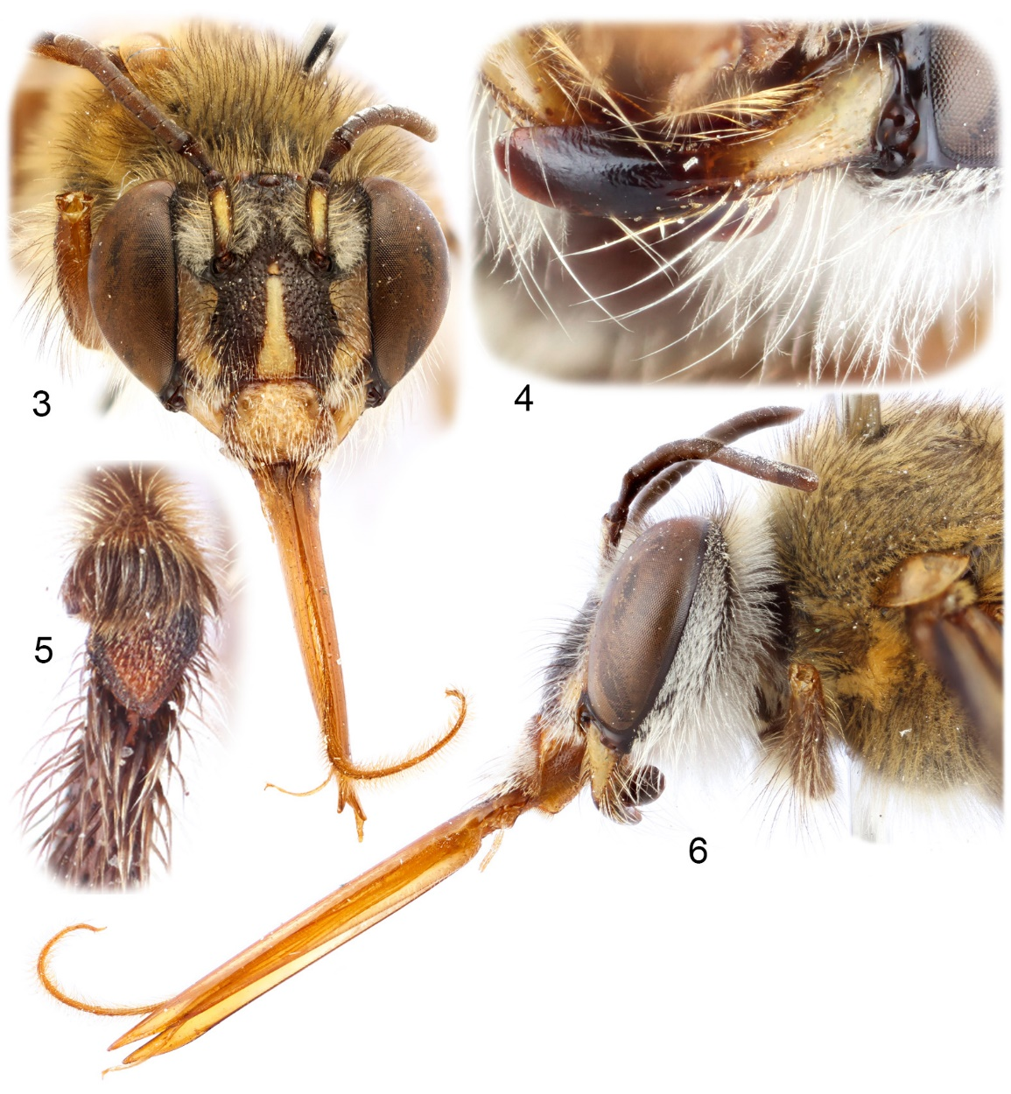

Figure 7. Wing venation of Varthemapistra edentata, new genus and species, from Brunei.

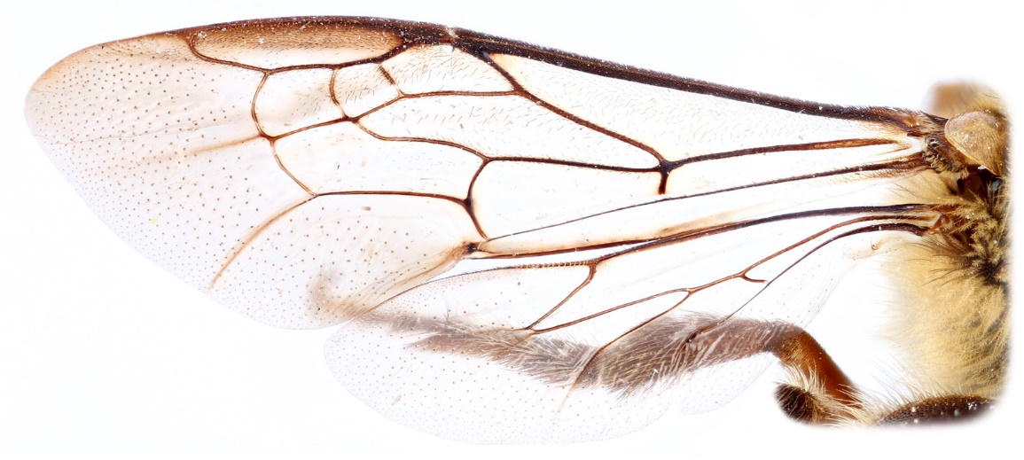

Figures 8–15. Wing venation from representative species of Anthophorini. 8. Anthophora (Lophanthophora) dammersi Timberlake. 9. Amegilla quadrifasciata (de Villers). 10. Habropoda depressa Fowler. 11. Elaphropoda percarinata (Cockerell). 12. Pachymelus (Pachymelus) unicolor (Saussure). 13. Deltoptila sp. 14. Habrophorula nubilipennis (Cockerell). 15. Varthemapistra edentata, new genus and species.

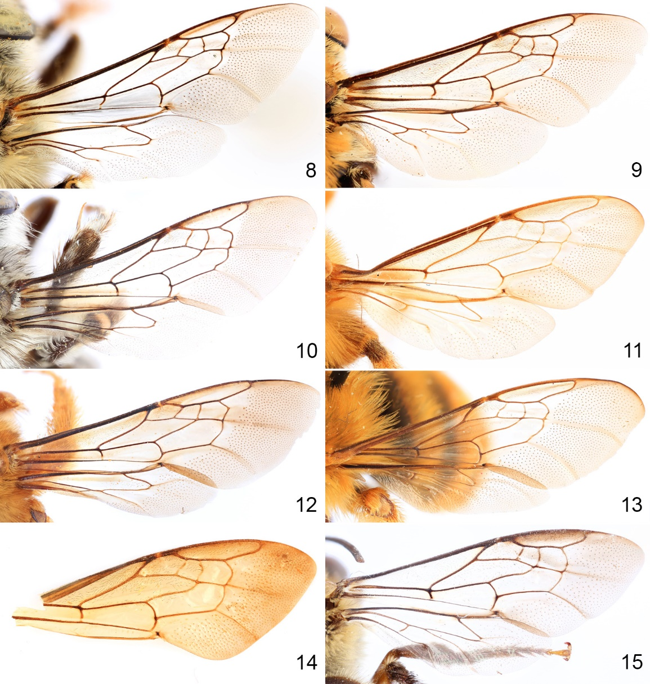

Figures 16–19. Representative anthophorine bees. 16. Amegilla quadrifasciata (de Villers), lateral habitus. 17. A. quadrifasciata, facial view. 18. Elaphropoda khasiana (Schulz), lateral habitus. 19. E. khasiana, facial view.

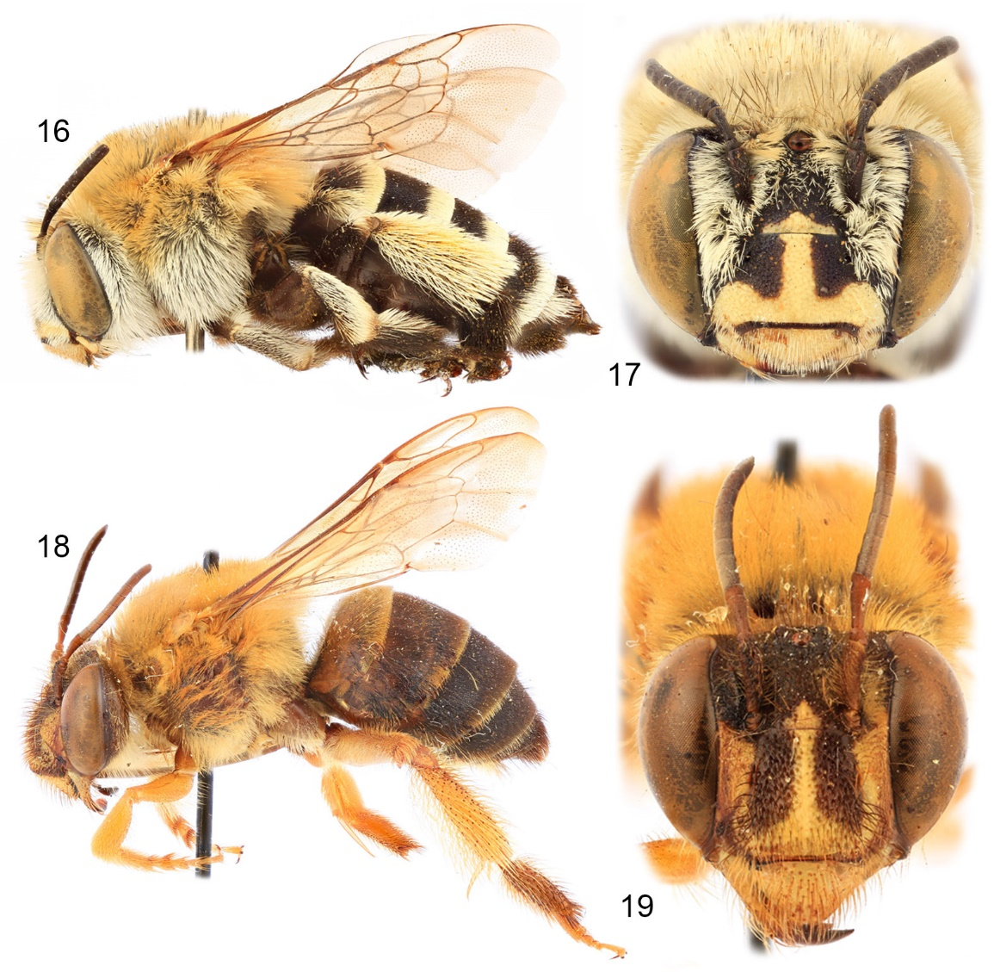

Figures 20–23. Representative anthophorine bees. 20. Habrophorula nubilipennis (Cockerell), lateral habitus. 21. H. nubilipennis, facial view. 22. Habropoda miserabilis (Cresson), lateral habitus. 23. H. miserabilis, facial view.

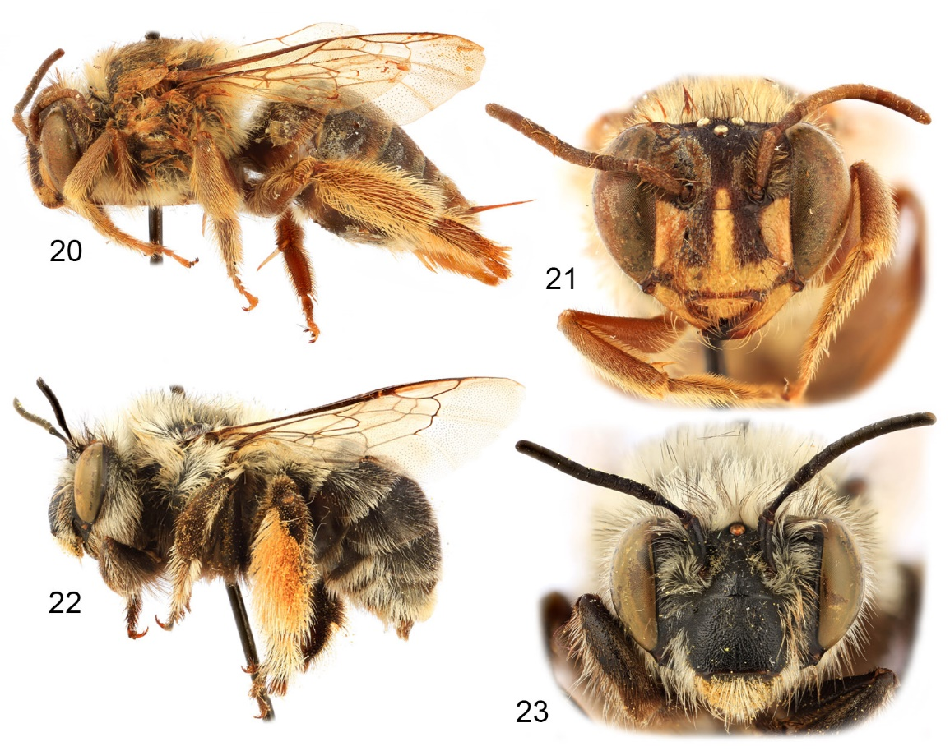

Figures 24–27. Representative anthophorine bees. 24. Pachymelus (Pachymelopsis) festivus (Dours), lateral habitus. 25. P. (Pachymelus) unicolor (Saussure), facial view. 26. Deltoptila badia (Dours), lateral habitus. 27. D. badia, facial view.

