Novitates Paleoentomologicae

A giant termite of the genus Gyatermes from the late Miocene
of Nagano Prefecture, Japan (Isoptera)

Michael S. Engel¹ & Toshiaki Tanaka²

¹ Division of Entomology, Natural History Museum, and Department of Ecology & Evolutionary Biology, 1501 Crestline Drive – Suite 140, University of Kansas, Lawrence, Kansas 66045, USA (msengel@ku.edu).
² 3-7-15, Kosugaya, Sakae, Yokohama City, Kanagawa 247-0007, Japan (sareha21@jcom.zaq.ne.jp).

Abstract. A new species of the termite genus Gyatermes Engel & Gross (Archotermopsidae) is described and figured from a beautifully preserved forewing in late Neogene sediments of Nagano Prefecture, central Japan. The approximately 27-mm long forewing of Gyatermes naganoensis Engel & Tanaka, new species, is preserved in late Miocene (late Messinian) mudstone of the Ogawa Formation (ca. 6 Ma), and is distinguished from its slightly older and larger congener G. styriensis Engel & Gross, from the early Tortonian of Styria, Austria. Comments are provided regarding the paleoclimatic implications of a giant termite in the Miocene fauna of Nagano.

INTRODUCTION

The approximately 3110 species of living termites (Dictyoptera: Isoptera) are among the most influential of insect lineages, their highly organized eusocial colonies wielding considerable ecological dominance in almost every environment in which they are known to occur. These often maligned insects reshape landscapes, breakdown large volumes of lignocellulose, augment atmospheric gases, and, among a comparatively small subset of species, have the power to ravage human habitations and agricultural ecosystems (Grimaldi & Engel, 2005). Termites have been about since at least the earliest Cretaceous and likely the latter Jurassic (Grimaldi & Engel, 2005; Engel et al., 2009; Ware et al., 2010; Krishna et al., 2013), although the group did not radiate considerably in number of species and abundance until the middle Tertiary (Engel et al., 2009). There is today a rather robust fossil record for Isoptera, with a diversity of phylogenetically primitive lineages spanning the Cretaceous and Tertiary (Engel et al., 2009). While many of these are preserved with considerable fidelity and have illuminated much of the early history of the termites (Engel et al., 2009), there remain just as many that are challenging to interpret, regardless of whether preserved in amber or as compressions/impressions, given that they are known only from wings shed by dispersing alates or are exceedingly fragmentary (e.g., Pongrácz, 1928; Emerson, 1967, 1965; Weidner, 1967; Weidner & Riou, 1986; Prokop & Nel, 1999; Engel & Delclòs, 2010; Engel et al., 2011a; Engel, 2014). Despite the challenges of ascertaining the phylogenetic relationships of such taxa, they do aid faunal reconstructions as well as give insights into the diversity (and disparity) of termites living within a given geological formation and region. Not surprisingly, the largest number of fossil termite species and available specimens come from Tertiary, largely Neogene, sediments, with particularly well studied faunas being those in amber from the early Eocene of India (Engel et al., 2011b), the middle Eocene of Europe (Rosen, 1913; Weidner, 1955; Engel et al., 2007a; Engel, 2008), the early Miocene of Chiapas (Snyder, 1960; Krishna & Emerson, 1983; Emerson, 1969, 1971; Krishna, 1996; Engel & Krishna, 2007a, 2007b), and the early Miocene of the Dominican Republic (Krishna & Grimaldi, 2009), the latter of which is the most diverse fossil termite fauna known at this time.
While fossil insects are well known and studied from across the islands of Japan, termites are relatively rarely encountered. Prior records of fossil termites from Japan have all originated from late Miocene deposits in the northeast of Honshu (Prefectures of Akita, Iwate, Miyagi, and Yamagata) (Fujiyama, 1983; Hayashi & Nagasawa, 2000). Fujiyama (1983) recorded five late Miocene termite species, almost all of which represented primitive isopteran families (i.e., all families basal to the clade Icoisoptera and consisting of the families Mastotermitidae, Termopsidae, Hodotermitidae, Archotermopsidae, and Stolotermitidae: Engel et al., 2009, 2013; Krishna et al., 2013), and included two species of the extinct genus Ulmeriella Meunier (possibly Archotermopsidae but its actual phylogenetic position remains controversial), a species of Hodotermopsis Holmgren (Archotermopsidae), a species of Stolotermes Hagen (Stolotermitidae). The fifth species was putatively of the neoisopteran family Rhinotermitidae, put not assignable beyond familial attribution (Fujiyama, 1983). Interestingly, among primitive termite families the modern Japanese fauna includes only a single species, Hodotermopsis sjostedti Holmgren (Krishna et al., 2013). Hayashi & Yamagata (2000) recorded further material considered near to the Hodotermopsis originally documented by Fujiyama (1983). No other species of fossil Isoptera have been hitherto added to the paleofaunas of Japan.
Here we provide the description of a new giant termite (Figs. 1–2) from the Neogene sediments of Nagano Prefecture, Japan. The specimen was discovered among plant material preserved in tuffaceous mudstone and recorded by Koike & Tanaka (2015) as “Termopsidae gen. et sp. indet.”, representing the first record of a termite from the Miocene of central Japan. Further study of the details of the venation of the present specimen reveals that it is representative of a new species in the archotermopsid genus Gyatermes Engel & Gross, known previously from the late Miocene of the Styrian Basin in Austria (Engel & Gross, 2009). This is the first Asiatic record of Gyatermes and, together with the aforementioned H. sjostedti and the Miocene H. iwatensis Fujiyama, are the only archotermopsids from the islands of Japan (Krishna et al., 2013). The enigmatic genus Ulmeriella Meunier is likely also an archotermopsid and perhaps near Archotermopsis Desneux as both have a uniquely apomorphic lenticular compound eye (Weidner, 1955; Emerson, 1968; Engel et al., 2007a; Engel, pers. obs.), and there are two putative species of the genus in the Miocene of Japan – Ulmeriella uemurai Fujiyama and U. shizukuishiensis Fujiyama (Fujiyama, 1983). However, Ulmeriella is poorly defined and various forms ascribed to the genus may belong to different, potentially unrelated groups, including those species described from Japan (Engel, pers. obs.). Reflection on the botheration posed by Ulmeriella is beyond the scope of the present contribution but remains a pernicious puzzle in the systematics of Tertiary Isoptera.

MATERIAL AND METHODS

The wing was recovered along with numerous botanicals (Fig. 1) from the Mt. Chausuyama locality of Nagano, central Japan, and is deposited in the Shinshushinmachi Fossil Museum. The specimen originated in the Ronji Mudstone Member of the Ogawa Formation at Mt. Chausuyama, Nagano City. The south side of Mt. Chausuyama is a cliff formed by repeated landslides (Fig. 3). The lower part of the cliff exposes the Susobana Tuff Member with the Ronji Mudstome Member conformably deposited above it (Fig. 4). The wing was found in the tuffaceous mudstone situated on a bed of lignite within the cliff face (Fig. 4). Also within the same tuffaceous mudstones were recovered several specimens of Taxodium dubium (Sternberg) Heer (Cupressaceae) and species of Alnus Mill. (Betulaceae). Over 60 species of plants have been reported from the stratum, collectively referred to the Mt. Chausuyama Fossil Plant Flora (Tomizawa, 1962). Species of the mussel genera Cristaria Schumacher and Anodonta Lamarck (both Unionoida: Unionidae) and clams of the genus Corbicula Megerle von Mühlfeld (Veneroida: Corbiculidae), all of which inhabit fresh or brackish waters, were found in the silt bed just beneath the lignite layer (Fig. 4). It is believed that the stratum was deposited in a river delta and marsh environment. The wing is remarkably complete and only portions of the base and apex are damaged, and with a small bit of the basal leading edge covered by overlaying matrix (Fig. 2). The fine details of the membrane surface are preserved, and the high fidelity of the fossil lends hope to the discovery of further insects and their possible implications for the fauna.
Although descriptive work or science within the comparative method is mistakenly considered not synthetic or of limited value, it is in reality one of the more fundamental and critical of efforts and is the basis from which broader patterns and explanations are extrapolated (Grimaldi & Engel, 2007), and the below descriptive account is provided in that context. For the systematic descriptions and consideration we follow the forewing terminology of Engel et al. (2007b, 2009), Grimaldi et al. (2008), and Krishna et al. (2013), and the format employed elsewhere for primitive fossil termite species (e.g., Wappler & Engel, 2006; Engel & Gross, 2009; Engel et al., 2013, in press). We have followed the classification of Krishna et al. (2013), and retained use of the name Isoptera as advocated by Lo et al. (2007) and others (e.g., Engel & Krishna, 2004; Engel et al., 2009; Engel, 2011). Photography was done using an Olympus Stylus TG-2 ‘Tough’ digital camera, with images arranged in Adobe Photoshop®.

SYSTEMATIC PALEONTOLOGY

Infraorder Isoptera Brullé
Parvorder Euisoptera Engel et al.
Family Archotermopsidae Engel et al.
Genus Gyatermes Engel & Gross

Gyatermes Engel & Gross, 2009: 291. Type species: Gyatermes styriensis Engel & Gross, 2009, by original designation.

Diagnosis (after Engel & Gross, 2009): Imago. Large termites (forewing length, including wing scale ca. 26.5–33.5 mm), with densely reticulate archedictyon on wing membranes; forewing scale with basal cleavage suture convex, CuP (claval fissue) terminating into suture just prior to posterior wing margin (known only for Gyatermes styriensis Engel & Gross), with reticulations present between CuA and CuP, and posterior to CuP (known only for G. styriensis), humeral margin apparently straight; Sc and R elongate; R branched, with up to four branches; Rs with superior and at least some inferior branches, encompassing wing apex; M extensively developed, encompassing most of posterior wing margin; CuA forming pectinate series of branches in proximal quarter of wing.

Gyatermes naganoensis Engel & Tanaka, new species
(Figs. 1–2)

Termopsidae gen. et sp. indet.: Koike & Tanaka, 2015: 2 (figs. 2–4).

Diagnosis: The new species differs from its congener, G. styriensis, in its slightly smaller size (length from base to apex 26.5 mm in G. naganoensis versus 33.5 mm in G. styriensis), the pectinately-branched R₂ (R₂ more dichotomously branched in G. styriensis), the less developed Rs with only two distinct branches apically and numerous incomplete inferior branches (Rs with several complete superior and inferior branches in G. styriensis), the terminating of Rs just posterior to wing apex (Rs encompassing a larger field in G. styriensis), and the initial branching of M within the scale (M does not branch until outside of scale in G. styriensis).
Description: Imago forewing. Length including scale (as preserved) 26.5 mm; forewing maximum width (as preserved) 7.0 mm. Coloration of wing not preserved, membrane densely reticulate with well-developed archedictyon, membrane lacking nodulation or other texturing. Wing scale with all veins originating within scale (basal cleavage suture faint, discernible anteriorly as preserved), M and CuA with their initial forks inside of scale; scale surface not clearly preserved; veins Sc, R, and Rs apparently stronger than other veins; Sc long (partially preserved), extending to between one-third and one-half wing length; R long (partially preserved), forking into R₁ and R₂ inside of scale, R₁ apparently simple (the leading edge is not fully exposed and we cannot exclude the possibility of short anterior branches on R₁), R₁ apparently terminating on anterior wing margin just beyond wing midlength, R₂ branching in apical two-thirds of wing length, with at least 5 anterior branches, each branch simple and arising in pectinate arrangement, posterior-apicalmost branch of R₂ apparently terminating just anterior wing apex; Rs apparently encompassing wing apex, with several incomplete posterior branches that merge into archedictyon, forking more distinctly in apical fifth of wing length, posteriormost branch apparently terminating just posterior to wing apex; M extensively developed, anteriormost branch apparently terminating on posterior wing margin just posterior to wing apex, posteriormost branch terminating on posterior wing margin at basal quarter of wing length, with at least 13 main branches, several with subsidiary branches and forking near wing margin, although most in basal half of wing length simple; CuA short (similar to that of G. styriensis, Zootermopsis Emerson, and Termopsis ukapirmasi Engel et al.), forming a series of pectinate branches in basal quarter of wing length, all branches terminating along posterior wing margin.
Holotype: Imago forewing; CHAF-20038, late Miocene (late Messinian, ca. 6 Ma), Ronji Member, Ogawa Formation, Mt. Chausuyama, Shinonoi, Nagano City, Nagano Prefecture, Chūbu Region, Honshu, Japan, collector Shigeru Karasawa; deposited in the Shinshushinmachi Fossil Museum, Nagano, Japan.
Etymology: The specific epithet is based on Nagano Prefecture, from which the specimen originates.

DISCUSSION

It is remarkable that a giant termite referable to Gyatermes might be recovered from late Miocene deposits of central Japan, and at considerable distance from the Styrian Basin where G. styriensis was discovered. During the Miocene and early Pliocene Honshu was already separated from mainland Asia, and as would be expected the climate was generally warmer than at present. The flora of the deposits is indicative of a mixed temperate and moist environment, with many deciduous plants of both warm and some cool temperate clades as well as some subtropical elements, such as Glyptostrobus Endlicher (Tomizawa, 1962). The preceding Tortonian was characterized by generally warm temperate, fully humid, and hot summer conditions across Japan (Tang et al., 2011), and this would have persisted to some degree through to the early Pliocene (Zanclean), when seemingly permanent ‘El Niño’ effects were still present (Wara et al., 2005). The presence of a large-bodied termite such as G. naganoensis in the fauna around Nagano is certainly consistent with a warmer, more humid climate. It is not surprising that with the much later close of the Pliocene and the dramatic shift into the colder global environment of the Pleistocene (Filippelli & Flores, 2009), species such as G. naganoensis would have been unable to survive, although it is at present unknown to what degree such large-bodied, primitive dampwood termites would have extended beyond the Messinian. Unfortunately, aside from its occurrence in the late Miocene, there is little more than we can infer from or deduce about G. naganoensis given the currently available information. It will be critical to continue exploration of these deposits for more completely preserved material, and perhaps even evidence of their feeding or nest-building behaviors. It is possible that the biology of Gyatermes was much like modern genera such as Zootermopsis or Archotermopsis, suggesting a possible preference for nesting in moist, rotting wood, and which would accord with a near coastal, forested riverine environment such as appears to be the case in late Miocene Nagano. Given the possible environmental conditions that were present, it is likely there was a more developed isopteran fauna, particularly for mastotermitid, stolotermitid, and other archotermopsid species, all of whom otherwise are today relict (Krishna et al., 2013). The presence of late Miocene species of the same genus in central Europe and central Japan indicates that the genus was either widespread across Eurasia during the Neogene, or was disjunct and perhaps already relict by the closing stages of the epoch. Extensively paleoentomological exploration is needed across the Neogene in order to expand and refine our understanding of termite evolution during the period as at present the vast majority of fossils come from a surprisingly restricted number of deposits (summarized in Krishna et al., 2013), impeding for the moment broader generalizations of isopteran historical biogeography.

ACKNOWLEDGEMENTS

We are grateful to H. Koike for assistance and permission to study the holotype. This is a contribution of the Division of Entomology, University of Kansas Natural History Museum.

REFERENCES

Emerson, A.E. 1965. A review of the Mastotermitidae (Isoptera), including a new fossil genus from Brazil. American Museum Novitates 2236: 1–46.
Emerson, A.E. 1967 [1968]. Cretaceous insects from Labrador. 3. A new genus and species of termite (Isoptera: Hodotermitidae). Psyche 74(4): 276–289.
Emerson, A.E. 1968. A revision of the fossil genus Ulmeriella (Isoptera, Hodotermitidae, Hodotermitinae). American Museum Novitates 2332: 1–22.
Emerson, A.E. 1969. A revision of the Tertiary fossil species of the Kalotermitidae (Isoptera). American Museum Novitates 2359: 1–57.
Emerson, A.E. 1971. Tertiary fossil species of the Rhinotermitidae (Isoptera), phylogeny of genera, and reciprocal phylogeny of associated Flagellata (Protozoa) and the Staphylinidae (Coleoptera). Bulletin of the American Museum of Natural History 146(3): 243–303.
Engel, M.S. 2008. Two new termites in Baltic amber (Isoptera). Journal of the Kansas Entomological Society 81(3): 194–203.
Engel, M.S. 2011. Family-group names for termites (Isoptera), redux. ZooKeys 148: 171–184.
Engel, M.S. 2014. A termite (Isoptera) in Late Cretaceous amber from Vendée, northwestern France. Paleontological Contributions 10E: 21–24.
Engel, M.S., & X. Delclòs. 2010. Primitive termites in Cretaceous amber from Spain and Canada (Isoptera). Journal of the Kansas Entomological Society 83(2): 111–128.
Engel, M.S., & M. Gross. 2009. A giant termite from the late Miocene of Styria, Austria (Isoptera). Naturwissenschaften 96(2): 289–295.
Engel, M.S., & K. Krishna. 2004. Family-group names for termites (Isoptera). American Museum Novitates 3432: 1–9.
Engel, M.S., & K. Krishna. 2007a. New Dolichorhinotermes from Ecuador and in Mexican amber (Isoptera: Rhinotermitidae). American Museum Novitates 3592: 1–8.
Engel, M.S., & K. Krishna. 2007b. Drywood termites in Dominican amber (Isoptera: Kalotermitidae). Beiträge zur Entomologie 57(2): 263–275.
Engel, M.S., D.A. Grimaldi, & K. Krishna. 2007a. A synopsis of Baltic amber termites (Isoptera). Stuttgarter Beiträge zur Naturkunde, Serie B (Geologie und Paläontologie) 372: 1–20.
Engel, M.S., D.A. Grimaldi, & K. Krishna. 2007b. Primitive termites from the Early Cretaceous of Asia (Isoptera). Stuttgarter Beiträge zur Naturkunde, Serie B (Geologie und Paläontologie) 371: 1–32.
Engel, M.S., D.A. Grimaldi, & K. Krishna. 2009. Termites (Isoptera): Their phylogeny, classification, and rise to ecological dominance. American Museum Novitates 3650: 1–27.
Engel, M.S., A. Nel, D. Azar, C. Soriano, P. Tafforeau, D. Néraudeau, J.-P. Colin, & V. Perrichot. 2011a. New, primitive termites (Isoptera) from Early Cretaceous ambers of France and Lebanon. Palaeodiversity 4: 39–49.
Engel, M.S., D.A. Grimaldi, P.C. Nascimbene, & H. Singh. 2011b. The termites of early Eocene Cambay amber, with the earliest record of the Termitidae (Isoptera). ZooKeys 148: 105–123.
Engel, M.S., A.D. Pan, & B.F. Jacobs. 2013. A termite from the late Oligocene of northern Ethiopia. Acta Palaeontologica Polonica 58(2): 331–334.
Engel, M.S., E.D. Currano, & B.F. Jacobs. In press. The first mastotermitid termite from Africa (Isoptera: Mastotermitidae): A new species of Mastotermes from the early Miocene of Ethiopia. Journal of Paleontology
Filippelli, G.M., & J.-A. Flores. 2009. From the warm Pliocene to the cold Pleistocene: A tale of two oceans. Geology 37(10): 959–960.
Fujiyama, I. 1983. Neogene termites from northeastern districts of Japan, with references to the occurrence of fossil insects in the districts. Memoirs of the National Science Museum, Tokyo 16: 83–98, +1 pl.
Grimaldi, D., & M.S. Engel. 2005. Evolution of the Insects. Cambridge University Press; Cambridge, UK; xv+755 pp.
Grimaldi, D., & M.S. Engel. 2007. Why descriptive science still matters. BioScience 57(8): 646–647.
Grimaldi, D.A., M.S. Engel, & K. Krishna. 2008. The species of Isoptera (Insecta) from the Early Cretaceous Crato Formation: A revision. American Museum Novitates 3626: 1–30.
Hayashi, M., & K. Nagasawa. 2000. A fossil termite from the Upper Miocene Yamaguchi Formation in Barazaki, Tendo City, Yamagata Prefecture, Japan. Bulletin of the Yamagata Prefectural Museum 21: 1–5, +1 pl.
Handa, N. 2014. Review of the Neogene vertebrate fossils from Shinshushinmachi, Nagano Prefecture, central Japan. Bulletin of the Nagano City Museum, Division of Natural Sciences 15: 108–118.
Koike, H., & T. Tanaka. 2015. Fossil insects from the Neogene Period of Nagano Prefecture, central Japan. Bulletin of the Nagano City Museum, Division of Natural Sciences 16: 1–7.
Krishna, K. 1996. New fossil species of termites of the subfamily Nasutitermitinae from Dominican and Mexican amber (Isoptera, Termitidae). American Museum Novitates 3176: 1–13.
Krishna, K., & A.E. Emerson. 1983. A new fossil species of termite from Mexican amber, Mastotermes electromexicus (Isoptera, Mastotermitidae). American Museum Novitates 2767: 1–8.
Krishna, K., & D.A. Grimaldi. 2009. Diverse Rhinotermitidae and Termitidae (Isoptera) in Dominican amber. American Museum Novitates 3640: 1–48.
Krishna, K., D.A. Grimaldi, V. Krishna, & M.S. Engel. 2013. Treatise on the Isoptera of the world. Bulletin of the American Museum of Natural History 377: 1–2704.
Lo, N., M.S. Engel, S. Cameron, C.A. Nalepa, G. Tokuda, D. Grimaldi, O. Kitade, K. Krishna, K.-D. Klass, K. Maekawa, T. Miura, & G.J. Thompson. 2007. Save Isoptera: A comment on Inward et al. Biology Letters 3(5): 562–563.
Nel, A., & J.-C. Paicheler. 1993. Les Isoptera fossils. État actuel des connaissances, implications paléoécologiques et paléoclimatologiques [Insecta, Dictyoptera]. Cahiers de Paléontologie 1993: 103–179.
Pongrácz, A. 1928. Die fossilen Insekten von Ungarn, mit besonderer Berücksichtigung der Entwicklung der europäischen Insekten-Fauna. Annales Historico-Naturales Musei Nationalis Hungarici 25: 91–194.
Prokop, J., & A. Nel. 1999. Tertiary termite from the Bílina mine locality in northern Bohemia (Isoptera: Hodotermitidae). Klapalekiana 35: 141–144.
Rosen, K., von. 1913. Die fossilen Termiten: Eine kurze Zusammenfassung der bis jetzt bekannten Funde. Transactions of the Second International Congress of Entomology, Oxford 1912(2): 318–335, +6 pls.
Snyder, T.E. 1960. Fossil termites from Tertiary amber of Chiapas, Mexico. Journal of Paleontology 34(3): 493–494.
Tang, H., A. Micheels, J. Eronen, & M. Fortelius. 2011. Regional climate model experiments to investigate the Asian monsoon in the late Miocene. Climate of the Past 7(3): 847–868.
Tomizawa, T. 1962. The Neogene formations of the Chausuyama District, Shinonoi City, Nagano Prefecture, Japan. Journal of the Geological Society of Japan 68(797): 53–64.
Wappler, T., & M.S. Engel. 2006. A new record of Mastotermes from the Eocene of Germany (Isoptera: Mastotermitidae). Journal of Paleontology 80(2): 380–385.
Wara, M.W., A.C. Ravelo, & M.L. Delaney. 2005. Permanent El Niño-like conditions during the Pliocene warm period. Science 309(5735): 758–761.
Ware, J.L., D.A. Grimaldi, & M.S. Engel. 2010. The effects of fossil placement and calibration on divergence time and rates: An example from the termites (Insecta: Isoptera). Arthropod Structure and Development 39(2): 204–219.
Weidner, H. 1955. Die Bernstein-Termiten der Sammlung des Geologischen Staatsinstituts Hamburg. Mitteilungen aus dem Geologischen Staatsinstitut in Hamburg 24: 55–74.
Weidner, H. 1967. Termiten aus dem deutschen Pliozän von Willershausen. Bericht der Naturhistorischen Gesellschaft zu Hannover 111: 65–75.
Weidner, H., & B. Riou. 1986. Termiten (Isoptera) aus dem Obermiozän von St-Bauzile (Ardéche, Frankreich). Mitteilungen aus dem Geologisch-Paläontologischen Institut der Universität Hamburg 61: 343–365.

FIGURE CAPTIONS

Figures 1–2. Photographs of holotype (CHAF-20038) of Gyatermes naganoensis, new species, from the Miocene of central Japan. 1. Entire slab containing the termite and plant debris. 2. Detail of wing.

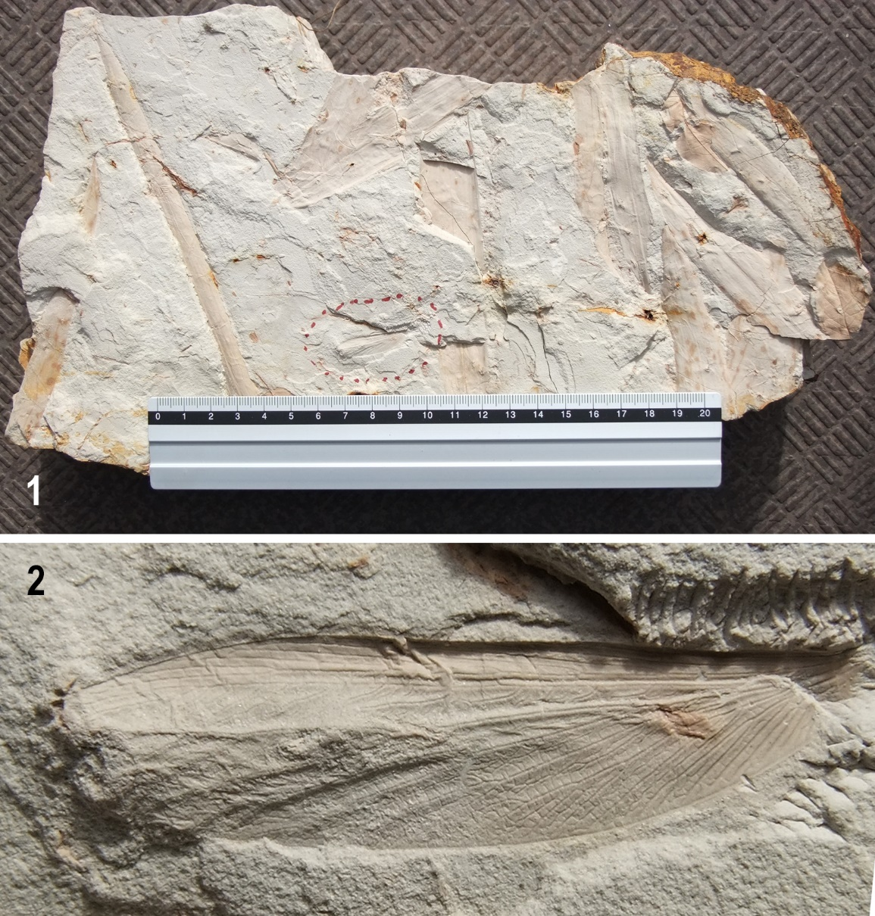

Figure 2. Photograph of the cliff face at Mt. Chausuyama from which the holotype (CHAF-20038) of Gyatermes naganoensis, new species, was recovered (photograph by T. Tanaka).

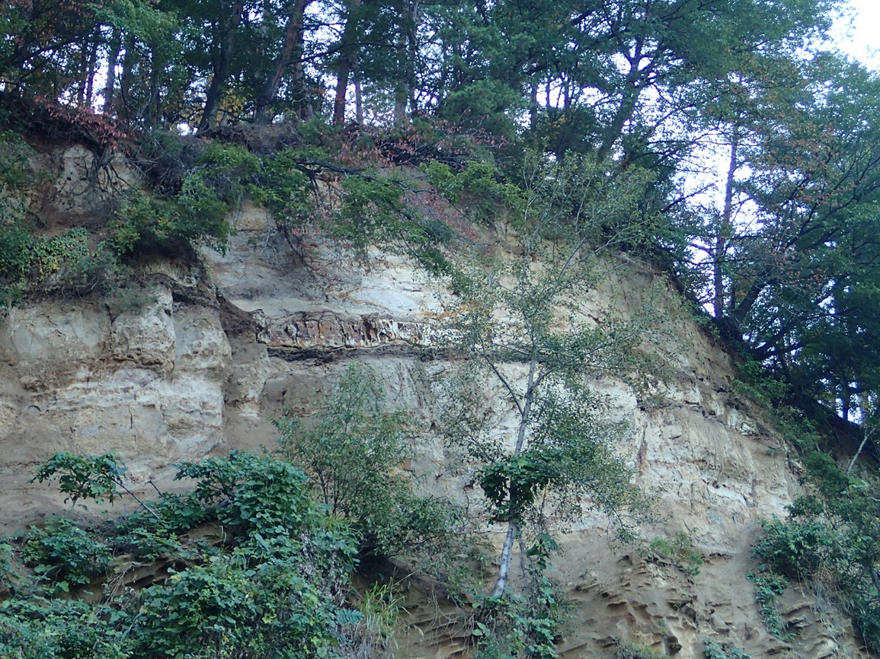

Figure 4. Generalized stratigraphic section (at left) from Shinshushinmachi near Mt. Chausuyama and columnar section of the cliff at Mt. Chausuayama (at right) (redrawn and modified from Handa, 2014, and Tomizawa, 1962).

